UNITED STATES
SECURITIES AND EXCHANGE COMMISSION
Washington, D.C. 20549
Form 6-K
Report of Foreign Private Issuer
Pursuant to Rule 13a-16 or 15d-16 under the Securities Exchange Act of 1934
For the month of October 2026
Commission File Number 001-37626
Mesoblast Limited
(Exact name of Registrant as specified in its charter)
Not Applicable
(Translation of Registrant’s name into English)
Australia
(Jurisdiction of incorporation or organization)

Silviu Itescu
Chief Executive Officer and Executive Director
Level 38
55 Collins Street
Melbourne 3000
Australia
(Address of principal executive offices)

Indicate by check mark whether the registrant files or will file annual reports under cover Form 20-F or Form 40-F:
Form 20-F ☑ Form 40-F ☐

INFORMATION CONTAINED ON THIS REPORT ON FORM 6-K
On October 14, 2026, Mesoblast Limited filed with the Australian Securities Exchange a new issue announcement, notification of cessation of securities (Appendix 3H) which is attached hereto as Exhibit 99.1, and is incorporated herein by reference.
On October 14, 2026, Mesoblast Limited filed with the Australian Securities Exchange a new issue announcement, notification of issue, conversion or payment up of unquoted equity securities (Appendix 3G) which is attached hereto as Exhibit 99.2, and is incorporated herein by reference.
On October 14, 2026, Mesoblast Limited filed with the Australian Securities Exchange a new issue announcement, application for quotation of securities (Appendix 2A) which is attached hereto as Exhibit 99.3, and is incorporated herein by reference.

SIGNATURES
Pursuant to the requirements of the Securities Exchange Act of 1934, the registrant has duly caused this report to be signed on its behalf by the undersigned, thereunto duly organized.
Mesoblast Limited
/s/ Niva Sivakumar
Niva Sivakumar
Company Secretary
Dated: October 14, 2026

INDEX TO EXHIBITS
Item
99.1 |  |  |  |  |  | Appendix 3H of Mesoblast Ltd, dated October 14, 2026.
99.2 |  |  |  |  |  | Appendix 3G of Mesoblast Ltd, dated October 14, 2026.
99.3 |  |  |  |  |  | Appendix 2A of Mesoblast Ltd, dated October 14, 2026.

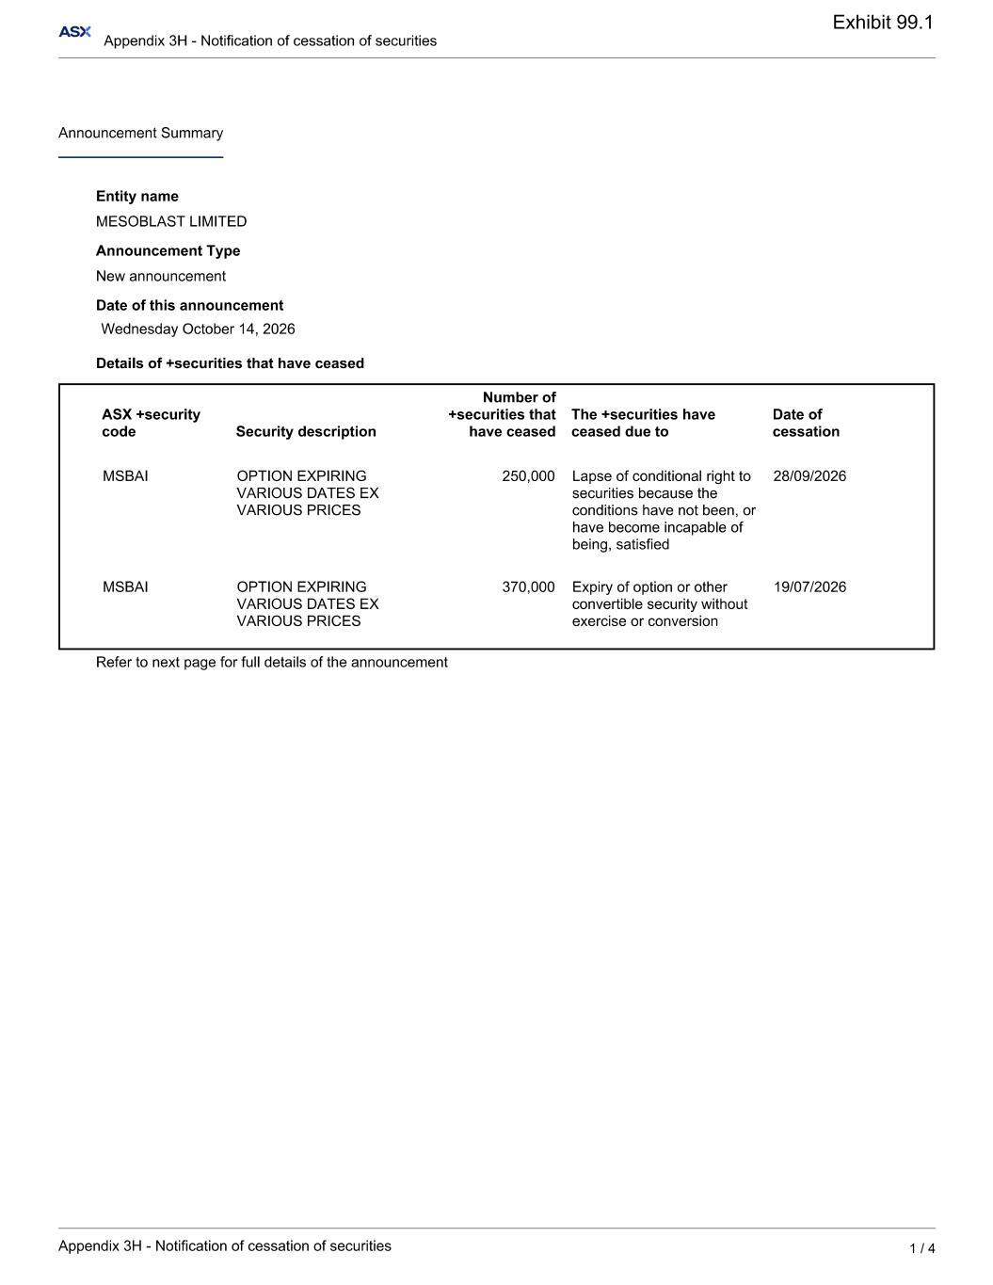

Exhibit 99.1

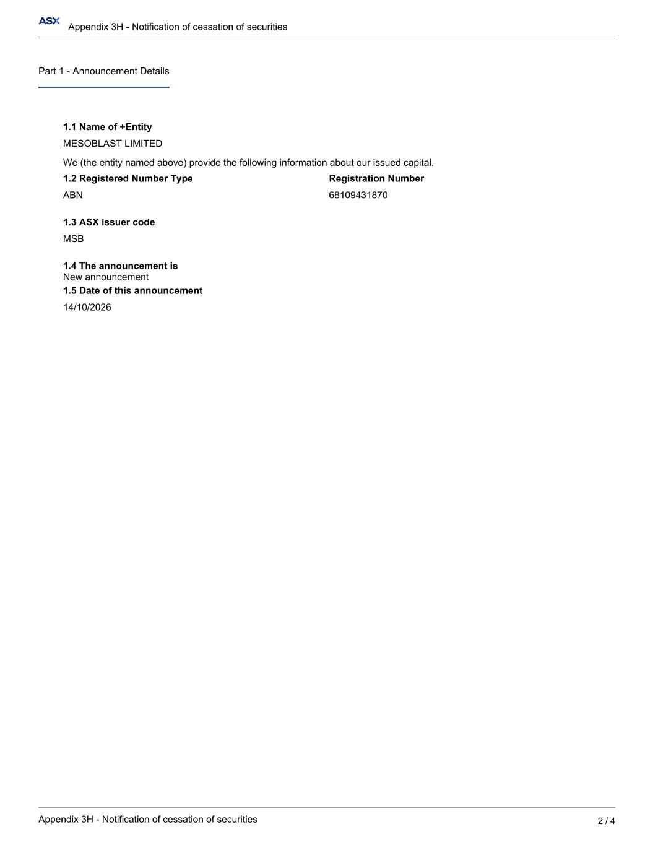

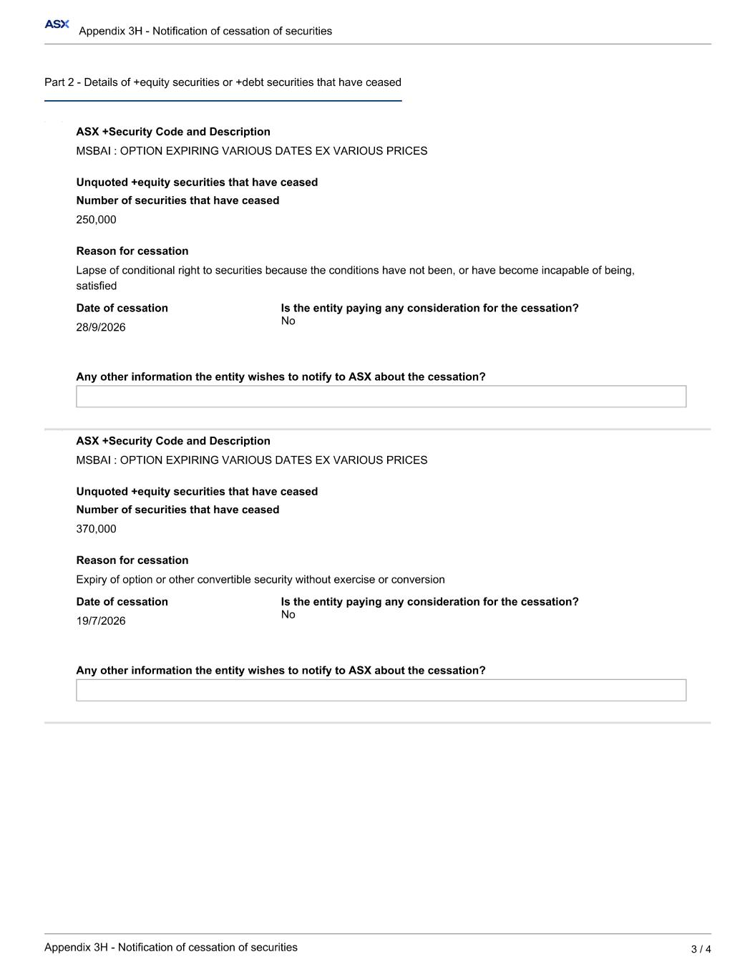

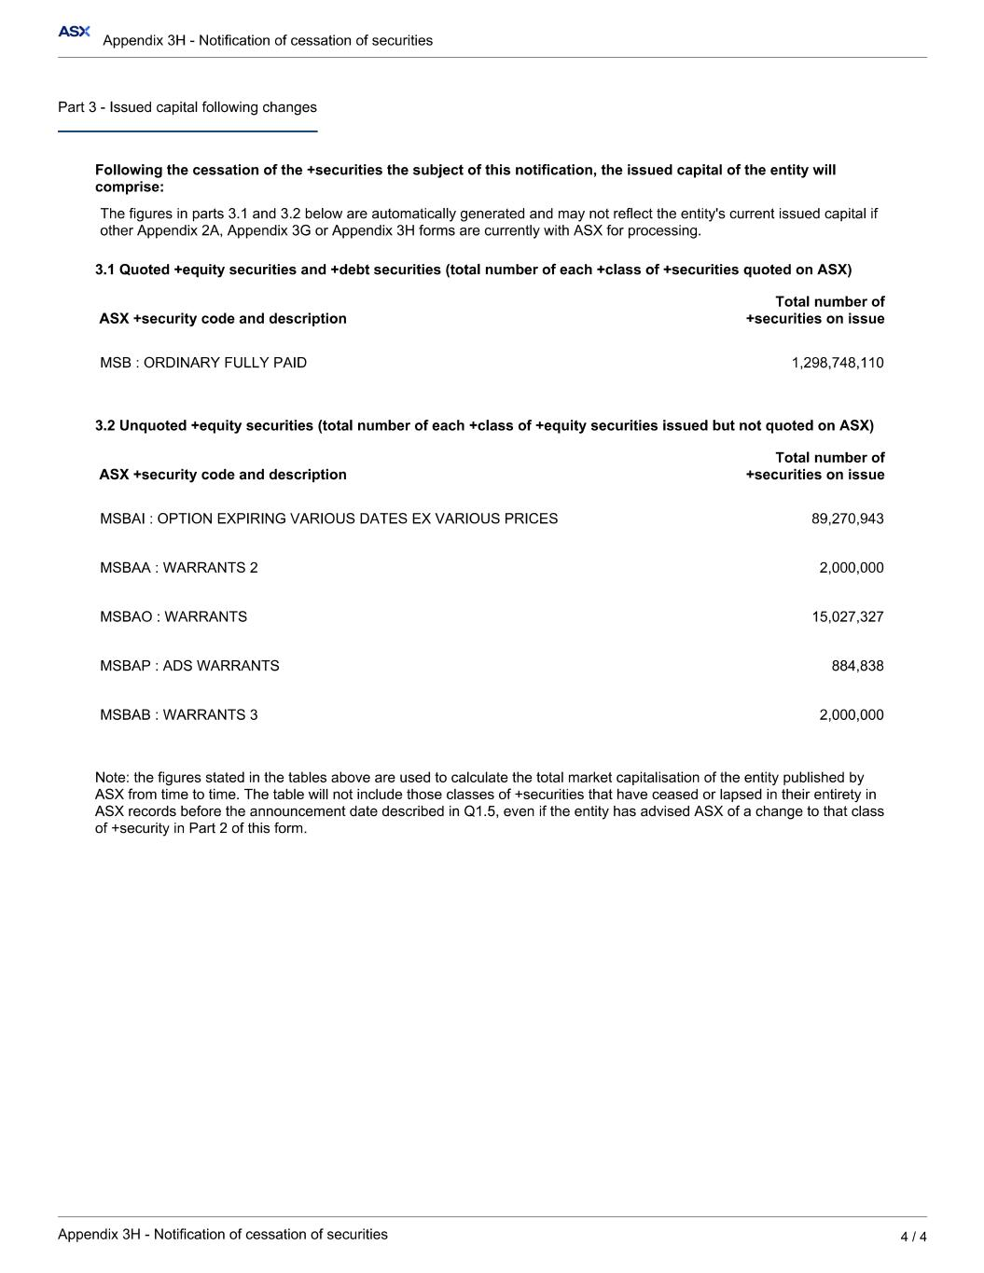

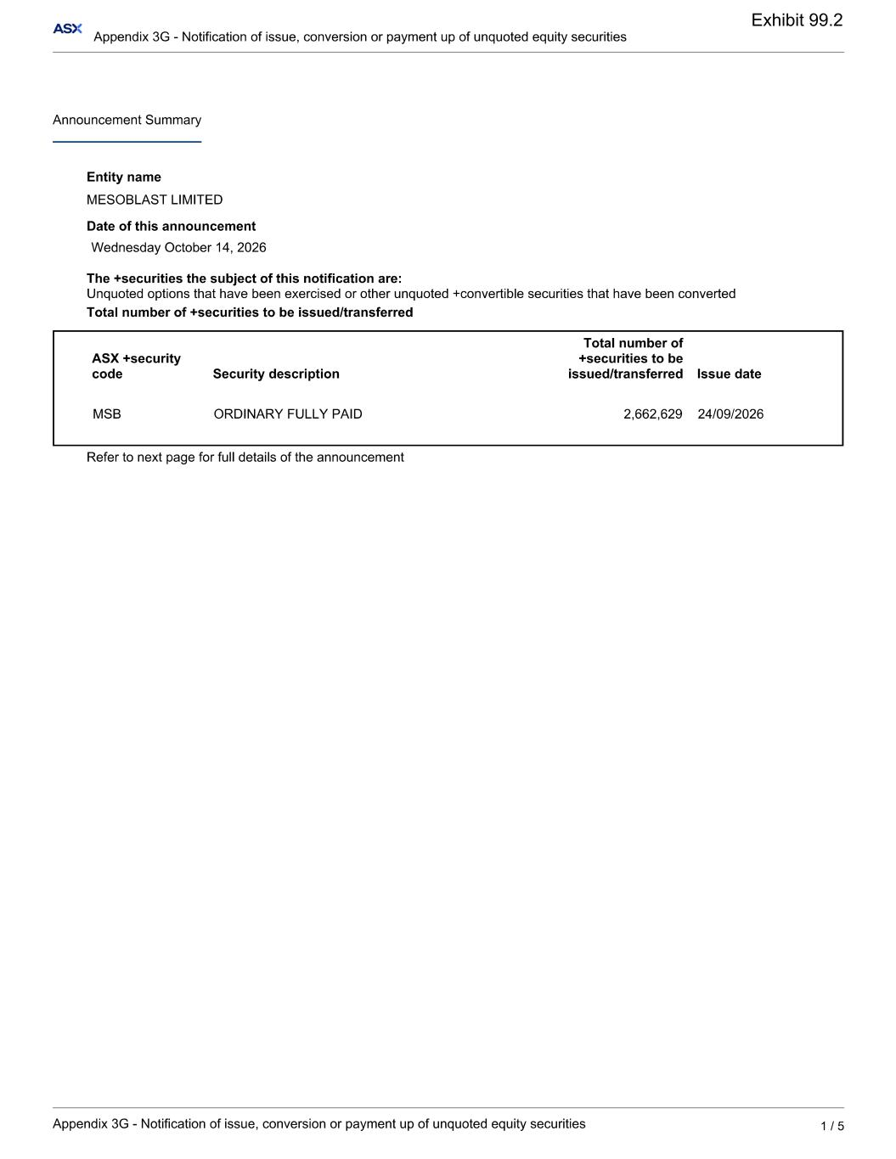
Exhibit 99.2

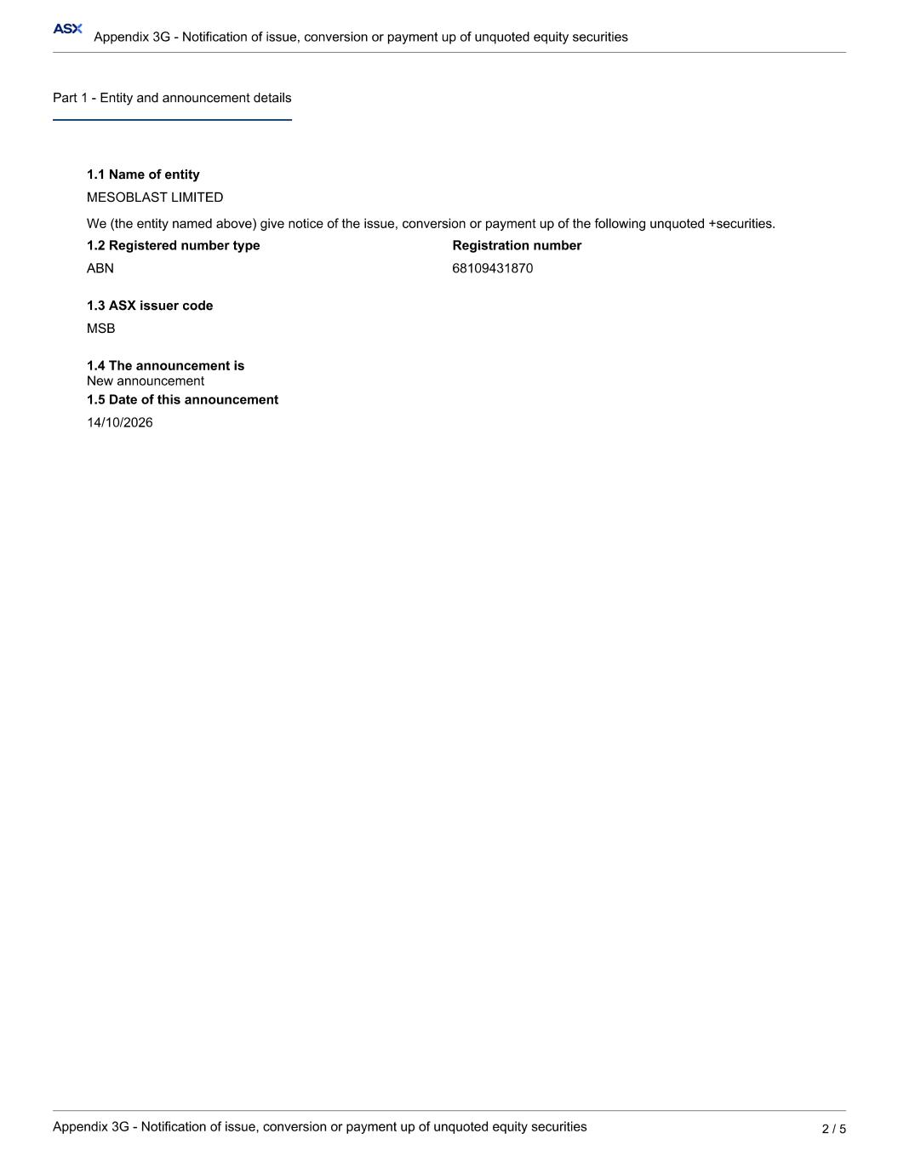

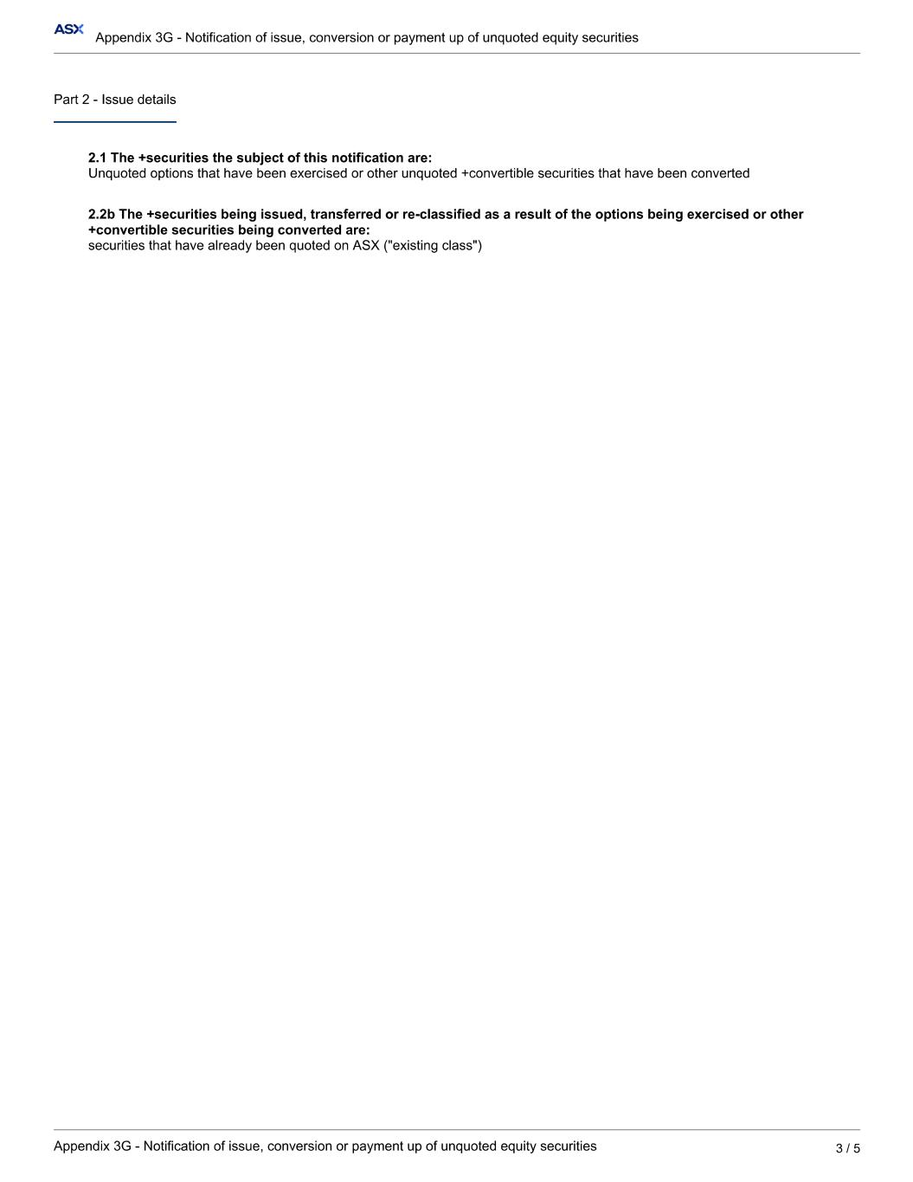

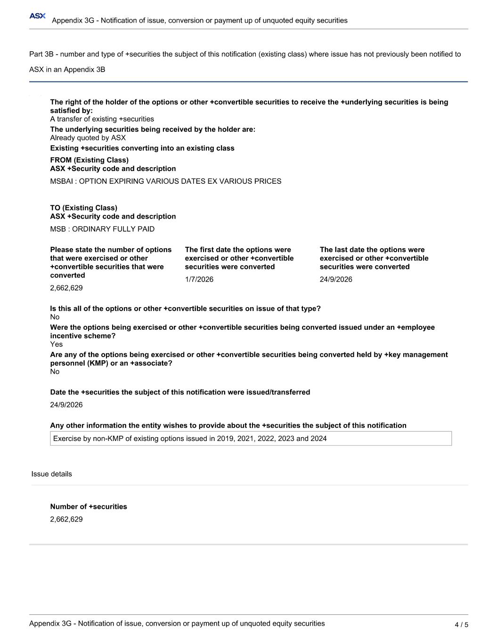

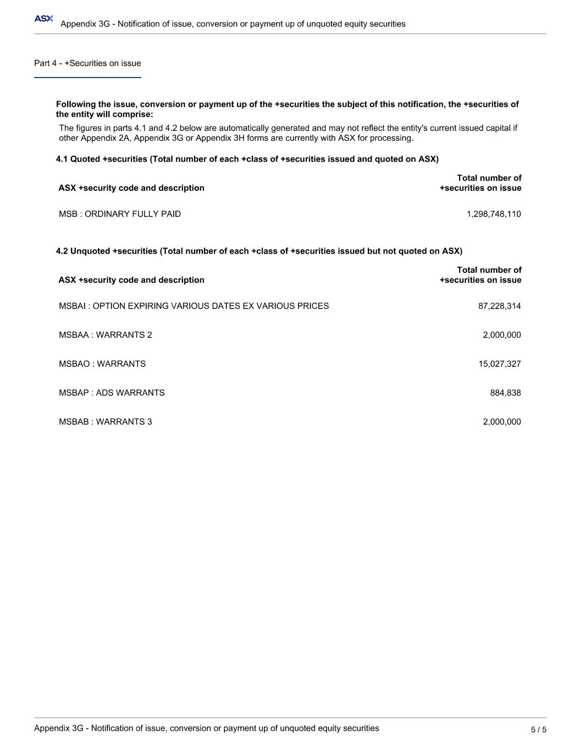

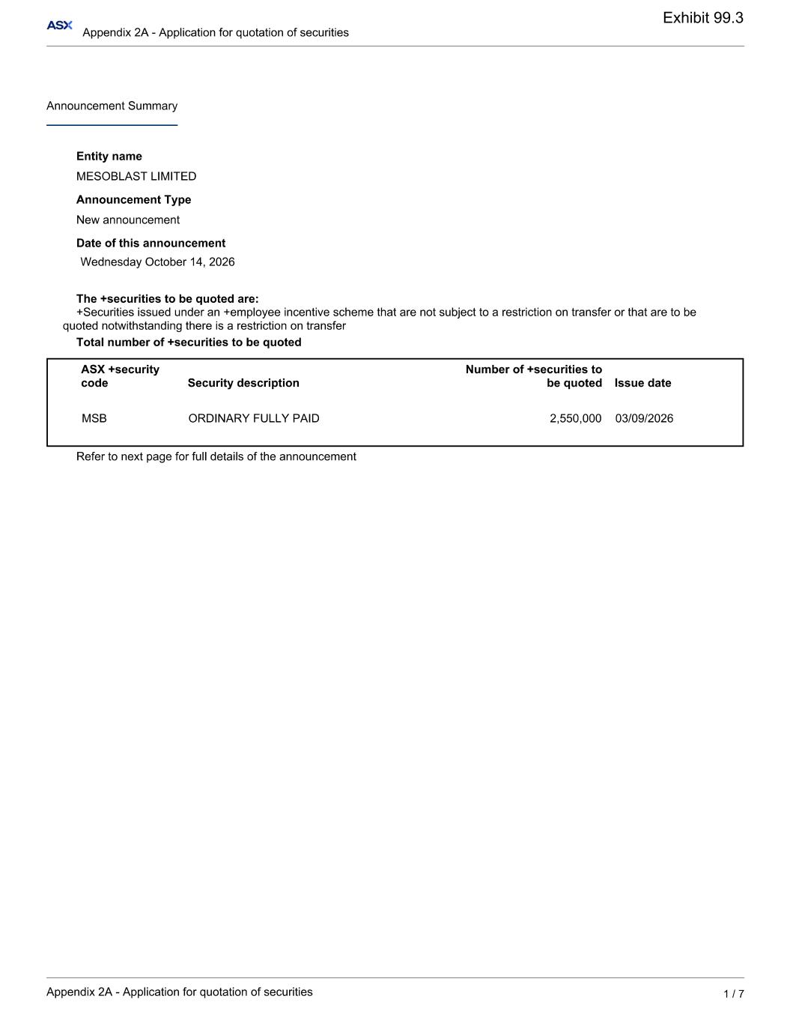
Exhibit 99.3



