UNITED STATES
SECURITIES AND EXCHANGE COMMISSION
Washington, D.C. 20549
Form 6-K
Report of Foreign Private Issuer
Pursuant to Rule 13a-16 or 15d-16 under the Securities Exchange Act of 1934
For the month of July 2026
Commission File Number 001-37626
Mesoblast Limited
(Exact name of Registrant as specified in its charter)
Not Applicable
(Translation of Registrant’s name into English)
Australia
(Jurisdiction of incorporation or organization)

Silviu Itescu
Chief Executive Officer and Executive Director
Level 38
55 Collins Street
Melbourne 3000
Australia
(Address of principal executive offices)

Indicate by check mark whether the registrant files or will file annual reports under cover Form 20-F or Form 40-F:
Form 20-F ☑ Form 40-F ☐

INFORMATION CONTAINED ON THIS REPORT ON FORM 6-K
On July 21, 2026, Mesoblast Limited filed with the Australian Securities Exchange a new issue announcement, which is attached hereto as Exhibit 99.1, and is incorporated herein by reference.
On July 21, 2026, Mesoblast Limited filed with the Australian Securities Exchange a new issue announcement, change of director’s interest notice (Appendix 3Y) which is attached hereto as Exhibit 99.2, and is incorporated herein by reference.
On July 21, 2026, Mesoblast Limited filed with the Australian Securities Exchange a new issue announcement, notification of issue, conversion or payment up of unquoted equity securities (Appendix 3G) which is attached hereto as Exhibit 99.3, and is incorporated herein by reference.
On July 21, 2026, Mesoblast Limited filed with the Australian Securities Exchange a new issue announcement, application for quotation of securities (Appendix 2A) which is attached hereto as Exhibit 99.4, and is incorporated herein by reference.

SIGNATURES
Pursuant to the requirements of the Securities Exchange Act of 1934, the registrant has duly caused this report to be signed on its behalf by the undersigned, thereunto duly organized.
Mesoblast Limited
/s/ Niva Sivakumar
Niva Sivakumar
Company Secretary
Dated: July 21, 2026

INDEX TO EXHIBITS
Item
99.1 |  |  |  |  |  | Press release of Mesoblast Ltd, dated July 21, 2026.
99.2 |  |  |  |  |  | Appendix 3Y of Mesoblast Ltd, dated July 21, 2026.
99.3 |  |  |  |  |  | Appendix 3G of Mesoblast Ltd, dated July 21, 2026.
99.4 |  |  |  |  |  | Appendix 2A of Mesoblast Ltd, dated July 21, 2026.

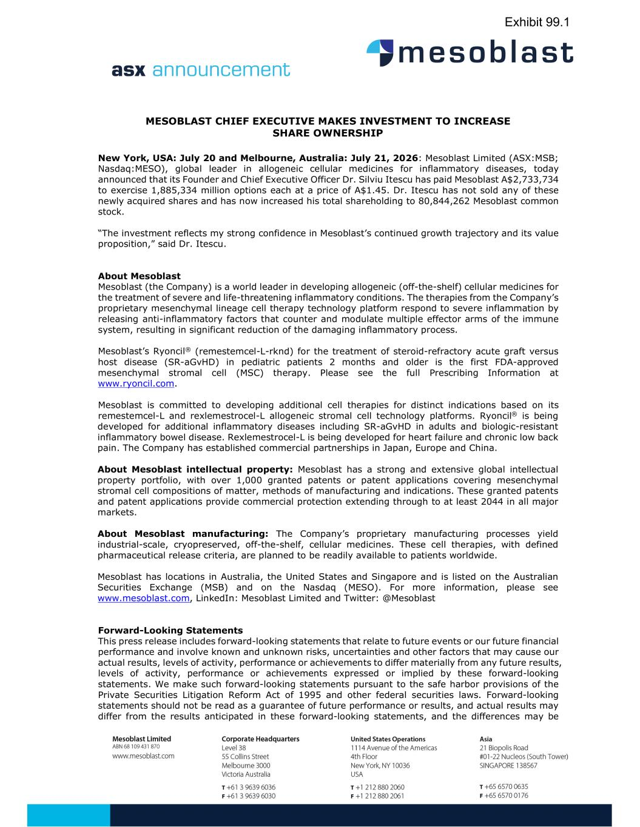

MESOBLAST CHIEF EXECUTIVE MAKES INVESTMENT TO INCREASE SHARE OWNERSHIP New York, USA: July 20 and Melbourne, Australia: July 21, 2026: Mesoblast Limited (ASX:MSB; Nasdaq:MESO), global leader in allogeneic cellular medicines for inflammatory diseases, today announced that its Founder and Chief Executive Officer Dr. Silviu Itescu has paid Mesoblast A$2,733,734 to exercise 1,885,334 million options each at a price of A$1.45. Dr. Itescu has not sold any of these newly acquired shares and has now increased his total shareholding to 80,844,262 Mesoblast common stock. “The investment reflects my strong confidence in Mesoblast’s continued growth trajectory and its value proposition,” said Dr. Itescu. About Mesoblast Mesoblast (the Company) is a world leader in developing allogeneic (off-the-shelf) cellular medicines for the treatment of severe and life-threatening inflammatory conditions. The therapies from the Company’s proprietary mesenchymal lineage cell therapy technology platform respond to severe inflammation by releasing anti-inflammatory factors that counter and modulate multiple effector arms of the immune system, resulting in significant reduction of the damaging inflammatory process. Mesoblast’s Ryoncil® (remestemcel-L-rknd) for the treatment of steroid-refractory acute graft versus host disease (SR-aGvHD) in pediatric patients 2 months and older is the first FDA-approved mesenchymal stromal cell (MSC) therapy. Please see the full Prescribing Information at www.ryoncil.com. Mesoblast is committed to developing additional cell therapies for distinct indications based on its remestemcel-L and rexlemestrocel-L allogeneic stromal cell technology platforms. Ryoncil® is being developed for additional inflammatory diseases including SR-aGvHD in adults and biologic-resistant inflammatory bowel disease. Rexlemestrocel-L is being developed for heart failure and chronic low back pain. The Company has established commercial partnerships in Japan, Europe and China. About Mesoblast intellectual property: Mesoblast has a strong and extensive global intellectual property portfolio, with over 1,000 granted patents or patent applications covering mesenchymal stromal cell compositions of matter, methods of manufacturing and indications. These granted patents and patent applications provide commercial protection extending through to at least 2044 in all major markets. About Mesoblast manufacturing: The Company’s proprietary manufacturing processes yield industrial-scale, cryopreserved, off-the-shelf, cellular medicines. These cell therapies, with defined pharmaceutical release criteria, are planned to be readily available to patients worldwide. Mesoblast has locations in Australia, the United States and Singapore and is listed on the Australian Securities Exchange (MSB) and on the Nasdaq (MESO). For more information, please see www.mesoblast.com, LinkedIn: Mesoblast Limited and Twitter: @Mesoblast Forward-Looking Statements This press release includes forward-looking statements that relate to future events or our future financial performance and involve known and unknown risks, uncertainties and other factors that may cause our actual results, levels of activity, performance or achievements to differ materially from any future results, levels of activity, performance or achievements expressed or implied by these forward-looking statements. We make such forward-looking statements pursuant to the safe harbor provisions of the Private Securities Litigation Reform Act of 1995 and other federal securities laws. Forward-looking statements should not be read as a guarantee of future performance or results, and actual results may differ from the results anticipated in these forward-looking statements, and the differences may be Exhibit 99.1

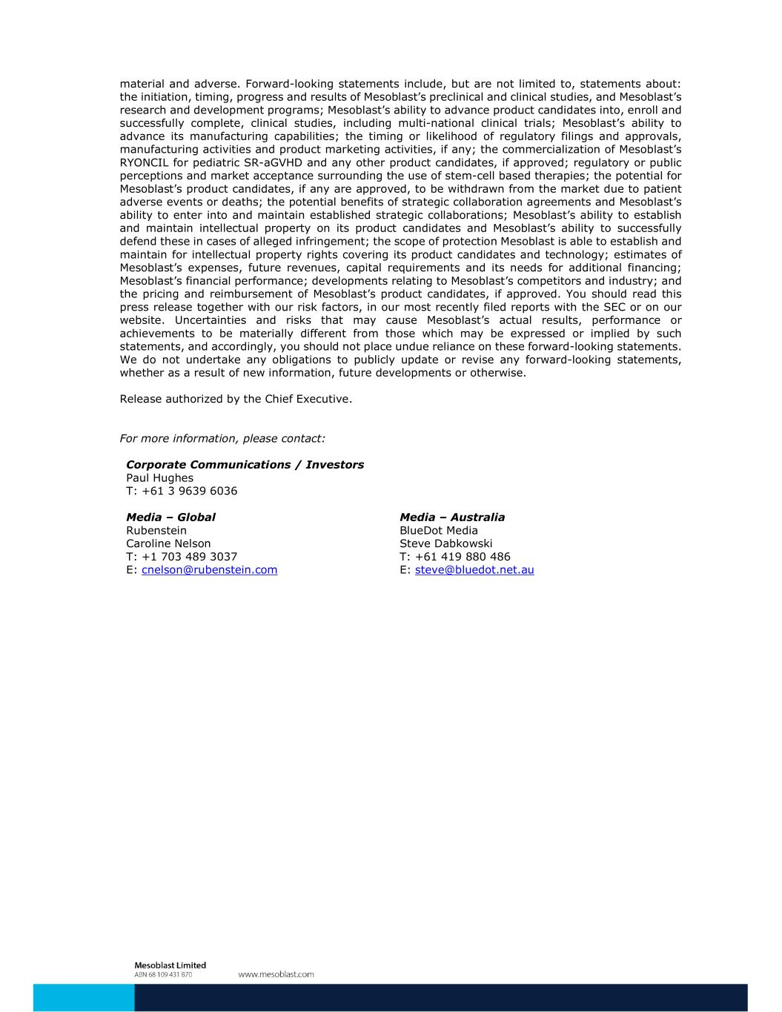
material and adverse. Forward-looking statements include, but are not limited to, statements about: the initiation, timing, progress and results of Mesoblast’s preclinical and clinical studies, and Mesoblast’s research and development programs; Mesoblast’s ability to advance product candidates into, enroll and successfully complete, clinical studies, including multi-national clinical trials; Mesoblast’s ability to advance its manufacturing capabilities; the timing or likelihood of regulatory filings and approvals, manufacturing activities and product marketing activities, if any; the commercialization of Mesoblast’s RYONCIL for pediatric SR-aGVHD and any other product candidates, if approved; regulatory or public perceptions and market acceptance surrounding the use of stem-cell based therapies; the potential for Mesoblast’s product candidates, if any are approved, to be withdrawn from the market due to patient adverse events or deaths; the potential benefits of strategic collaboration agreements and Mesoblast’s ability to enter into and maintain established strategic collaborations; Mesoblast’s ability to establish and maintain intellectual property on its product candidates and Mesoblast’s ability to successfully defend these in cases of alleged infringement; the scope of protection Mesoblast is able to establish and maintain for intellectual property rights covering its product candidates and technology; estimates of Mesoblast’s expenses, future revenues, capital requirements and its needs for additional financing; Mesoblast’s financial performance; developments relating to Mesoblast’s competitors and industry; and the pricing and reimbursement of Mesoblast’s product candidates, if approved. You should read this press release together with our risk factors, in our most recently filed reports with the SEC or on our website. Uncertainties and risks that may cause Mesoblast’s actual results, performance or achievements to be materially different from those which may be expressed or implied by such statements, and accordingly, you should not place undue reliance on these forward-looking statements. We do not undertake any obligations to publicly update or revise any forward-looking statements, whether as a result of new information, future developments or otherwise. Release authorized by the Chief Executive. For more information, please contact: Corporate Communications / Investors Paul Hughes T: +61 3 9639 6036 Media – Global Media – Australia Rubenstein BlueDot Media Caroline Nelson Steve Dabkowski T: +1 703 489 3037 T: +61 419 880 486 E: cnelson@rubenstein.com E: steve@bluedot.net.au

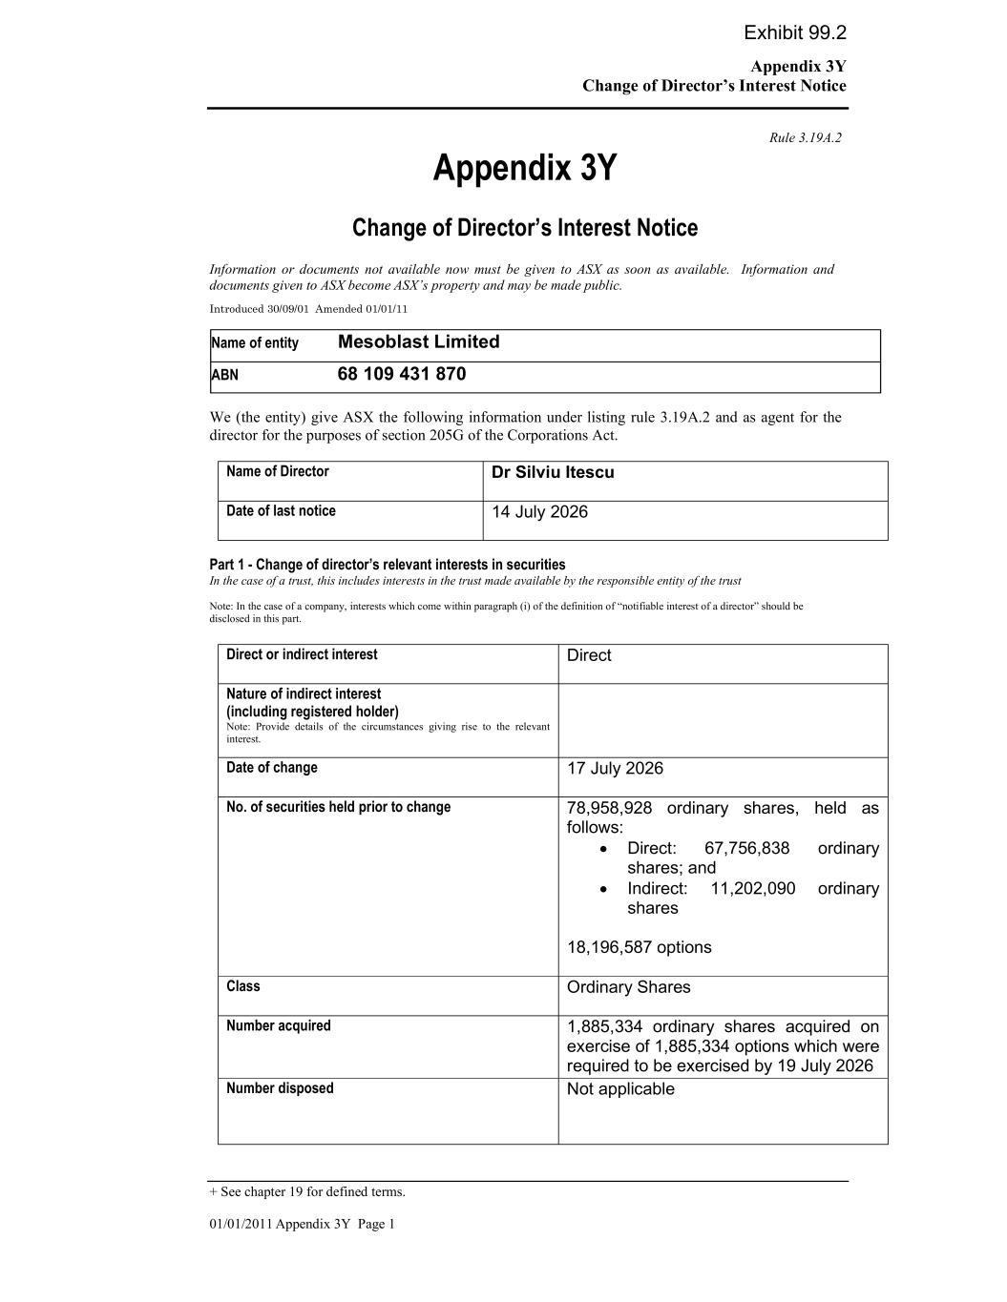
Appendix 3Y Change of Director’s Interest Notice + See chapter 19 for defined terms. 01/01/2011 Appendix 3Y Page 1 Rule 3.19A.2 Appendix 3Y Change of Director’s Interest Notice Information or documents not available now must be given to ASX as soon as available. Information and documents given to ASX become ASX’s property and may be made public. Introduced 30/09/01 Amended 01/01/11 Name of entity Mesoblast Limited ABN 68 109 431 870 We (the entity) give ASX the following information under listing rule 3.19A.2 and as agent for the director for the purposes of section 205G of the Corporations Act. Name of Director Dr Silviu Itescu Date of last notice 14 July 2026 Part 1 - Change of director’s relevant interests in securities In the case of a trust, this includes interests in the trust made available by the responsible entity of the trust Note: In the case of a company, interests which come within paragraph (i) of the definition of “notifiable interest of a director” should be disclosed in this part. Direct or indirect interest Direct Nature of indirect interest (including registered holder) Note: Provide details of the circumstances giving rise to the relevant interest. Date of change 17 July 2026 No. of securities held prior to change 78,958,928 ordinary shares, held as follows: • Direct: 67,756,838 ordinary shares; and • Indirect: 11,202,090 ordinary shares 18,196,587 options Class Ordinary Shares Number acquired 1,885,334 ordinary shares acquired on exercise of 1,885,334 options which were required to be exercised by 19 July 2026 Number disposed Not applicable Exhibit 99.2

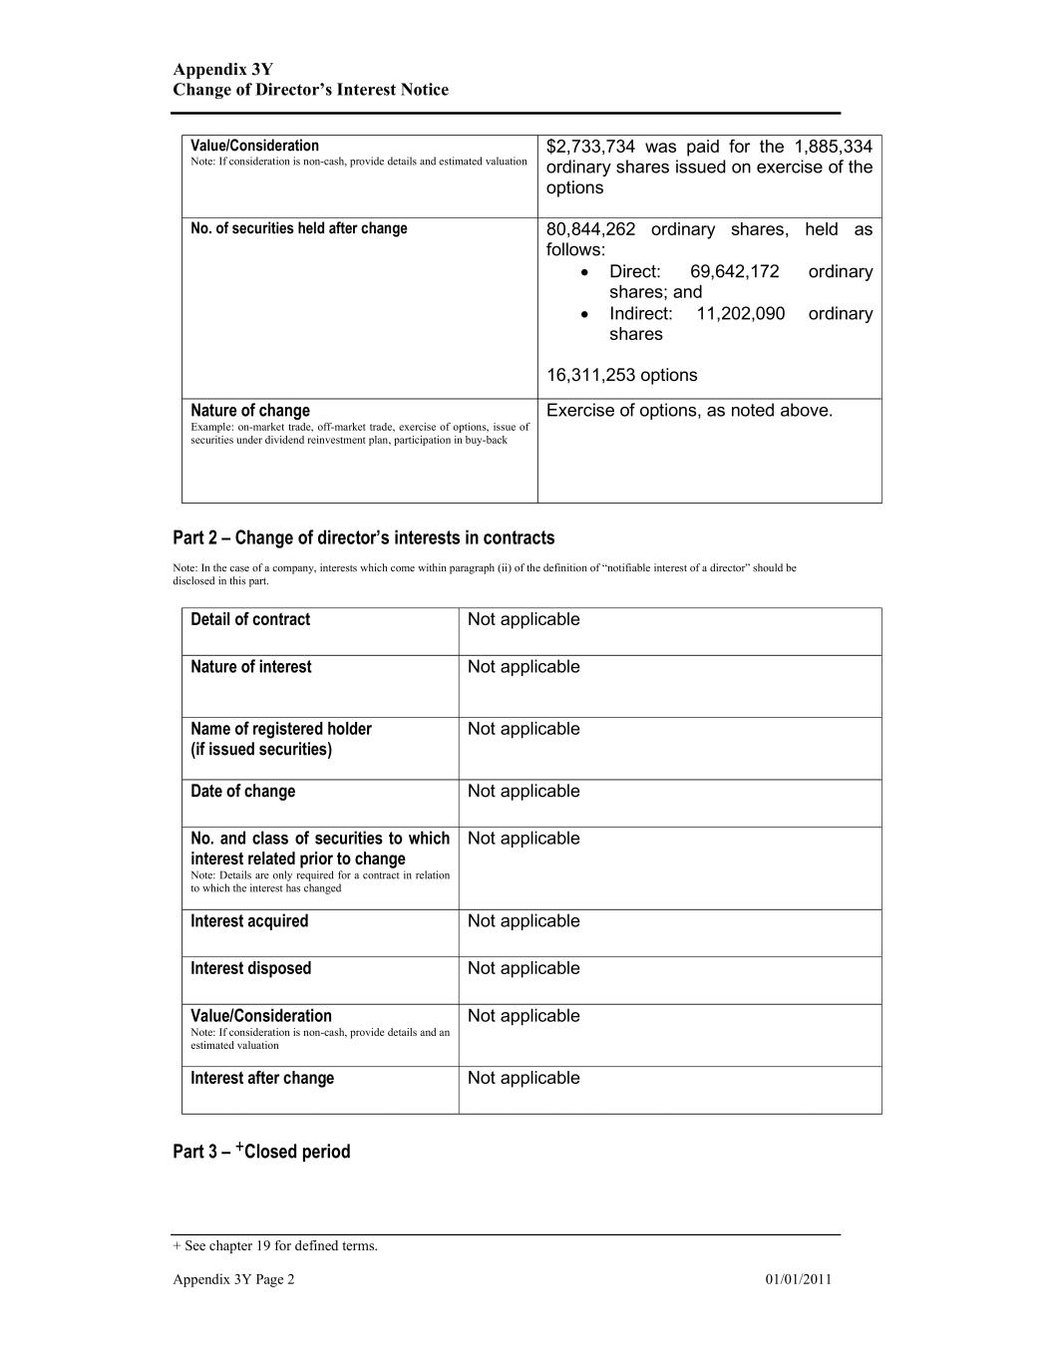
Appendix 3Y Change of Director’s Interest Notice + See chapter 19 for defined terms. Appendix 3Y Page 2 01/01/2011 Value/Consideration Note: If consideration is non-cash, provide details and estimated valuation $2,733,734 was paid for the 1,885,334 ordinary shares issued on exercise of the options No. of securities held after change 80,844,262 ordinary shares, held as follows: • Direct: 69,642,172 ordinary shares; and • Indirect: 11,202,090 ordinary shares 16,311,253 options Nature of change Example: on-market trade, off-market trade, exercise of options, issue of securities under dividend reinvestment plan, participation in buy-back Exercise of options, as noted above. Part 2 – Change of director’s interests in contracts Note: In the case of a company, interests which come within paragraph (ii) of the definition of “notifiable interest of a director” should be disclosed in this part. Detail of contract Not applicable Nature of interest Not applicable Name of registered holder (if issued securities) Not applicable Date of change Not applicable No. and class of securities to which interest related prior to change Note: Details are only required for a contract in relation to which the interest has changed Not applicable Interest acquired Not applicable Interest disposed Not applicable Value/Consideration Note: If consideration is non-cash, provide details and an estimated valuation Not applicable Interest after change Not applicable Part 3 – +Closed period

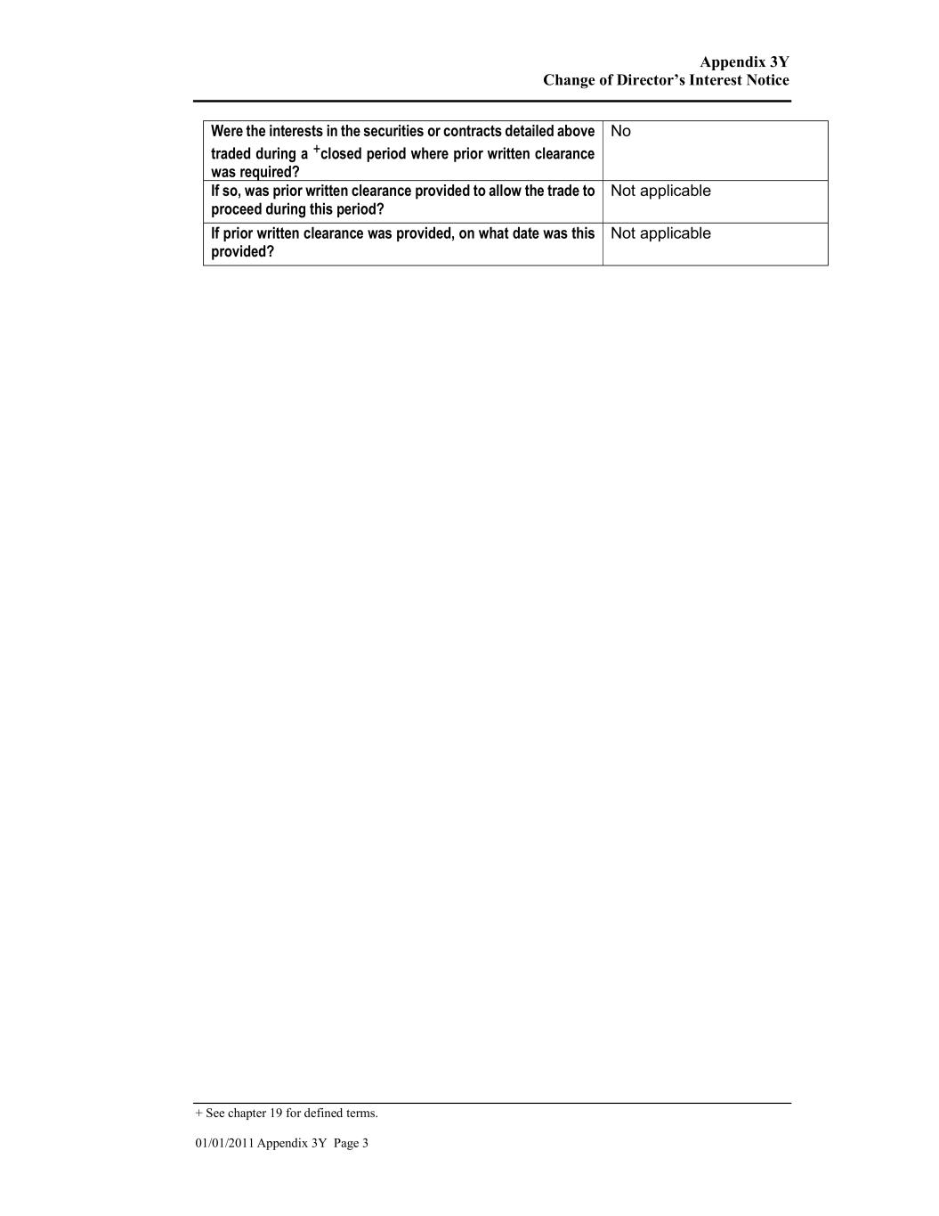
Appendix 3Y Change of Director’s Interest Notice + See chapter 19 for defined terms. 01/01/2011 Appendix 3Y Page 3 Were the interests in the securities or contracts detailed above traded during a +closed period where prior written clearance was required? No If so, was prior written clearance provided to allow the trade to proceed during this period? Not applicable If prior written clearance was provided, on what date was this provided? Not applicable

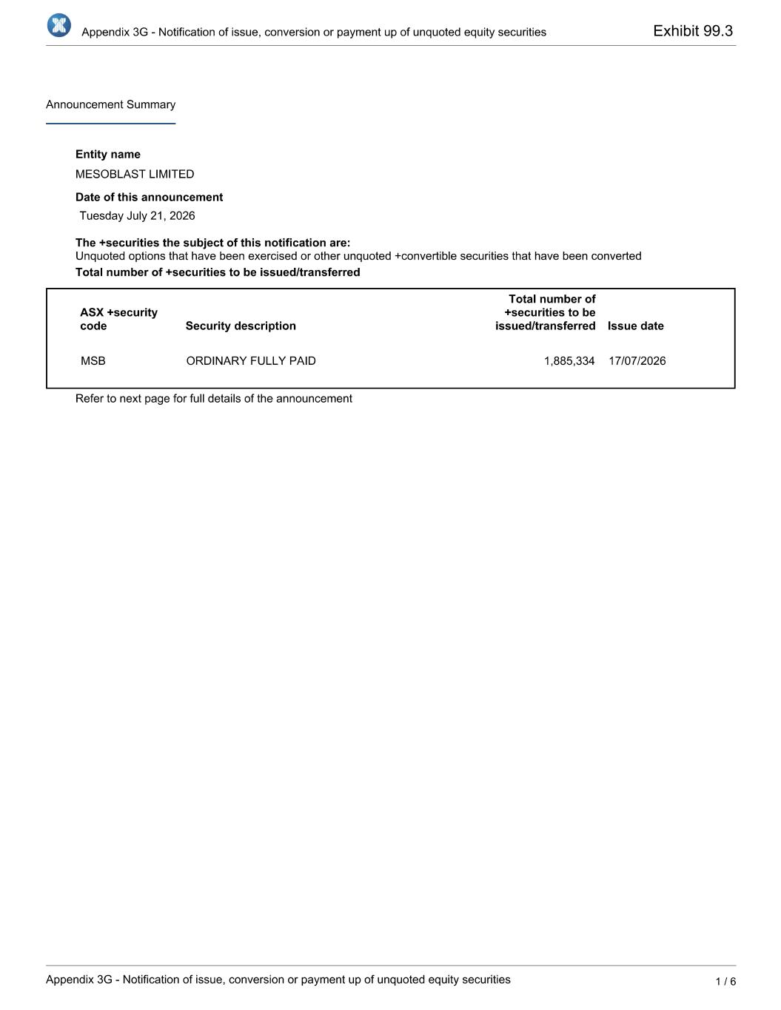
Exhibit 99.3

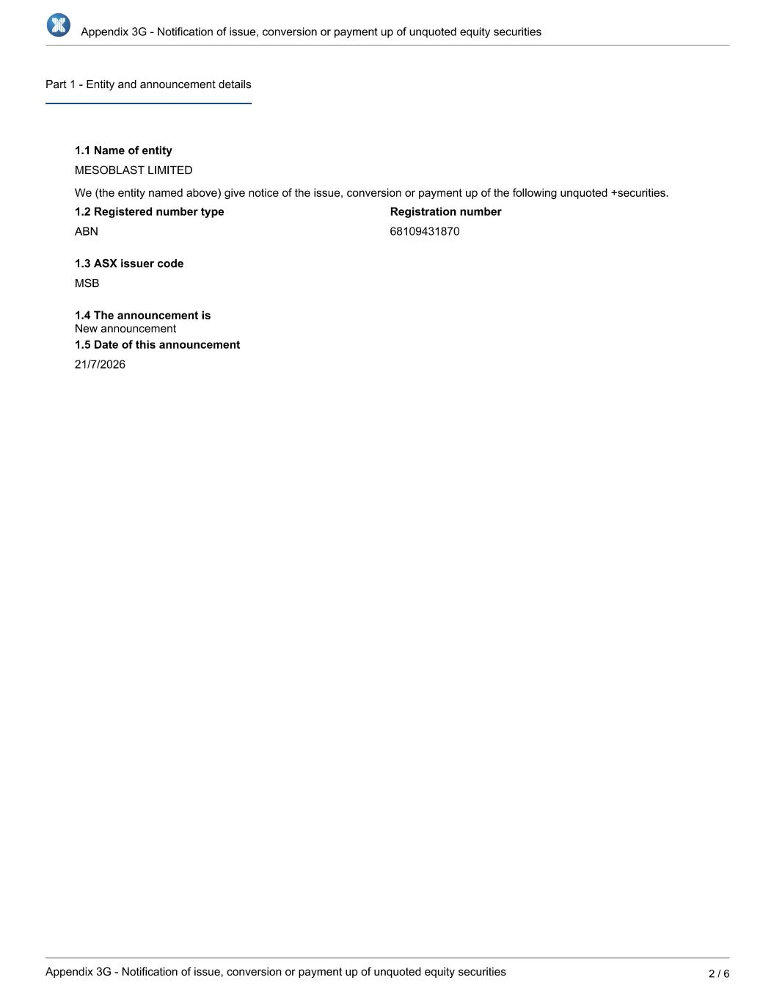

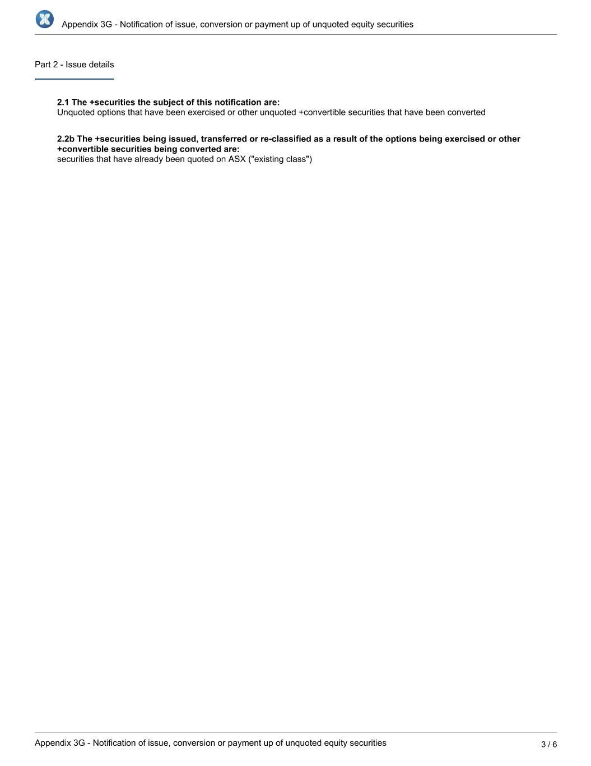

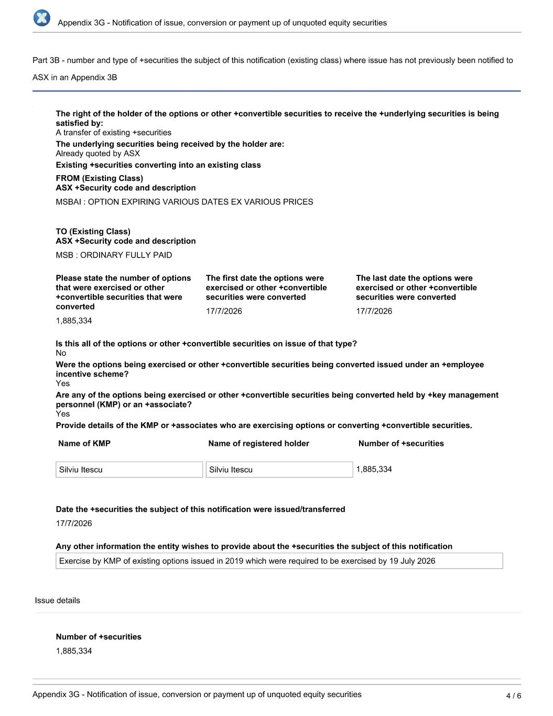

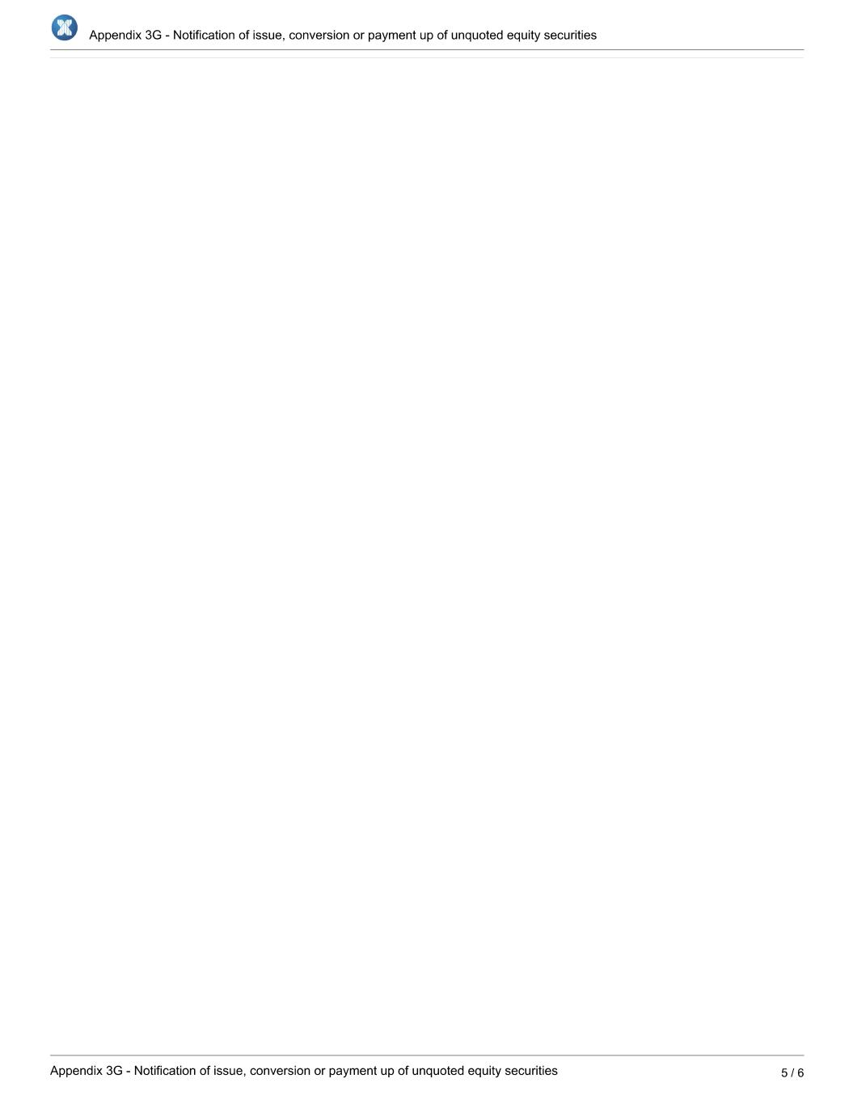

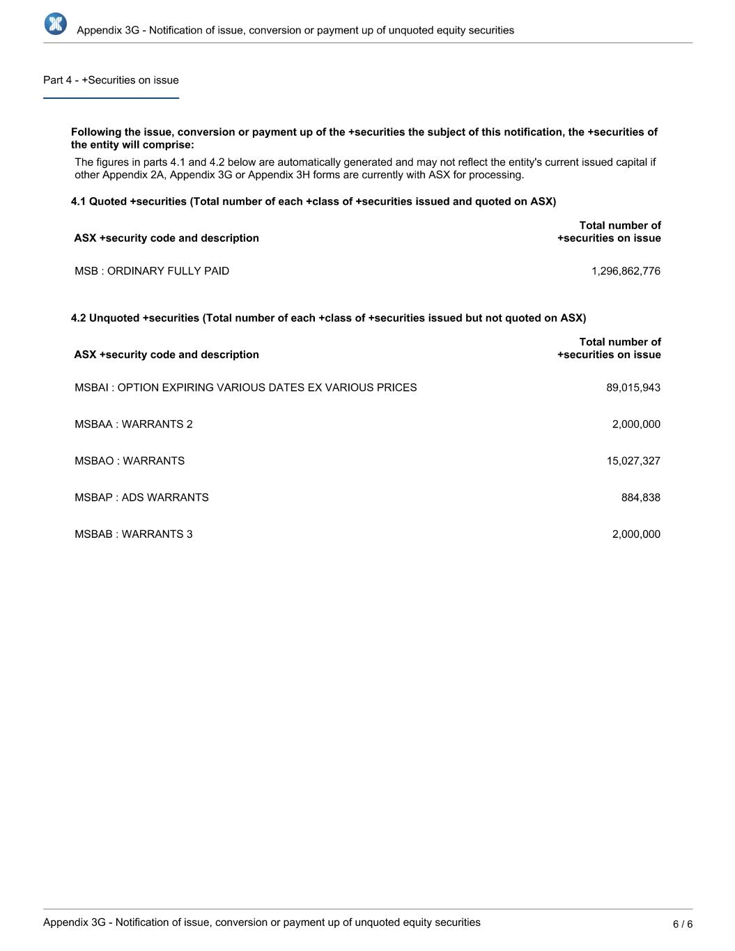

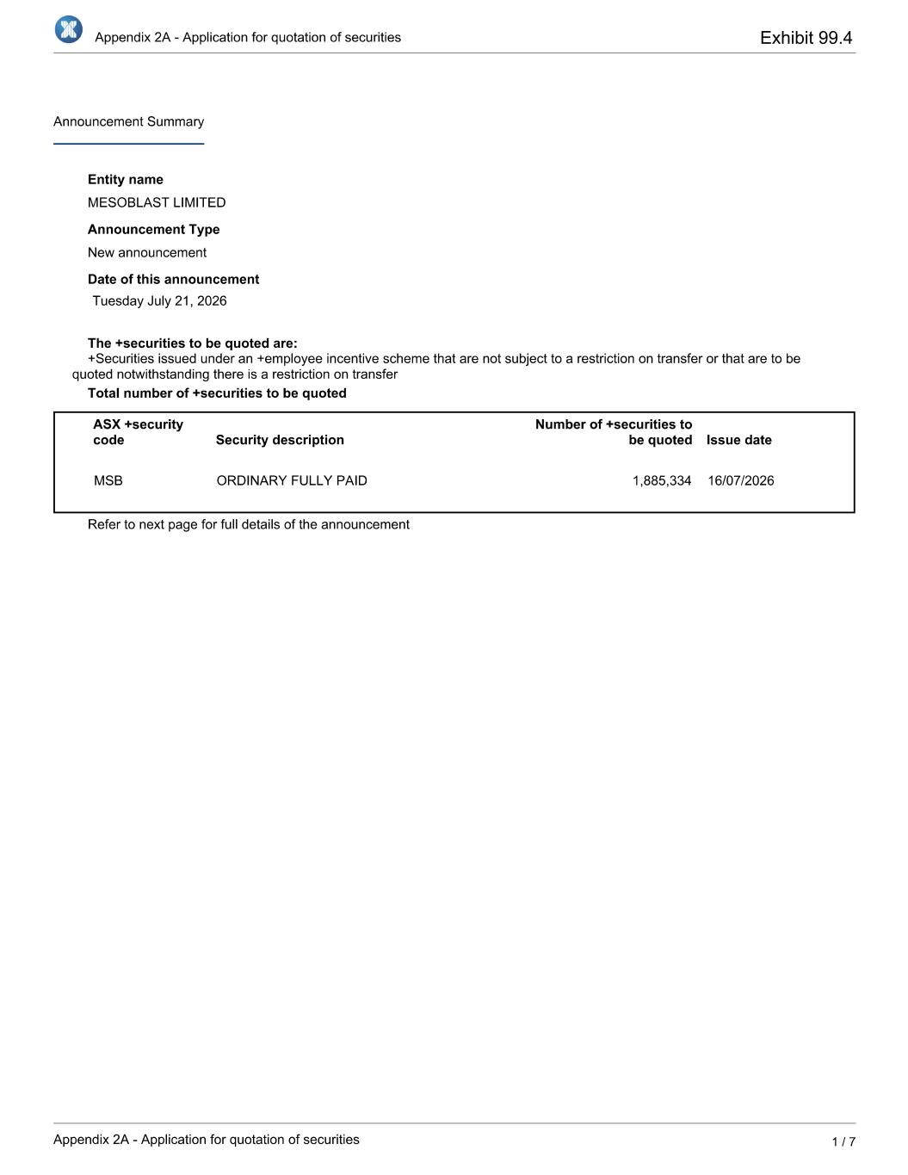
Exhibit 99.4



