UNITED STATES
SECURITIES AND EXCHANGE COMMISSION
Washington, D.C. 20549
Form 6-K
Report of Foreign Private Issuer
Pursuant to Rule 13a-16 or 15d-16 under the Securities Exchange Act of 1934
For the month of August 2026
Commission File Number 001-37626
Mesoblast Limited
(Exact name of Registrant as specified in its charter)
Not Applicable
(Translation of Registrant’s name into English)
Australia
(Jurisdiction of incorporation or organization)

Silviu Itescu
Chief Executive Officer and Executive Director
Level 38
55 Collins Street
Melbourne 3000
Australia
(Address of principal executive offices)

Indicate by check mark whether the registrant files or will file annual reports under cover Form 20-F or Form 40-F:
Form 20-F ☑ Form 40-F ☐

INFORMATION CONTAINED ON THIS REPORT ON FORM 6-K
On August 27, 2026, Mesoblast Limited filed with the Australian Securities Exchange a new release announcement and investor presentation, which are attached hereto as Exhibit 99.1 and Exhibit 99.2 and are incorporated herein by reference.

SIGNATURES
Pursuant to the requirements of the Securities Exchange Act of 1934, the registrant has duly caused this report to be signed on its behalf by the undersigned, thereunto duly organized.
Mesoblast Limited
/s/ Niva Sivakumar
Niva Sivakumar
Company Secretary
Dated: August 27, 2026

INDEX TO EXHIBITS
Item
99.1 |  |  |  |  |  | Press release of Mesoblast Ltd, dated August 27, 2026.
99.2 |  |  |  |  |  | Investor presentation of Mesoblast Ltd, dated August 27, 2026.

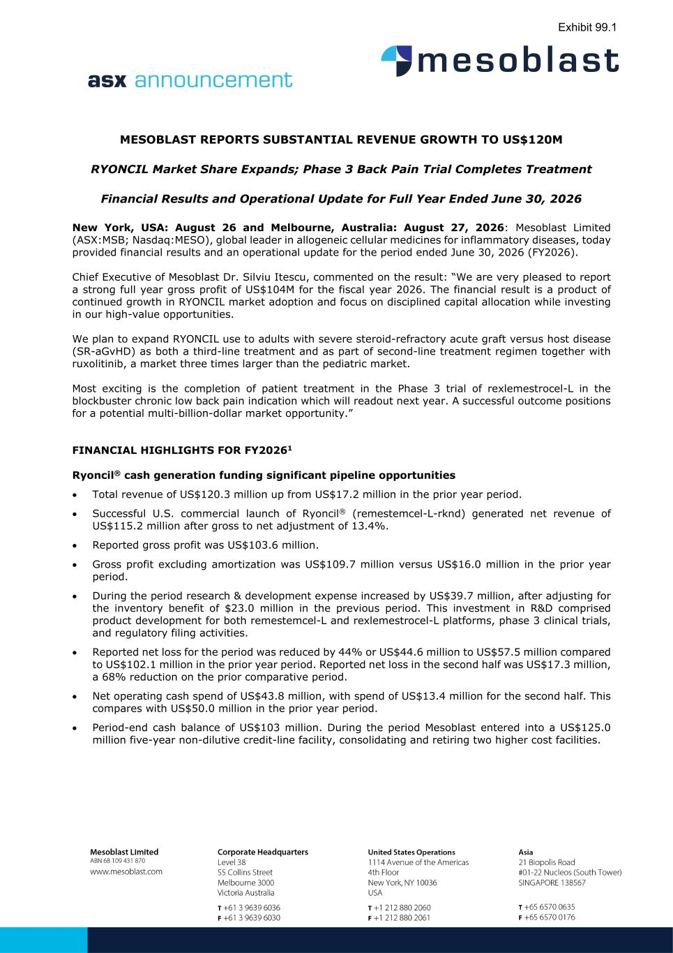

MESOBLAST REPORTS SUBSTANTIAL REVENUE GROWTH TO US$120M RYONCIL Market Share Expands; Phase 3 Back Pain Trial Completes Treatment Financial Results and Operational Update for Full Year Ended June 30, 2026 New York, USA: August 26 and Melbourne, Australia: August 27, 2026: Mesoblast Limited (ASX:MSB; Nasdaq:MESO), global leader in allogeneic cellular medicines for inflammatory diseases, today provided financial results and an operational update for the period ended June 30, 2026 (FY2026). Chief Executive of Mesoblast Dr. Silviu Itescu, commented on the result: “We are very pleased to report a strong full year gross profit of US$104M for the fiscal year 2026. The financial result is a product of continued growth in RYONCIL market adoption and focus on disciplined capital allocation while investing in our high-value opportunities. We plan to expand RYONCIL use to adults with severe steroid-refractory acute graft versus host disease (SR-aGvHD) as both a third-line treatment and as part of second-line treatment regimen together with ruxolitinib, a market three times larger than the pediatric market. Most exciting is the completion of patient treatment in the Phase 3 trial of rexlemestrocel-L in the blockbuster chronic low back pain indication which will readout next year. A successful outcome positions for a potential multi-billion-dollar market opportunity.” FINANCIAL HIGHLIGHTS FOR FY20261 Ryoncil® cash generation funding significant pipeline opportunities • Total revenue of US$120.3 million up from US$17.2 million in the prior year period. • Successful U.S. commercial launch of Ryoncil® (remestemcel-L-rknd) generated net revenue of US$115.2 million after gross to net adjustment of 13.4%. • Reported gross profit was US$103.6 million. • Gross profit excluding amortization was US$109.7 million versus US$16.0 million in the prior year period. • During the period research & development expense increased by US$39.7 million, after adjusting for the inventory benefit of $23.0 million in the previous period. This investment in R&D comprised product development for both remestemcel-L and rexlemestrocel-L platforms, phase 3 clinical trials, and regulatory filing activities. • Reported net loss for the period was reduced by 44% or US$44.6 million to US$57.5 million compared to US$102.1 million in the prior year period. Reported net loss in the second half was US$17.3 million, a 68% reduction on the prior comparative period. • Net operating cash spend of US$43.8 million, with spend of US$13.4 million for the second half. This compares with US$50.0 million in the prior year period. • Period-end cash balance of US$103 million. During the period Mesoblast entered into a US$125.0 million five-year non-dilutive credit-line facility, consolidating and retiring two higher cost facilities. Exhibit 99.1

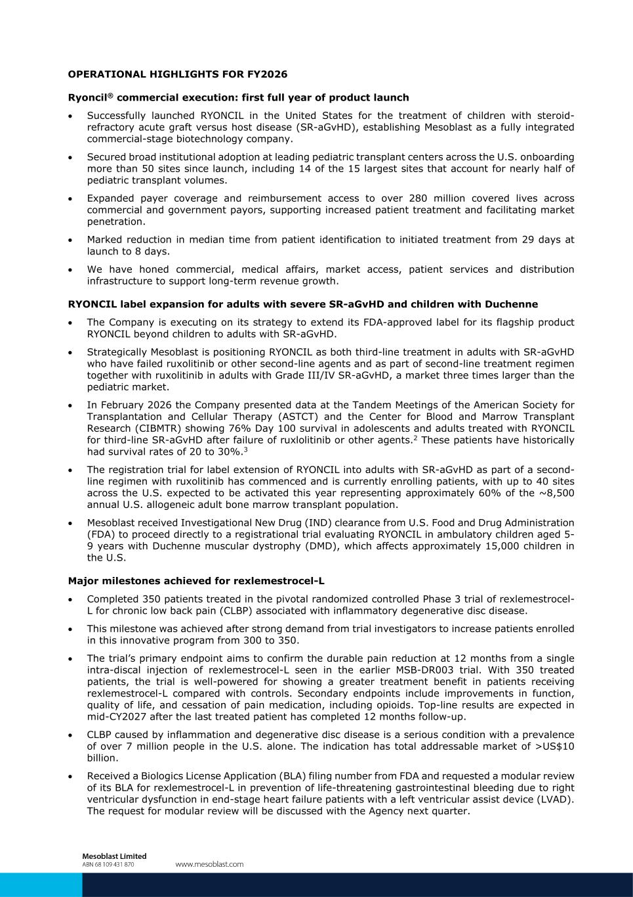
OPERATIONAL HIGHLIGHTS FOR FY2026 Ryoncil® commercial execution: first full year of product launch • Successfully launched RYONCIL in the United States for the treatment of children with steroid- refractory acute graft versus host disease (SR-aGvHD), establishing Mesoblast as a fully integrated commercial-stage biotechnology company. • Secured broad institutional adoption at leading pediatric transplant centers across the U.S. onboarding more than 50 sites since launch, including 14 of the 15 largest sites that account for nearly half of pediatric transplant volumes. • Expanded payer coverage and reimbursement access to over 280 million covered lives across commercial and government payors, supporting increased patient treatment and facilitating market penetration. • Marked reduction in median time from patient identification to initiated treatment from 29 days at launch to 8 days. • We have honed commercial, medical affairs, market access, patient services and distribution infrastructure to support long-term revenue growth. RYONCIL label expansion for adults with severe SR-aGvHD and children with Duchenne • The Company is executing on its strategy to extend its FDA-approved label for its flagship product RYONCIL beyond children to adults with SR-aGvHD. • Strategically Mesoblast is positioning RYONCIL as both third-line treatment in adults with SR-aGvHD who have failed ruxolitinib or other second-line agents and as part of second-line treatment regimen together with ruxolitinib in adults with Grade III/IV SR-aGvHD, a market three times larger than the pediatric market. • In February 2026 the Company presented data at the Tandem Meetings of the American Society for Transplantation and Cellular Therapy (ASTCT) and the Center for Blood and Marrow Transplant Research (CIBMTR) showing 76% Day 100 survival in adolescents and adults treated with RYONCIL for third-line SR-aGvHD after failure of ruxlolitinib or other agents.2 These patients have historically had survival rates of 20 to 30%.3 • The registration trial for label extension of RYONCIL into adults with SR-aGvHD as part of a second- line regimen with ruxolitinib has commenced and is currently enrolling patients, with up to 40 sites across the U.S. expected to be activated this year representing approximately 60% of the ~8,500 annual U.S. allogeneic adult bone marrow transplant population. • Mesoblast received Investigational New Drug (IND) clearance from U.S. Food and Drug Administration (FDA) to proceed directly to a registrational trial evaluating RYONCIL in ambulatory children aged 5- 9 years with Duchenne muscular dystrophy (DMD), which affects approximately 15,000 children in the U.S. Major milestones achieved for rexlemestrocel-L • Completed 350 patients treated in the pivotal randomized controlled Phase 3 trial of rexlemestrocel- L for chronic low back pain (CLBP) associated with inflammatory degenerative disc disease. • This milestone was achieved after strong demand from trial investigators to increase patients enrolled in this innovative program from 300 to 350. • The trial’s primary endpoint aims to confirm the durable pain reduction at 12 months from a single intra-discal injection of rexlemestrocel-L seen in the earlier MSB-DR003 trial. With 350 treated patients, the trial is well-powered for showing a greater treatment benefit in patients receiving rexlemestrocel-L compared with controls. Secondary endpoints include improvements in function, quality of life, and cessation of pain medication, including opioids. Top-line results are expected in mid-CY2027 after the last treated patient has completed 12 months follow-up. • CLBP caused by inflammation and degenerative disc disease is a serious condition with a prevalence of over 7 million people in the U.S. alone. The indication has total addressable market of >US$10 billion. • Received a Biologics License Application (BLA) filing number from FDA and requested a modular review of its BLA for rexlemestrocel-L in prevention of life-threatening gastrointestinal bleeding due to right ventricular dysfunction in end-stage heart failure patients with a left ventricular assist device (LVAD). The request for modular review will be discussed with the Agency next quarter.

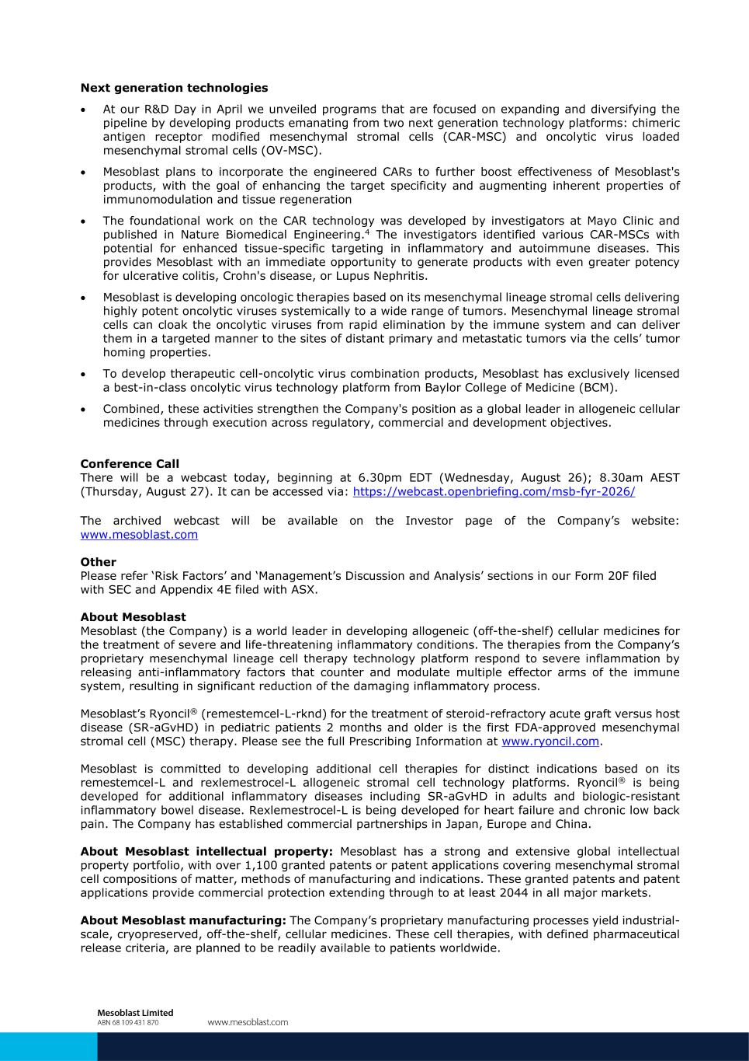
Next generation technologies • At our R&D Day in April we unveiled programs that are focused on expanding and diversifying the pipeline by developing products emanating from two next generation technology platforms: chimeric antigen receptor modified mesenchymal stromal cells (CAR-MSC) and oncolytic virus loaded mesenchymal stromal cells (OV-MSC). • Mesoblast plans to incorporate the engineered CARs to further boost effectiveness of Mesoblast's products, with the goal of enhancing the target specificity and augmenting inherent properties of immunomodulation and tissue regeneration • The foundational work on the CAR technology was developed by investigators at Mayo Clinic and published in Nature Biomedical Engineering.4 The investigators identified various CAR-MSCs with potential for enhanced tissue-specific targeting in inflammatory and autoimmune diseases. This provides Mesoblast with an immediate opportunity to generate products with even greater potency for ulcerative colitis, Crohn's disease, or Lupus Nephritis. • Mesoblast is developing oncologic therapies based on its mesenchymal lineage stromal cells delivering highly potent oncolytic viruses systemically to a wide range of tumors. Mesenchymal lineage stromal cells can cloak the oncolytic viruses from rapid elimination by the immune system and can deliver them in a targeted manner to the sites of distant primary and metastatic tumors via the cells’ tumor homing properties. • To develop therapeutic cell-oncolytic virus combination products, Mesoblast has exclusively licensed a best-in-class oncolytic virus technology platform from Baylor College of Medicine (BCM). • Combined, these activities strengthen the Company's position as a global leader in allogeneic cellular medicines through execution across regulatory, commercial and development objectives. Conference Call There will be a webcast today, beginning at 6.30pm EDT (Wednesday, August 26); 8.30am AEST (Thursday, August 27). It can be accessed via: https://webcast.openbriefing.com/msb-fyr-2026/ The archived webcast will be available on the Investor page of the Company’s website: www.mesoblast.com Other Please refer ‘Risk Factors’ and ‘Management’s Discussion and Analysis’ sections in our Form 20F filed with SEC and Appendix 4E filed with ASX. About Mesoblast Mesoblast (the Company) is a world leader in developing allogeneic (off-the-shelf) cellular medicines for the treatment of severe and life-threatening inflammatory conditions. The therapies from the Company’s proprietary mesenchymal lineage cell therapy technology platform respond to severe inflammation by releasing anti-inflammatory factors that counter and modulate multiple effector arms of the immune system, resulting in significant reduction of the damaging inflammatory process. Mesoblast’s Ryoncil® (remestemcel-L-rknd) for the treatment of steroid-refractory acute graft versus host disease (SR-aGvHD) in pediatric patients 2 months and older is the first FDA-approved mesenchymal stromal cell (MSC) therapy. Please see the full Prescribing Information at www.ryoncil.com. Mesoblast is committed to developing additional cell therapies for distinct indications based on its remestemcel-L and rexlemestrocel-L allogeneic stromal cell technology platforms. Ryoncil® is being developed for additional inflammatory diseases including SR-aGvHD in adults and biologic-resistant inflammatory bowel disease. Rexlemestrocel-L is being developed for heart failure and chronic low back pain. The Company has established commercial partnerships in Japan, Europe and China. About Mesoblast intellectual property: Mesoblast has a strong and extensive global intellectual property portfolio, with over 1,100 granted patents or patent applications covering mesenchymal stromal cell compositions of matter, methods of manufacturing and indications. These granted patents and patent applications provide commercial protection extending through to at least 2044 in all major markets. About Mesoblast manufacturing: The Company’s proprietary manufacturing processes yield industrial- scale, cryopreserved, off-the-shelf, cellular medicines. These cell therapies, with defined pharmaceutical release criteria, are planned to be readily available to patients worldwide.

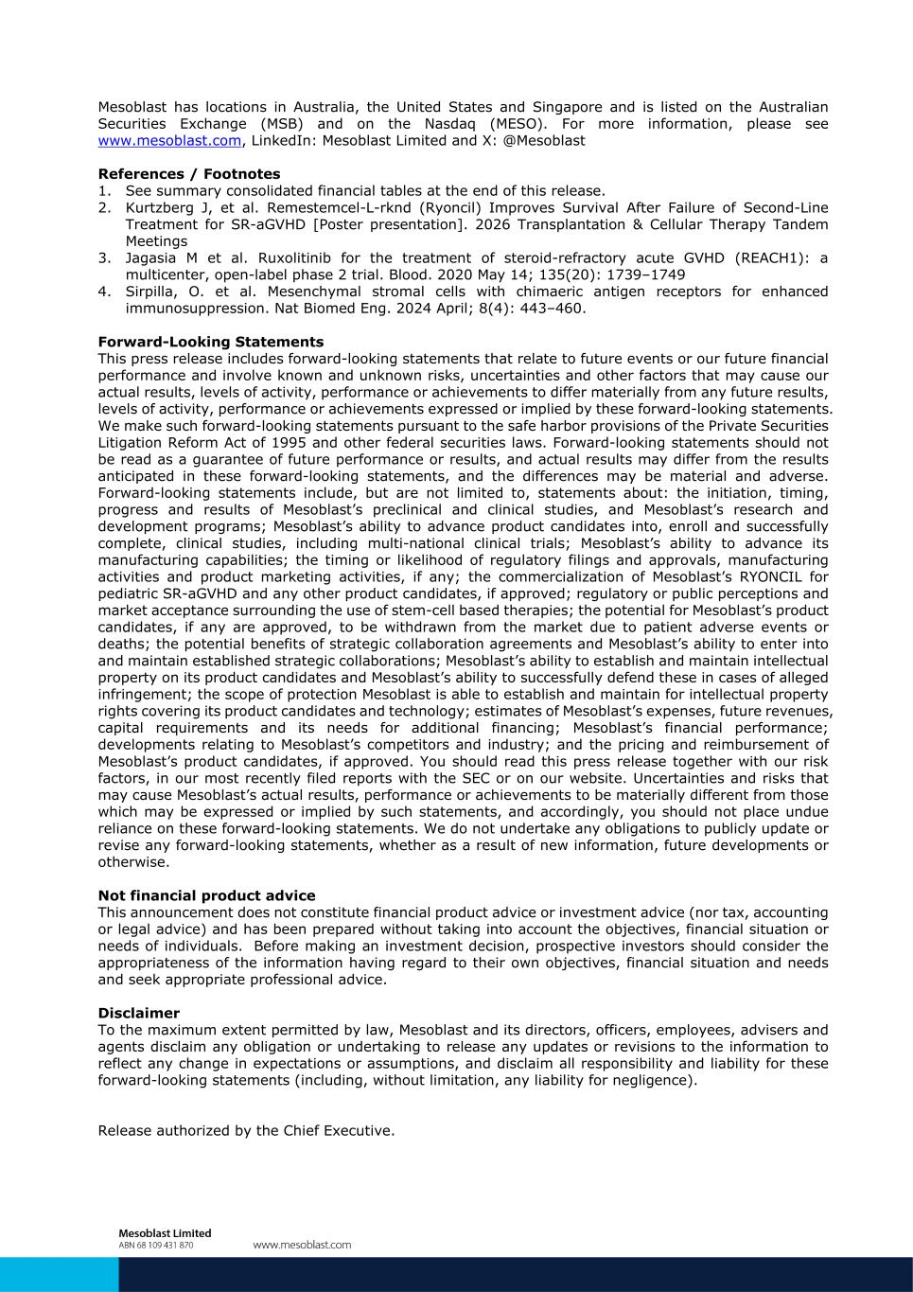
Mesoblast has locations in Australia, the United States and Singapore and is listed on the Australian Securities Exchange (MSB) and on the Nasdaq (MESO). For more information, please see www.mesoblast.com, LinkedIn: Mesoblast Limited and X: @Mesoblast References / Footnotes 1. See summary consolidated financial tables at the end of this release. 2. Kurtzberg J, et al. Remestemcel-L-rknd (Ryoncil) Improves Survival After Failure of Second-Line Treatment for SR-aGVHD [Poster presentation]. 2026 Transplantation & Cellular Therapy Tandem Meetings 3. Jagasia M et al. Ruxolitinib for the treatment of steroid-refractory acute GVHD (REACH1): a multicenter, open-label phase 2 trial. Blood. 2020 May 14; 135(20): 1739–1749 4. Sirpilla, O. et al. Mesenchymal stromal cells with chimaeric antigen receptors for enhanced immunosuppression. Nat Biomed Eng. 2024 April; 8(4): 443–460. Forward-Looking Statements This press release includes forward-looking statements that relate to future events or our future financial performance and involve known and unknown risks, uncertainties and other factors that may cause our actual results, levels of activity, performance or achievements to differ materially from any future results, levels of activity, performance or achievements expressed or implied by these forward-looking statements. We make such forward-looking statements pursuant to the safe harbor provisions of the Private Securities Litigation Reform Act of 1995 and other federal securities laws. Forward-looking statements should not be read as a guarantee of future performance or results, and actual results may differ from the results anticipated in these forward-looking statements, and the differences may be material and adverse. Forward-looking statements include, but are not limited to, statements about: the initiation, timing, progress and results of Mesoblast’s preclinical and clinical studies, and Mesoblast’s research and development programs; Mesoblast’s ability to advance product candidates into, enroll and successfully complete, clinical studies, including multi-national clinical trials; Mesoblast’s ability to advance its manufacturing capabilities; the timing or likelihood of regulatory filings and approvals, manufacturing activities and product marketing activities, if any; the commercialization of Mesoblast’s RYONCIL for pediatric SR-aGVHD and any other product candidates, if approved; regulatory or public perceptions and market acceptance surrounding the use of stem-cell based therapies; the potential for Mesoblast’s product candidates, if any are approved, to be withdrawn from the market due to patient adverse events or deaths; the potential benefits of strategic collaboration agreements and Mesoblast’s ability to enter into and maintain established strategic collaborations; Mesoblast’s ability to establish and maintain intellectual property on its product candidates and Mesoblast’s ability to successfully defend these in cases of alleged infringement; the scope of protection Mesoblast is able to establish and maintain for intellectual property rights covering its product candidates and technology; estimates of Mesoblast’s expenses, future revenues, capital requirements and its needs for additional financing; Mesoblast’s financial performance; developments relating to Mesoblast’s competitors and industry; and the pricing and reimbursement of Mesoblast’s product candidates, if approved. You should read this press release together with our risk factors, in our most recently filed reports with the SEC or on our website. Uncertainties and risks that may cause Mesoblast’s actual results, performance or achievements to be materially different from those which may be expressed or implied by such statements, and accordingly, you should not place undue reliance on these forward-looking statements. We do not undertake any obligations to publicly update or revise any forward-looking statements, whether as a result of new information, future developments or otherwise. Not financial product advice This announcement does not constitute financial product advice or investment advice (nor tax, accounting or legal advice) and has been prepared without taking into account the objectives, financial situation or needs of individuals. Before making an investment decision, prospective investors should consider the appropriateness of the information having regard to their own objectives, financial situation and needs and seek appropriate professional advice. Disclaimer To the maximum extent permitted by law, Mesoblast and its directors, officers, employees, advisers and agents disclaim any obligation or undertaking to release any updates or revisions to the information to reflect any change in expectations or assumptions, and disclaim all responsibility and liability for these forward-looking statements (including, without limitation, any liability for negligence). Release authorized by the Chief Executive.

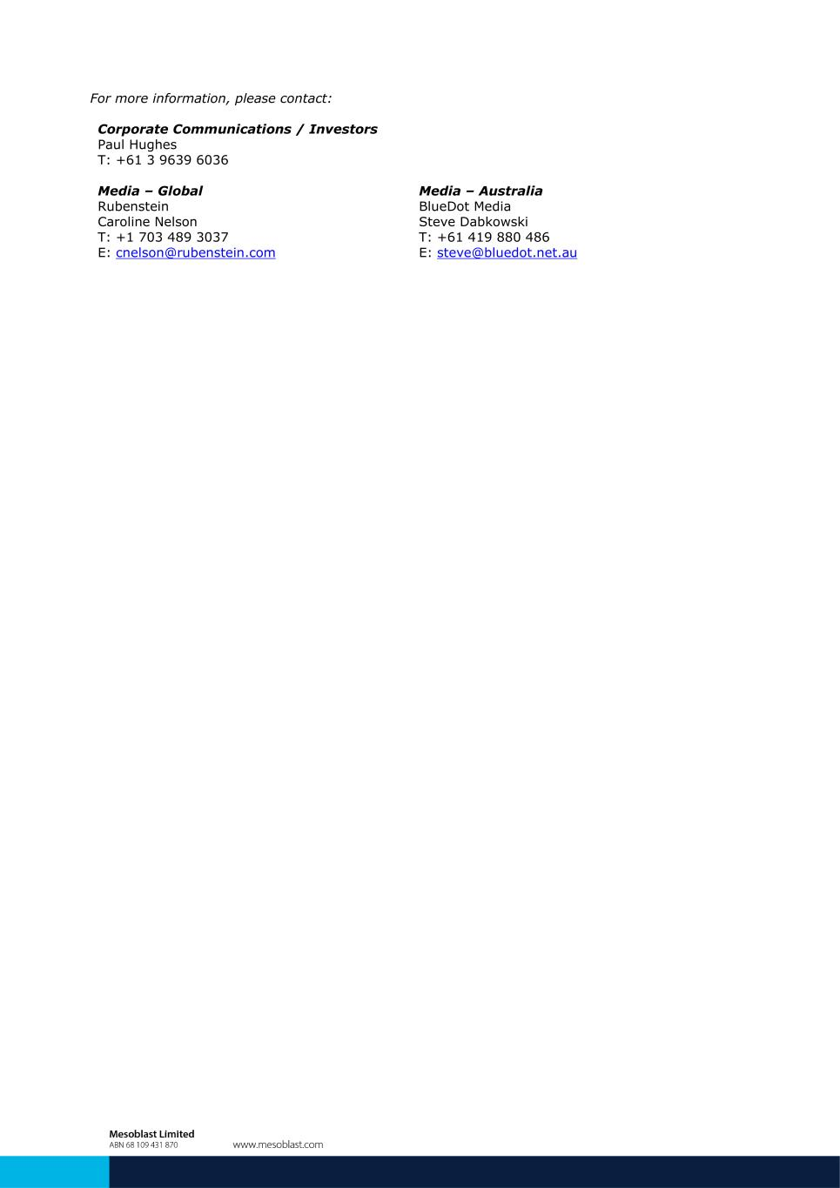
For more information, please contact: Corporate Communications / Investors Paul Hughes T: +61 3 9639 6036 Media – Global Media – Australia Rubenstein BlueDot Media Caroline Nelson Steve Dabkowski T: +1 703 489 3037 T: +61 419 880 486 E: cnelson@rubenstein.com E: steve@bluedot.net.au

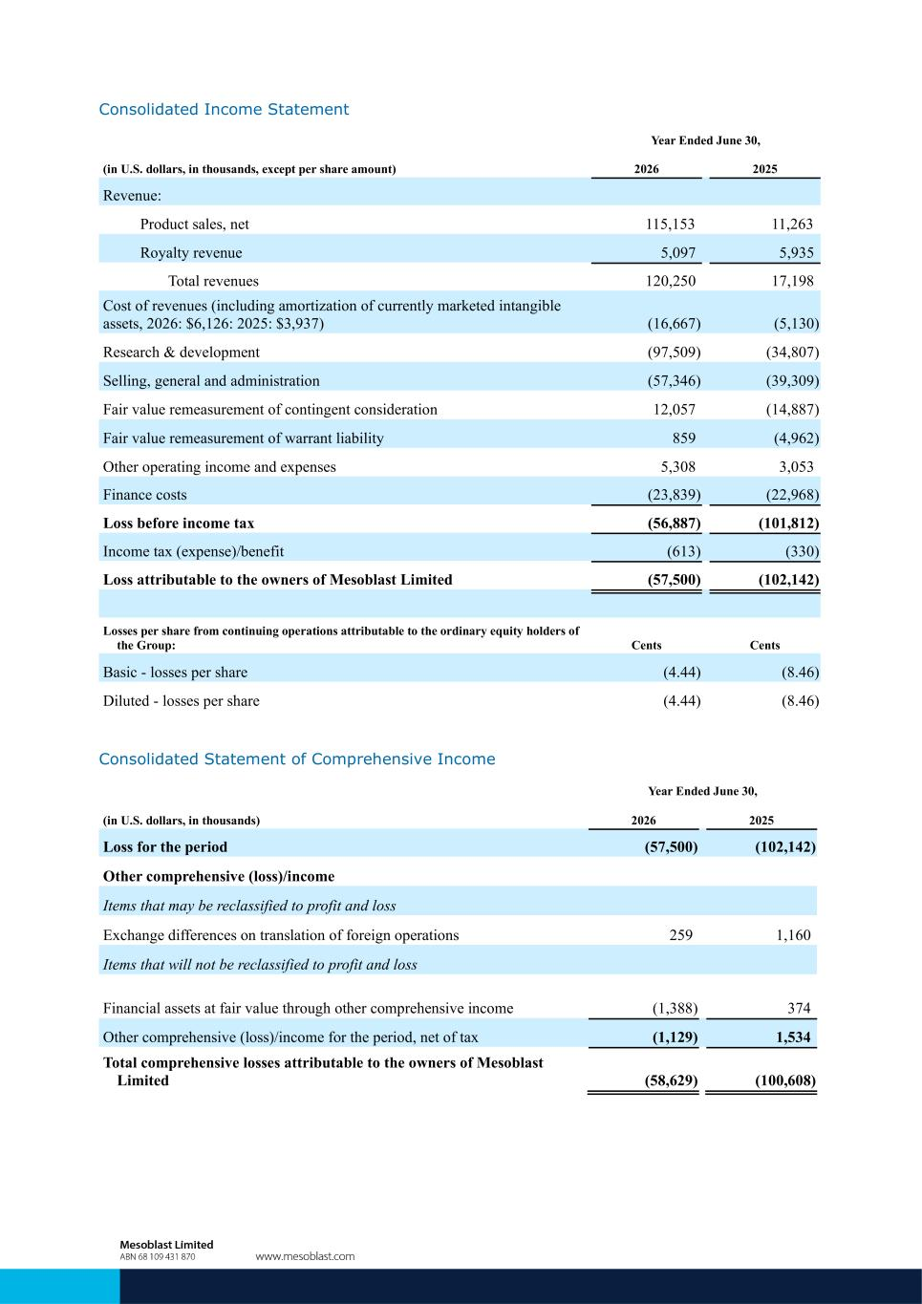
Consolidated Income Statement Year Ended June 30, (in U.S. dollars, in thousands, except per share amount) 2026 2025 Revenue: Product sales, net 115,153 11,263 Royalty revenue 5,097 5,935 Total revenues 120,250 17,198 Cost of revenues (including amortization of currently marketed intangible assets, 2026: $6,126: 2025: $3,937) (16,667) (5,130) Research & development (97,509) (34,807) Selling, general and administration (57,346) (39,309) Fair value remeasurement of contingent consideration 12,057 (14,887) Fair value remeasurement of warrant liability 859 (4,962) Other operating income and expenses 5,308 3,053 Finance costs (23,839) (22,968) Loss before income tax (56,887) (101,812) Income tax (expense)/benefit (613) (330) Loss attributable to the owners of Mesoblast Limited (57,500) (102,142) Losses per share from continuing operations attributable to the ordinary equity holders of the Group: Cents Cents Basic - losses per share (4.44) (8.46) Diluted - losses per share (4.44) (8.46) Consolidated Statement of Comprehensive Income Year Ended June 30, (in U.S. dollars, in thousands) 2026 2025 Loss for the period (57,500) (102,142) Other comprehensive (loss)/income Items that may be reclassified to profit and loss Exchange differences on translation of foreign operations 259 1,160 Items that will not be reclassified to profit and loss Financial assets at fair value through other comprehensive income (1,388) 374 Other comprehensive (loss)/income for the period, net of tax (1,129) 1,534 Total comprehensive losses attributable to the owners of Mesoblast Limited (58,629) (100,608)

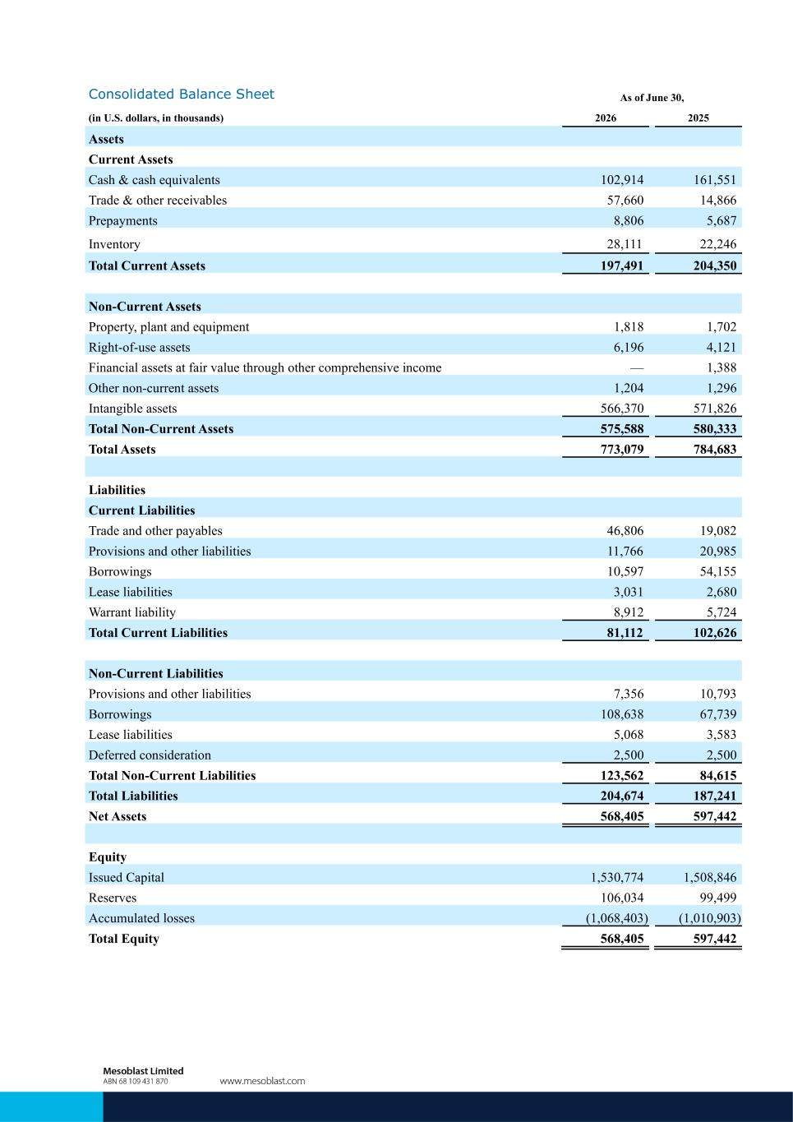
Consolidated Balance Sheet As of June 30, (in U.S. dollars, in thousands) 2026 2025 Assets Current Assets Cash & cash equivalents 102,914 161,551 Trade & other receivables 57,660 14,866 Prepayments 8,806 5,687 Inventory 28,111 22,246 Total Current Assets 197,491 204,350 Non-Current Assets Property, plant and equipment 1,818 1,702 Right-of-use assets 6,196 4,121 Financial assets at fair value through other comprehensive income — 1,388 Other non-current assets 1,204 1,296 Intangible assets 566,370 571,826 Total Non-Current Assets 575,588 580,333 Total Assets 773,079 784,683 Liabilities Current Liabilities Trade and other payables 46,806 19,082 Provisions and other liabilities 11,766 20,985 Borrowings 10,597 54,155 Lease liabilities 3,031 2,680 Warrant liability 8,912 5,724 Total Current Liabilities 81,112 102,626 Non-Current Liabilities Provisions and other liabilities 7,356 10,793 Borrowings 108,638 67,739 Lease liabilities 5,068 3,583 Deferred consideration 2,500 2,500 Total Non-Current Liabilities 123,562 84,615 Total Liabilities 204,674 187,241 Net Assets 568,405 597,442 Equity Issued Capital 1,530,774 1,508,846 Reserves 106,034 99,499 Accumulated losses (1,068,403) (1,010,903) Total Equity 568,405 597,442

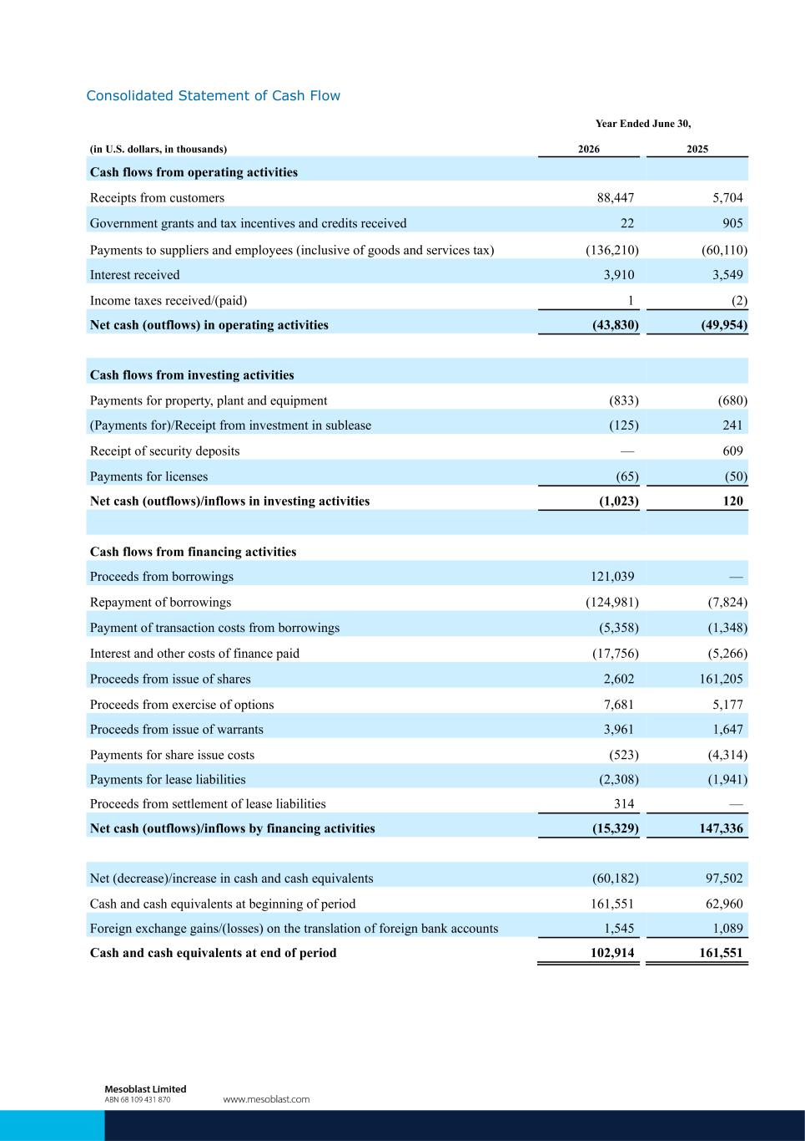
Consolidated Statement of Cash Flow Year Ended June 30, (in U.S. dollars, in thousands) 2026 2025 Cash flows from operating activities Receipts from customers 88,447 5,704 Government grants and tax incentives and credits received 22 905 Payments to suppliers and employees (inclusive of goods and services tax) (136,210) (60,110) Interest received 3,910 3,549 Income taxes received/(paid) 1 (2) Net cash (outflows) in operating activities (43,830) (49,954) Cash flows from investing activities Payments for property, plant and equipment (833) (680) (Payments for)/Receipt from investment in sublease (125) 241 Receipt of security deposits — 609 Payments for licenses (65) (50) Net cash (outflows)/inflows in investing activities (1,023) 120 Cash flows from financing activities Proceeds from borrowings 121,039 — Repayment of borrowings (124,981) (7,824) Payment of transaction costs from borrowings (5,358) (1,348) Interest and other costs of finance paid (17,756) (5,266) Proceeds from issue of shares 2,602 161,205 Proceeds from exercise of options 7,681 5,177 Proceeds from issue of warrants 3,961 1,647 Payments for share issue costs (523) (4,314) Payments for lease liabilities (2,308) (1,941) Proceeds from settlement of lease liabilities 314 — Net cash (outflows)/inflows by financing activities (15,329) 147,336 Net (decrease)/increase in cash and cash equivalents (60,182) 97,502 Cash and cash equivalents at beginning of period 161,551 62,960 Foreign exchange gains/(losses) on the translation of foreign bank accounts 1,545 1,089 Cash and cash equivalents at end of period 102,914 161,551


1 August 2026 | ASX: MSB; Nasdaq: MESO Financial Results & Operational Update for period ended June 30, 2026 1 Exhibit 99.2

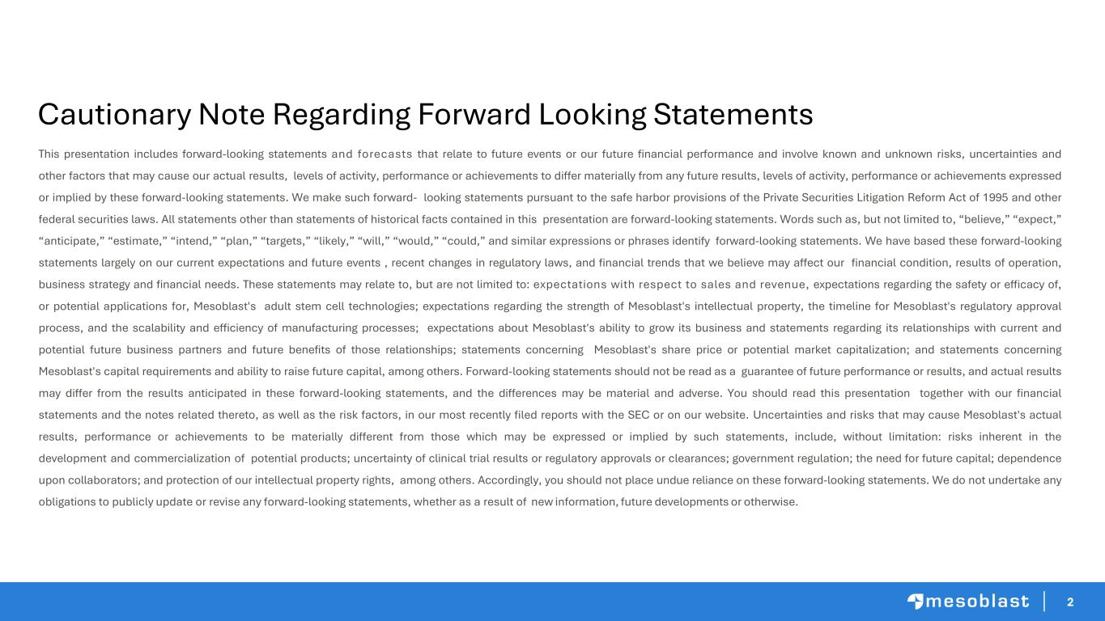
2 This presentation includes forward-looking statements and forecasts that relate to future events or our future financial performance and involve known and unknown risks, uncertainties and other factors that may cause our actual results, levels of activity, performance or achievements to differ materially from any future results, levels of activity, performance or achievements expressed or implied by these forward-looking statements. We make such forward- looking statements pursuant to the safe harbor provisions of the Private Securities Litigation Reform Act of 1995 and other federal securities laws. All statements other than statements of historical facts contained in this presentation are forward-looking statements. Words such as, but not limited to, “believe,” “expect,” “anticipate,” “estimate,” “intend,” “plan,” “targets,” “likely,” “will,” “would,” “could,” and similar expressions or phrases identify forward-looking statements. We have based these forward-looking statements largely on our current expectations and future events , recent changes in regulatory laws, and financial trends that we believe may affect our financial condition, results of operation, business strategy and financial needs. These statements may relate to, but are not limited to: expectations with respect to sales and revenue, expectations regarding the safety or efficacy of, or potential applications for, Mesoblast's adult stem cell technologies; expectations regarding the strength of Mesoblast's intellectual property, the timeline for Mesoblast's regulatory approval process, and the scalability and efficiency of manufacturing processes; expectations about Mesoblast's ability to grow its business and statements regarding its relationships with current and potential future business partners and future benefits of those relationships; statements concerning Mesoblast's share price or potential market capitalization; and statements concerning Mesoblast's capital requirements and ability to raise future capital, among others. Forward-looking statements should not be read as a guarantee of future performance or results, and actual results may differ from the results anticipated in these forward-looking statements, and the differences may be material and adverse. You should read this presentation together with our financial statements and the notes related thereto, as well as the risk factors, in our most recently filed reports with the SEC or on our website. Uncertainties and risks that may cause Mesoblast's actual results, performance or achievements to be materially different from those which may be expressed or implied by such statements, include, without limitation: risks inherent in the development and commercialization of potential products; uncertainty of clinical trial results or regulatory approvals or clearances; government regulation; the need for future capital; dependence upon collaborators; and protection of our intellectual property rights, among others. Accordingly, you should not place undue reliance on these forward-looking statements. We do not undertake any obligations to publicly update or revise any forward-looking statements, whether as a result of new information, future developments or otherwise. Cautionary Note Regarding Forward Looking Statements

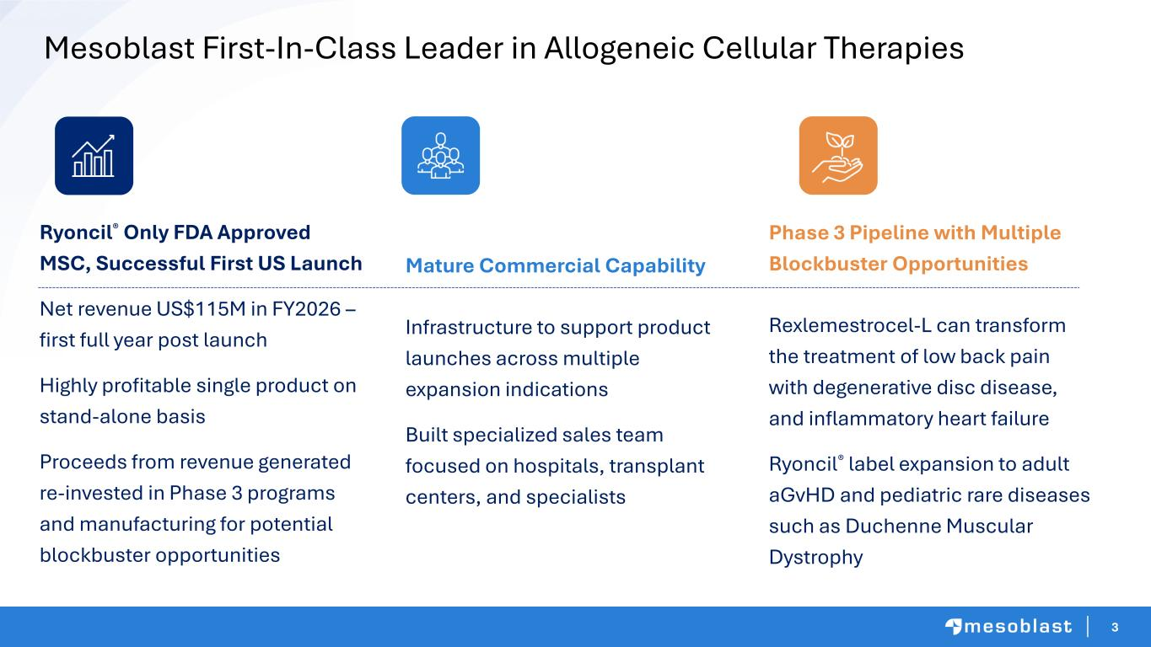
3 Mesoblast First-In-Class Leader in Allogeneic Cellular Therapies Ryoncil® Only FDA Approved MSC, Successful First US Launch Net revenue US$115M in FY2026 – first full year post launch Highly profitable single product on stand-alone basis Proceeds from revenue generated re-invested in Phase 3 programs and manufacturing for potential blockbuster opportunities Phase 3 Pipeline with Multiple Blockbuster Opportunities Rexlemestrocel-L can transform the treatment of low back pain with degenerative disc disease, and inflammatory heart failure Ryoncil® label expansion to adult aGvHD and pediatric rare diseases such as Duchenne Muscular Dystrophy Mature Commercial Capability Infrastructure to support product launches across multiple expansion indications Built specialized sales team focused on hospitals, transplant centers, and specialists

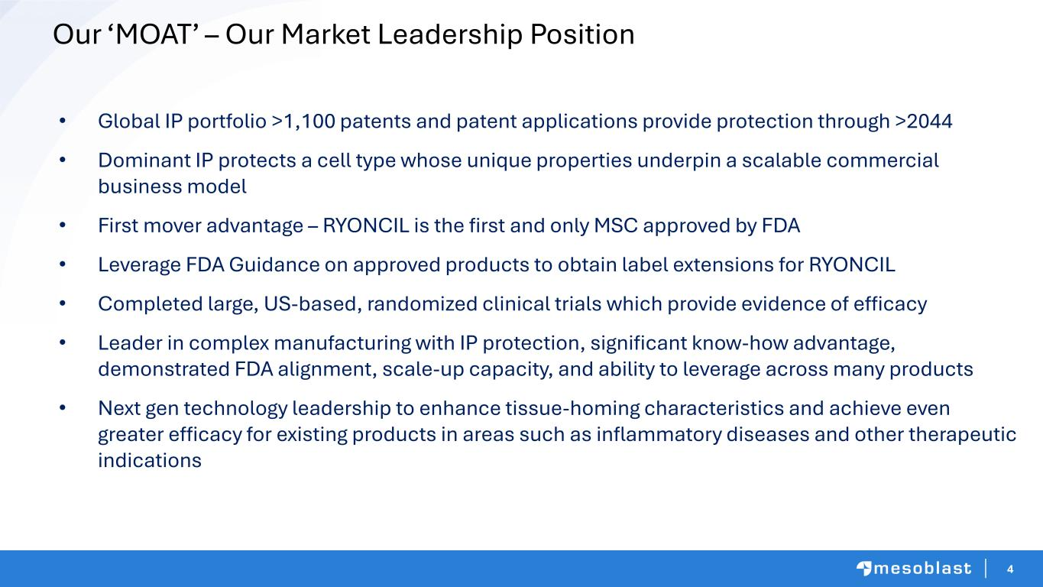
4 • Global IP portfolio >1,100 patents and patent applications provide protection through >2044 • Dominant IP protects a cell type whose unique properties underpin a scalable commercial business model • First mover advantage – RYONCIL is the first and only MSC approved by FDA • Leverage FDA Guidance on approved products to obtain label extensions for RYONCIL • Completed large, US-based, randomized clinical trials which provide evidence of efficacy • Leader in complex manufacturing with IP protection, significant know-how advantage, demonstrated FDA alignment, scale-up capacity, and ability to leverage across many products • Next gen technology leadership to enhance tissue-homing characteristics and achieve even greater efficacy for existing products in areas such as inflammatory diseases and other therapeutic indications Our ‘MOAT’ – Our Market Leadership Position

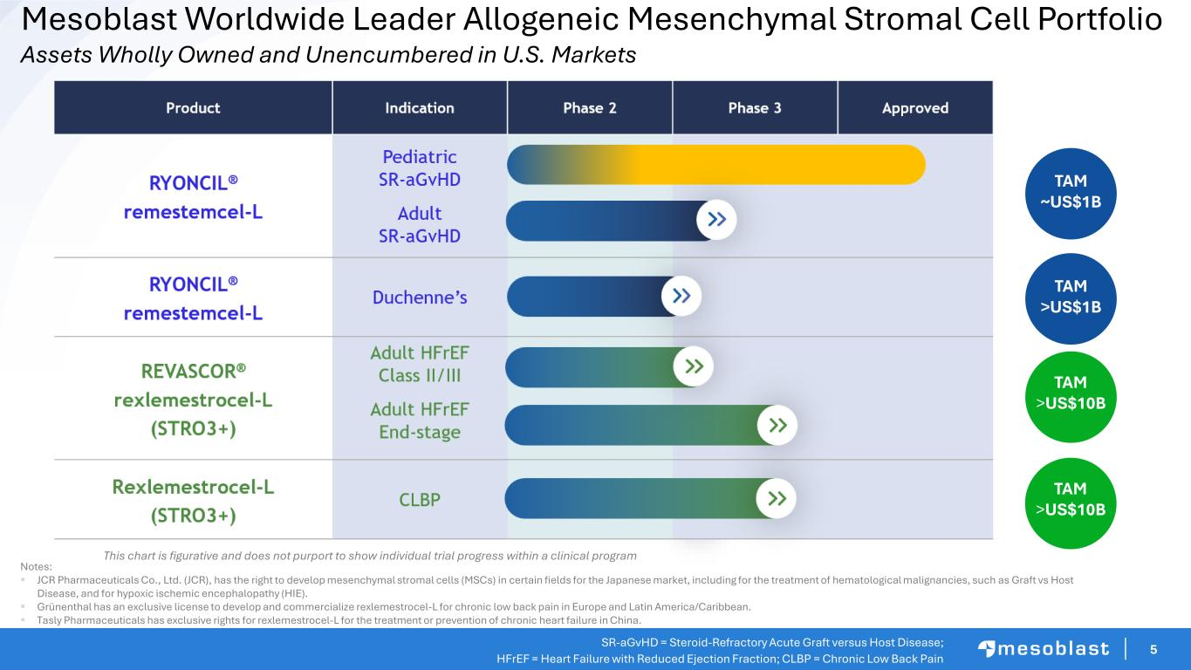
5 Mesoblast Worldwide Leader Allogeneic Mesenchymal Stromal Cell Portfolio Assets Wholly Owned and Unencumbered in U.S. Markets SR-aGvHD = Steroid-Refractory Acute Graft versus Host Disease; HFrEF = Heart Failure with Reduced Ejection Fraction; CLBP = Chronic Low Back Pain This chart is figurative and does not purport to show individual trial progress within a clinical program Notes: ▪ JCR Pharmaceuticals Co., Ltd. (JCR), has the right to develop mesenchymal stromal cells (MSCs) in certain fields for the Japanese market, including for the treatment of hematological malignancies, such as Graft vs Host Disease, and for hypoxic ischemic encephalopathy (HIE). ▪ Grünenthal has an exclusive license to develop and commercialize rexlemestrocel-L for chronic low back pain in Europe and Latin America/Caribbean. ▪ Tasly Pharmaceuticals has exclusive rights for rexlemestrocel-L for the treatment or prevention of chronic heart failure in China. TAM ~US$1B TAM >US$1B TA >US$1B TAM >US$10B TAM >US$10B

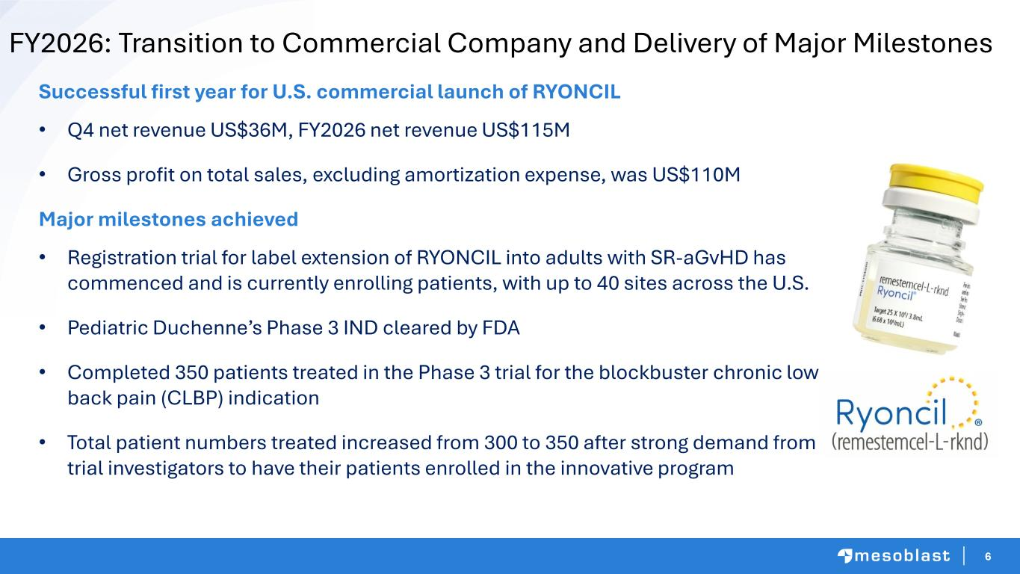
6 FY2026: Transition to Commercial Company and Delivery of Major Milestones Successful first year for U.S. commercial launch of RYONCIL • Q4 net revenue US$36M, FY2026 net revenue US$115M • Gross profit on total sales, excluding amortization expense, was US$110M Major milestones achieved • Registration trial for label extension of RYONCIL into adults with SR-aGvHD has commenced and is currently enrolling patients, with up to 40 sites across the U.S. • Pediatric Duchenne’s Phase 3 IND cleared by FDA • Completed 350 patients treated in the Phase 3 trial for the blockbuster chronic low back pain (CLBP) indication • Total patient numbers treated increased from 300 to 350 after strong demand from trial investigators to have their patients enrolled in the innovative program

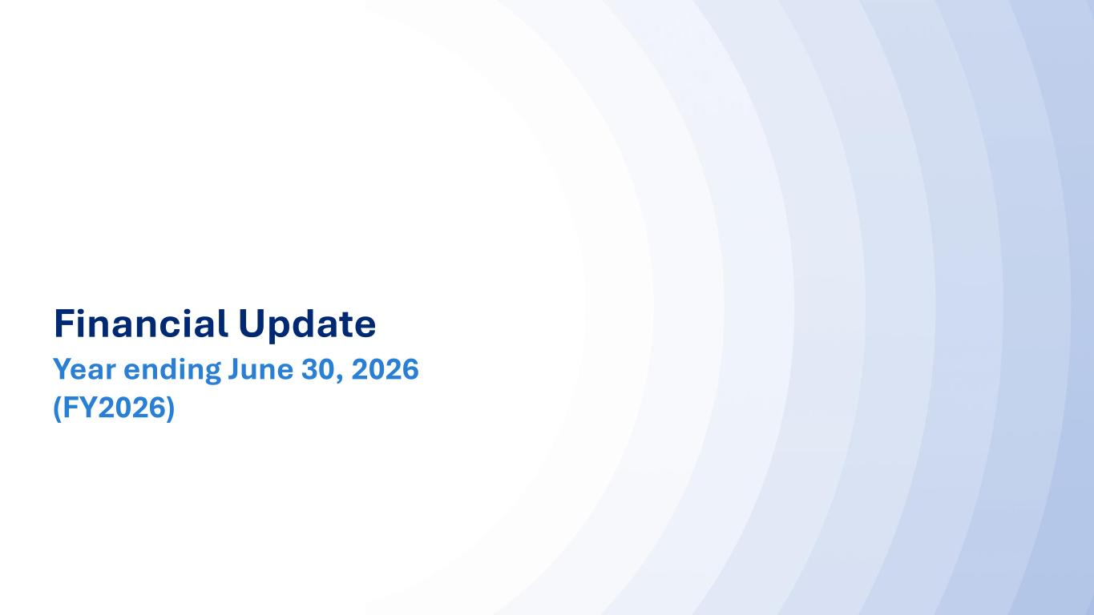
77 Financial Update Year ending June 30, 2026 (FY2026)

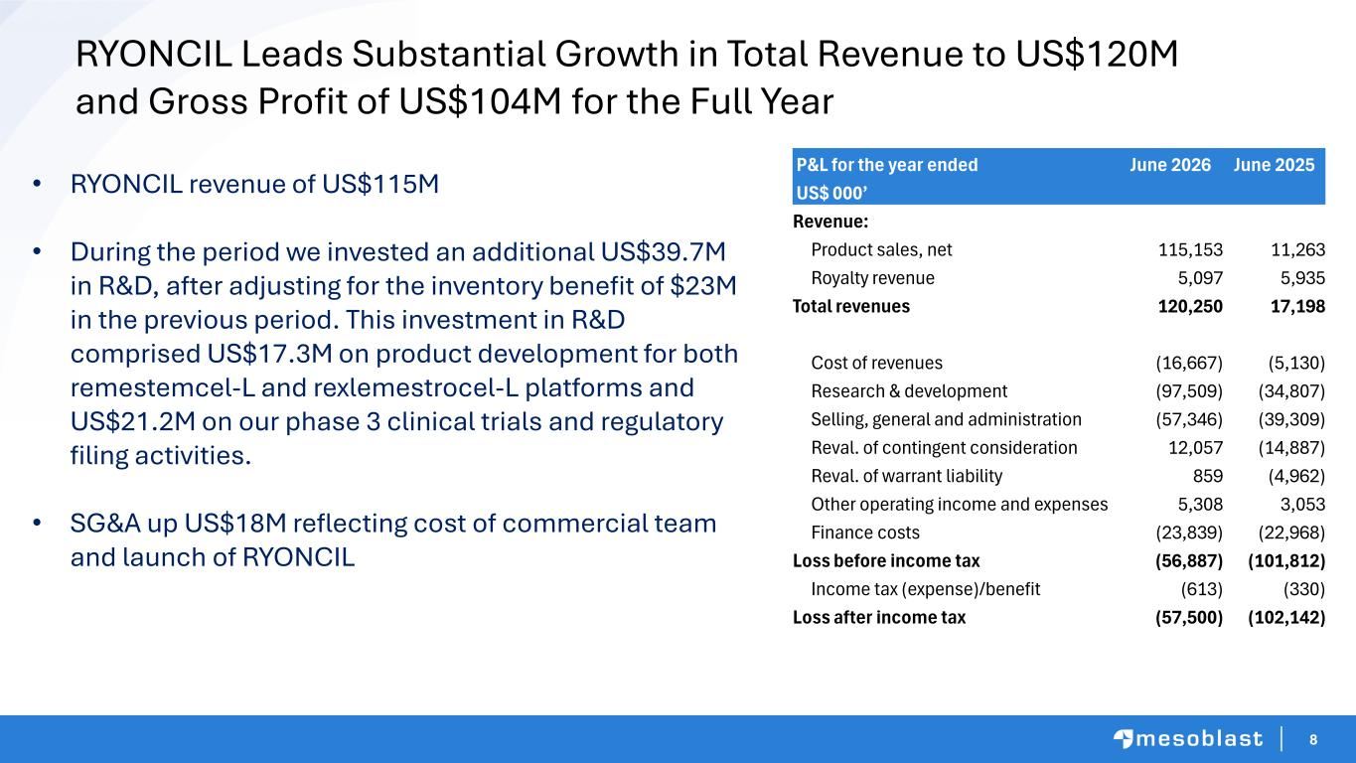
8 RYONCIL Leads Substantial Growth in Total Revenue to US$120M and Gross Profit of US$104M for the Full Year • RYONCIL revenue of US$115M • During the period we invested an additional US$39.7M in R&D, after adjusting for the inventory benefit of $23M in the previous period. This investment in R&D comprised US$17.3M on product development for both remestemcel-L and rexlemestrocel-L platforms and US$21.2M on our phase 3 clinical trials and regulatory filing activities. • SG&A up US$18M reflecting cost of commercial team and launch of RYONCIL P&L for the year ended June 2026 June 2025 US$ 000’ Revenue: Product sales, net 115,153 11,263 Royalty revenue 5,097 5,935 Total revenues 120,250 17,198 Cost of revenues (16,667) (5,130) Research & development (97,509) (34,807) Selling, general and administration (57,346) (39,309) Reval. of contingent consideration 12,057 (14,887) Reval. of warrant liability 859 (4,962) Other operating income and expenses 5,308 3,053 Finance costs (23,839) (22,968) Loss before income tax (56,887) (101,812) Income tax (expense)/benefit (613) (330) Loss after income tax (57,500) (102,142)

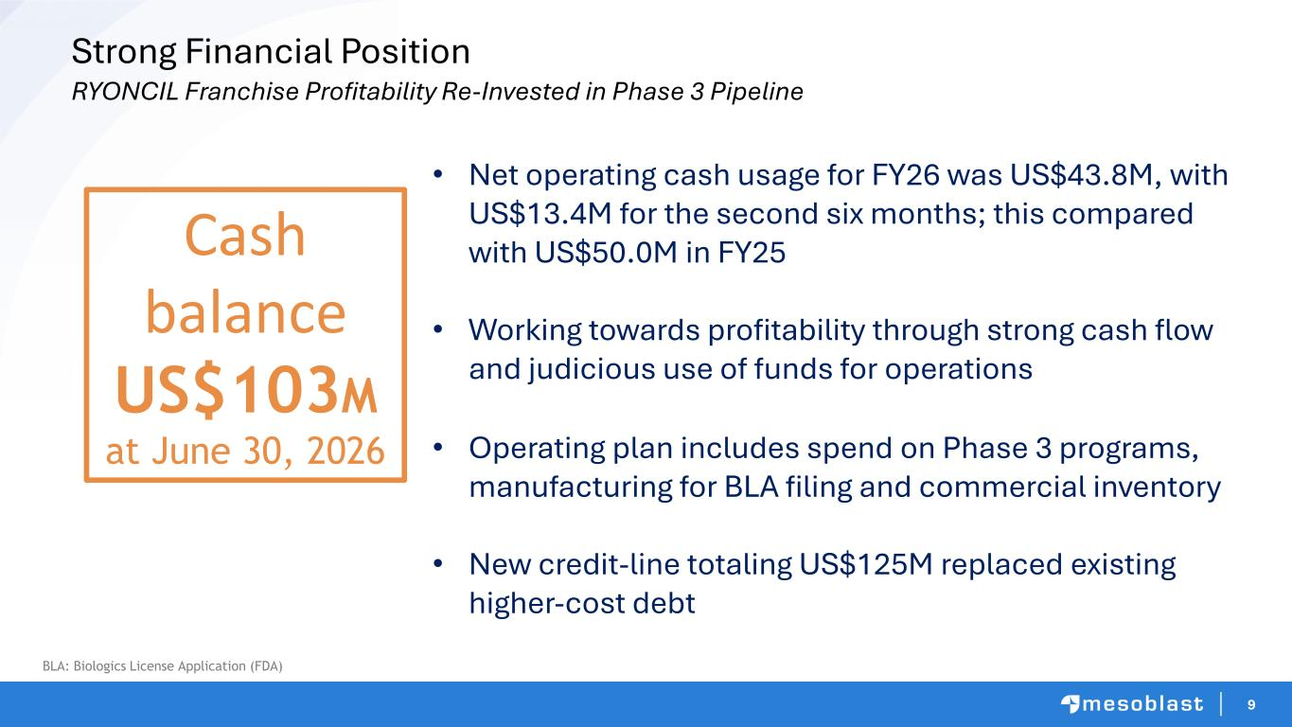
9 Strong Financial Position RYONCIL Franchise Profitability Re-Invested in Phase 3 Pipeline • Net operating cash usage for FY26 was US$43.8M, with US$13.4M for the second six months; this compared with US$50.0M in FY25 • Working towards profitability through strong cash flow and judicious use of funds for operations • Operating plan includes spend on Phase 3 programs, manufacturing for BLA filing and commercial inventory • New credit-line totaling US$125M replaced existing higher-cost debt Cash balance US$103M at June 30, 2026 BLA: Biologics License Application (FDA)


Steroid-Refractory Acute Graft versus Host Disease

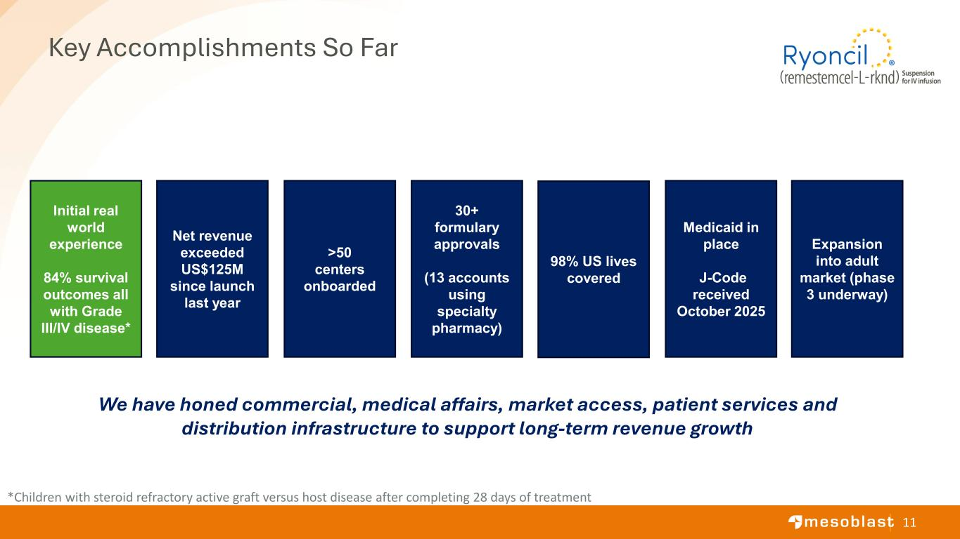
11 Key Accomplishments So Far 98% US lives covered Medicaid in place J-Code received October 2025 >50 centers onboarded Net revenue exceeded US$125M since launch last year Initial real world experience 84% survival outcomes all with Grade III/IV disease* 30+ formulary approvals (13 accounts using specialty pharmacy) Expansion into adult market (phase 3 underway) *Children with steroid refractory active graft versus host disease after completing 28 days of treatment We have honed commercial, medical affairs, market access, patient services and distribution infrastructure to support long-term revenue growth

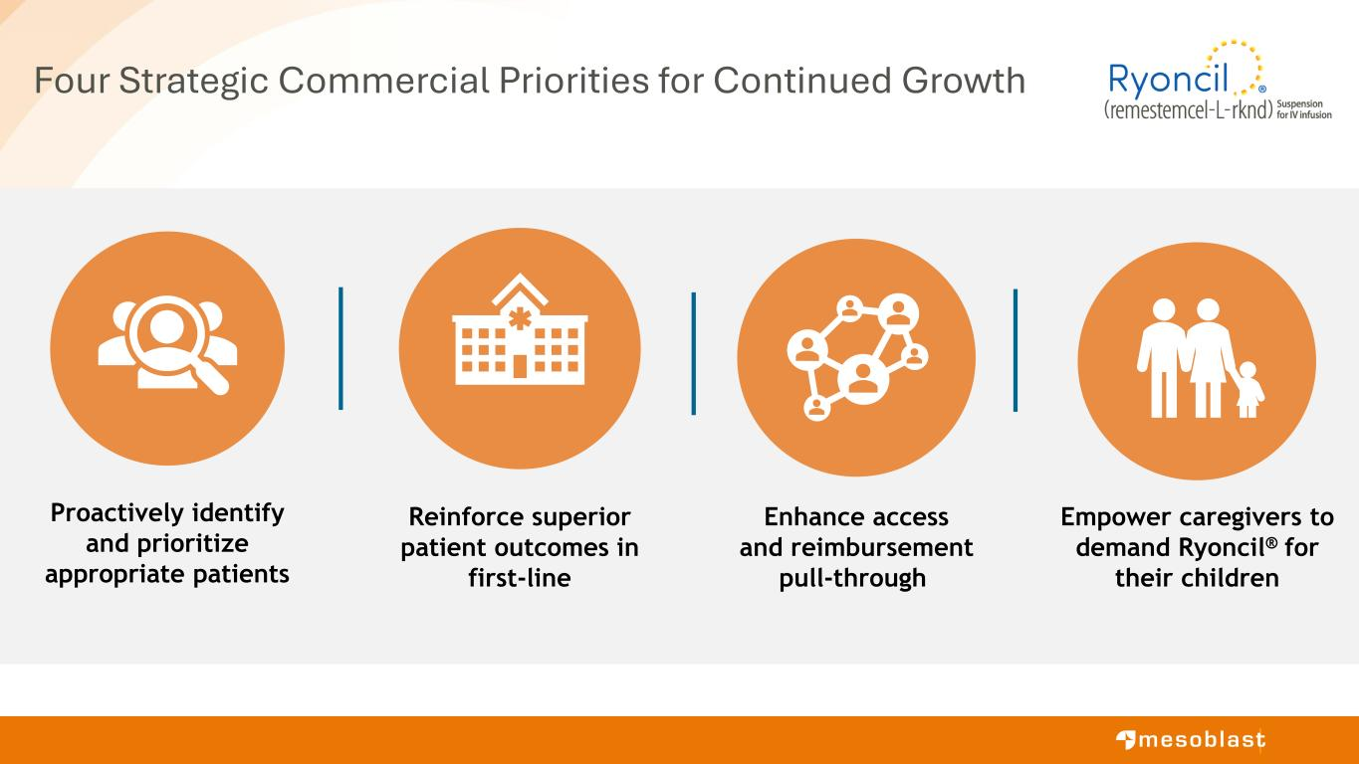
Four Strategic Commercial Priorities for Continued Growth Empower caregivers to demand Ryoncil® for their children Reinforce superior patient outcomes in first-line Proactively identify and prioritize appropriate patients Enhance access and reimbursement pull-through

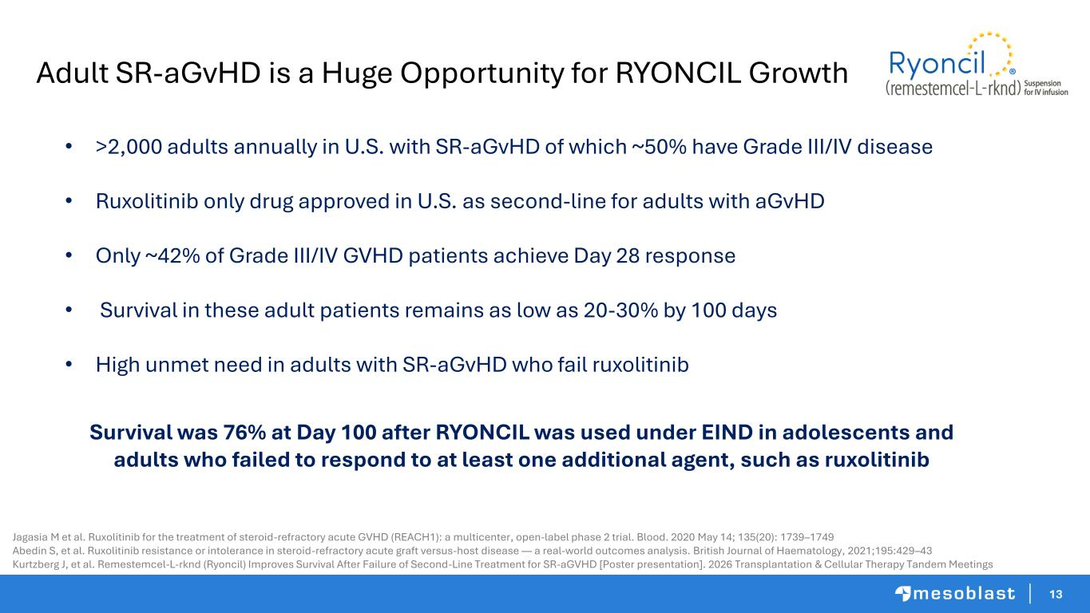
13 Adult SR-aGvHD is a Huge Opportunity for RYONCIL Growth Jagasia M et al. Ruxolitinib for the treatment of steroid-refractory acute GVHD (REACH1): a multicenter, open-label phase 2 trial. Blood. 2020 May 14; 135(20): 1739–1749 Abedin S, et al. Ruxolitinib resistance or intolerance in steroid-refractory acute graft versus-host disease — a real-world outcomes analysis. British Journal of Haematology, 2021;195:429–43 Kurtzberg J, et al. Remestemcel-L-rknd (Ryoncil) Improves Survival After Failure of Second-Line Treatment for SR-aGVHD [Poster presentation]. 2026 Transplantation & Cellular Therapy Tandem Meetings • >2,000 adults annually in U.S. with SR-aGvHD of which ~50% have Grade III/IV disease • Ruxolitinib only drug approved in U.S. as second-line for adults with aGvHD • Only ~42% of Grade III/IV GVHD patients achieve Day 28 response • Survival in these adult patients remains as low as 20-30% by 100 days • High unmet need in adults with SR-aGvHD who fail ruxolitinib Survival was 76% at Day 100 after RYONCIL was used under EIND in adolescents and adults who failed to respond to at least one additional agent, such as ruxolitinib

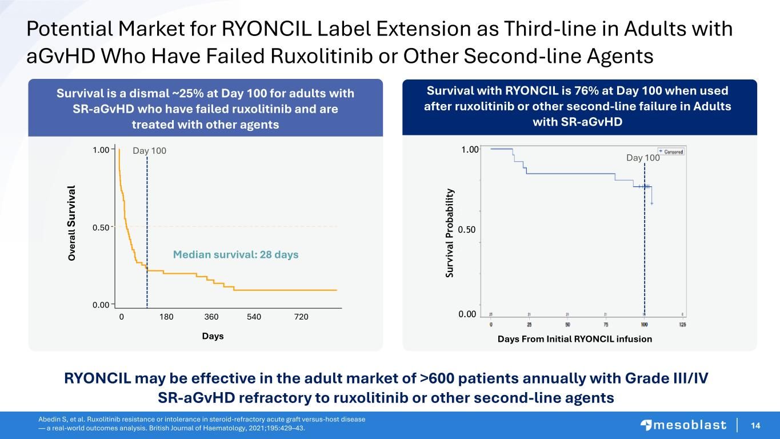
14 Survival with RYONCIL is 76% at Day 100 when used after ruxolitinib or other second-line failure in Adults with SR-aGvHD 0 180 540 720 Days 360 0.00 0.50 1.00 O ve ra ll Su rv iv al Median survival: 28 days Days From Initial RYONCIL infusion S u rv iv a l P ro b a b il it y 0.00 0.50 1.00 Potential Market for RYONCIL Label Extension as Third-line in Adults with aGvHD Who Have Failed Ruxolitinib or Other Second-line Agents Survival is a dismal ~25% at Day 100 for adults with SR-aGvHD who have failed ruxolitinib and are treated with other agents Abedin S, et al. Ruxolitinib resistance or intolerance in steroid-refractory acute graft versus-host disease — a real-world outcomes analysis. British Journal of Haematology, 2021;195:429–43. Day 100 Day 100 RYONCIL may be effective in the adult market of >600 patients annually with Grade III/IV SR-aGvHD refractory to ruxolitinib or other second-line agents

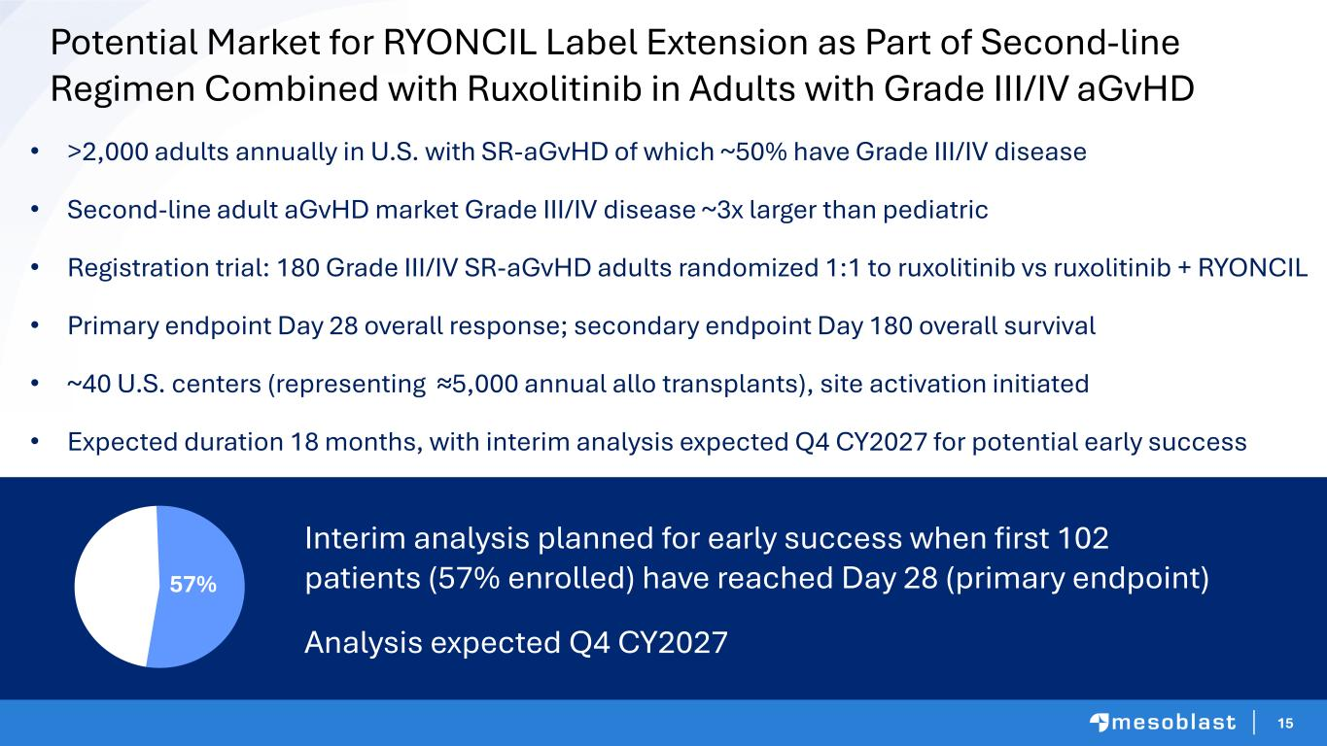
15 • >2,000 adults annually in U.S. with SR-aGvHD of which ~50% have Grade III/IV disease • Second-line adult aGvHD market Grade III/IV disease ~3x larger than pediatric • Registration trial: 180 Grade III/IV SR-aGvHD adults randomized 1:1 to ruxolitinib vs ruxolitinib + RYONCIL • Primary endpoint Day 28 overall response; secondary endpoint Day 180 overall survival • ~40 U.S. centers (representing ≈5,000 annual allo transplants), site activation initiated • Expected duration 18 months, with interim analysis expected Q4 CY2027 for potential early success Potential Market for RYONCIL Label Extension as Part of Second-line Regimen Combined with Ruxolitinib in Adults with Grade III/IV aGvHD Interim analysis planned for early success when first 102 patients (57% enrolled) have reached Day 28 (primary endpoint) Analysis expected Q4 CY2027 57%


16 Jess, this is the commercial section – per our call: • Orange bar on the bottom – pls keep for all slides in this section • Header text: please keep the same color for each slide • Logos: please keep as placed (even if a duplicate on the slides) • Slide 16 icons: ok to drop in size • Slide 17-18: please keep same box colors • Slide 19: glad for an alternative image • These notes apply to slides 13 – 23 • Ok to swap the font Rexlemestrocel-L for Chronic Lower Back Pain

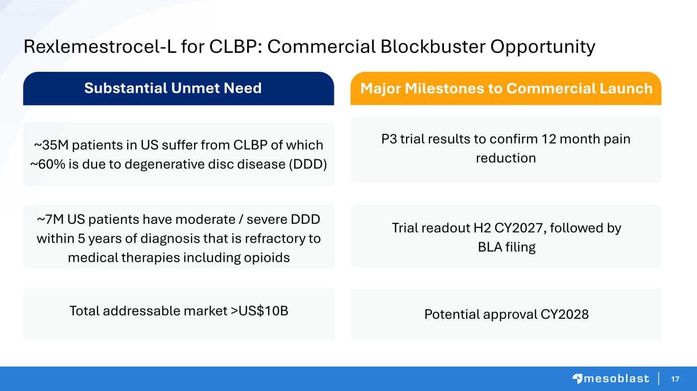
17 Rexlemestrocel-L for CLBP: Commercial Blockbuster Opportunity ~35M patients in US suffer from CLBP of which ~60% is due to degenerative disc disease (DDD) ~7M US patients have moderate / severe DDD within 5 years of diagnosis that is refractory to medical therapies including opioids P3 trial results to confirm 12 month pain reduction Potential approval CY2028Total addressable market >US$10B Trial readout H2 CY2027, followed by BLA filing Substantial Unmet Need Major Milestones to Commercial Launch

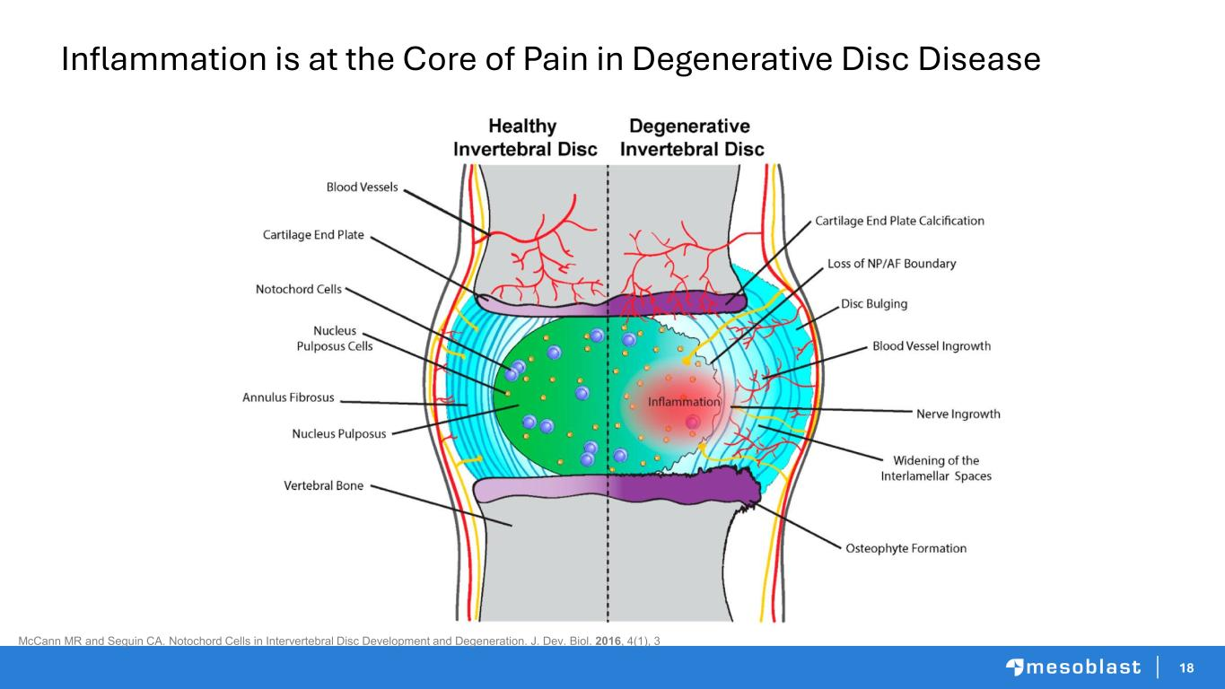
18 McCann MR and Seguin CA. Notochord Cells in Intervertebral Disc Development and Degeneration. J. Dev. Biol. 2016, 4(1), 3 Inflammation is at the Core of Pain in Degenerative Disc Disease

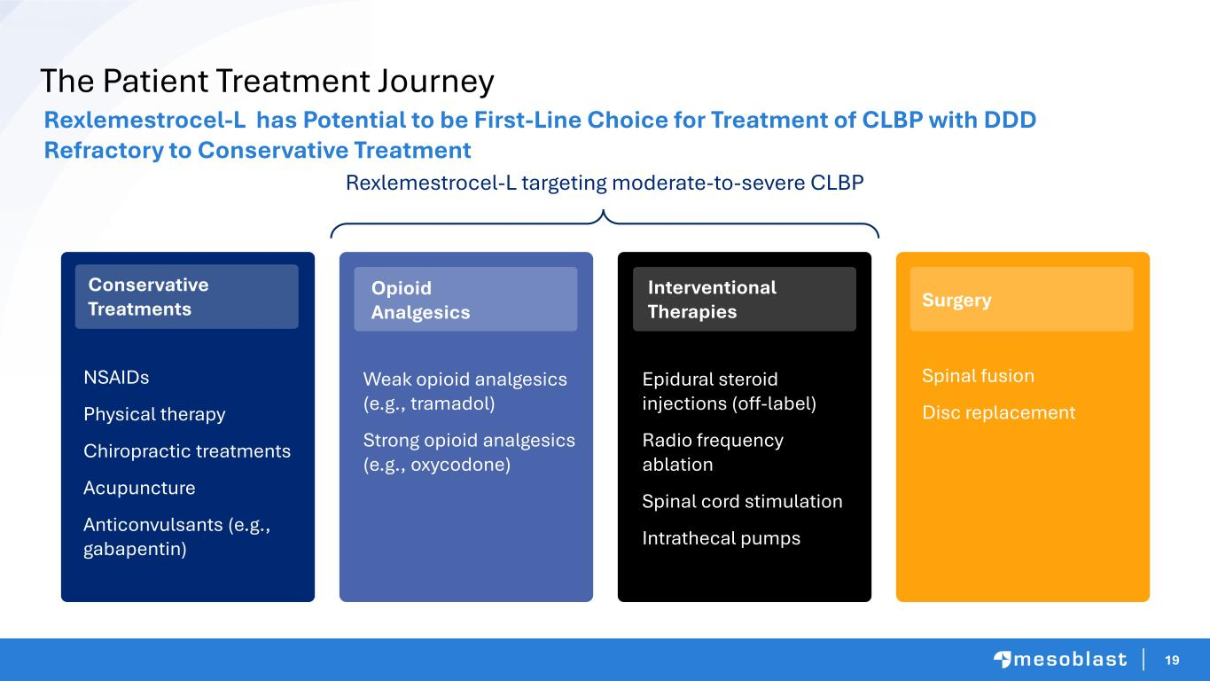
19 The Patient Treatment Journey Rexlemestrocel-L has Potential to be First-Line Choice for Treatment of CLBP with DDD Refractory to Conservative Treatment Rexlemestrocel-L targeting moderate-to-severe CLBP NSAIDs Physical therapy Chiropractic treatments Acupuncture Anticonvulsants (e.g., gabapentin) Epidural steroid injections (off-label) Radio frequency ablation Spinal cord stimulation Intrathecal pumps Conservative Treatments Opioid Analgesics Weak opioid analgesics (e.g., tramadol) Strong opioid analgesics (e.g., oxycodone) Interventional Therapies Surgery Spinal fusion Disc replacement

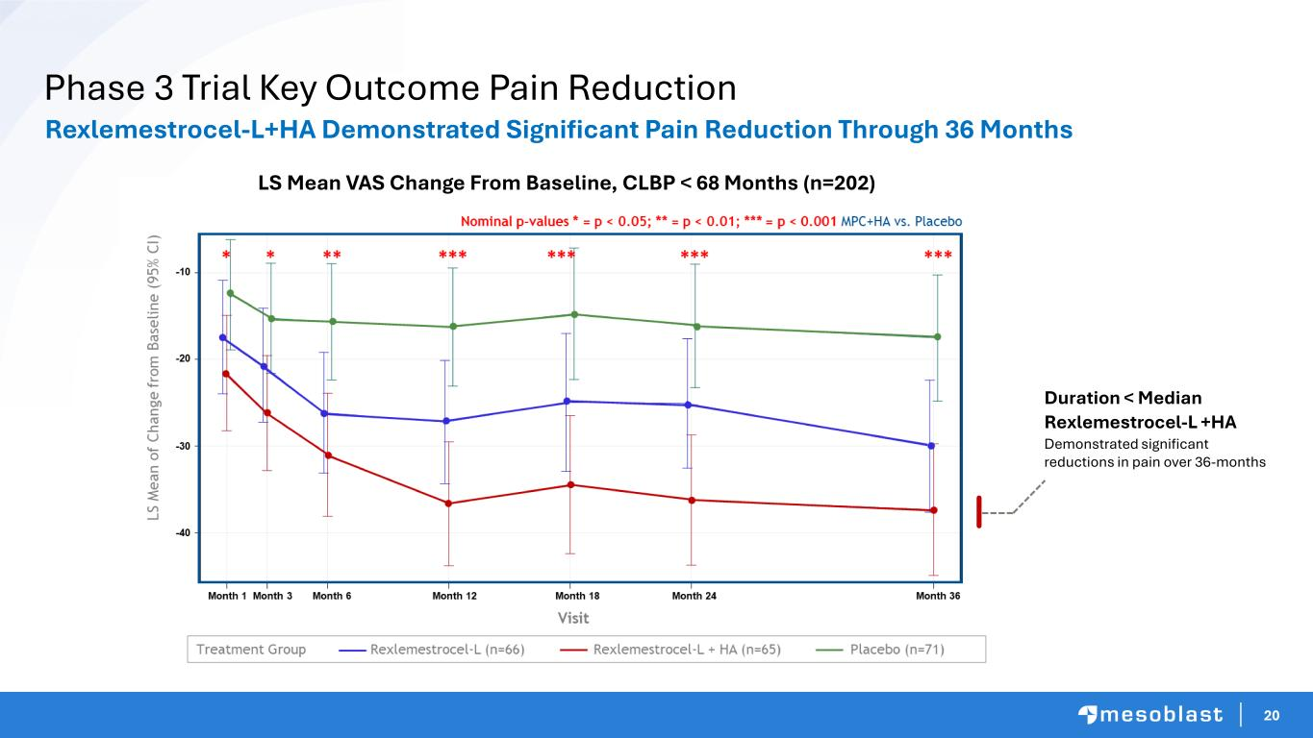
20 Phase 3 Trial Key Outcome Pain Reduction Duration < Median Rexlemestrocel-L +HA Demonstrated significant reductions in pain over 36-months LS Mean VAS Change From Baseline, CLBP < 68 Months (n=202) Rexlemestrocel-L+HA Demonstrated Significant Pain Reduction Through 36 Months

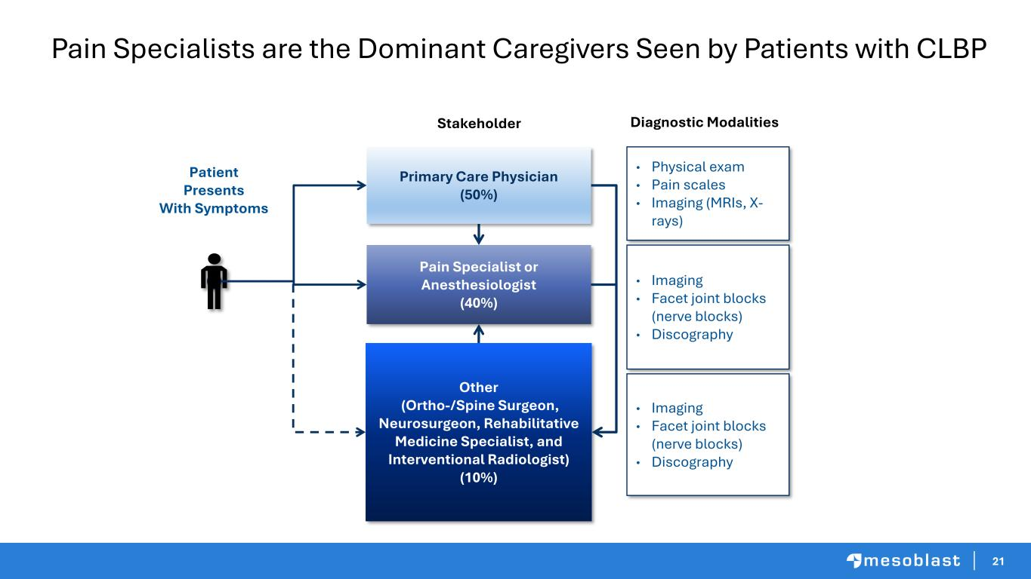
21 Pain Specialists are the Dominant Caregivers Seen by Patients with CLBP Primary Care Physician (50%) Other (Ortho-/Spine Surgeon, Neurosurgeon, Rehabilitative Medicine Specialist, and Interventional Radiologist) (10%) Patient Presents With Symptoms Pain Specialist or Anesthesiologist (40%) • Physical exam • Pain scales • Imaging (MRIs, X- rays) • Imaging • Facet joint blocks (nerve blocks) • Discography • Imaging • Facet joint blocks (nerve blocks) • Discography Stakeholder Diagnostic Modalities

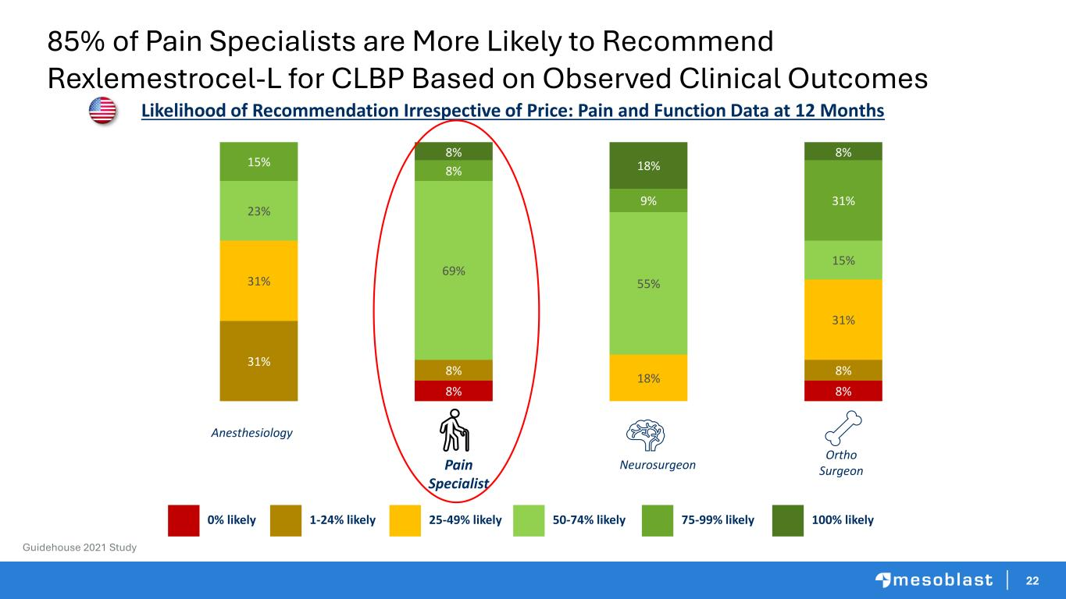
22 Pain Specialist Neurosurgeon Ortho Surgeon 8% 8% 31% 8% 8% 31% 18% 31% 23% 69% 55% 15% 15% 8% 9% 31% 8% 18% 8% Likelihood of Recommendation Irrespective of Price: Pain and Function Data at 12 Months 50-74% likely25-49% likely1-24% likely0% likely 75-99% likely 100% likely Anesthesiology Guidehouse 2021 Study 85% of Pain Specialists are More Likely to Recommend Rexlemestrocel-L for CLBP Based on Observed Clinical Outcomes

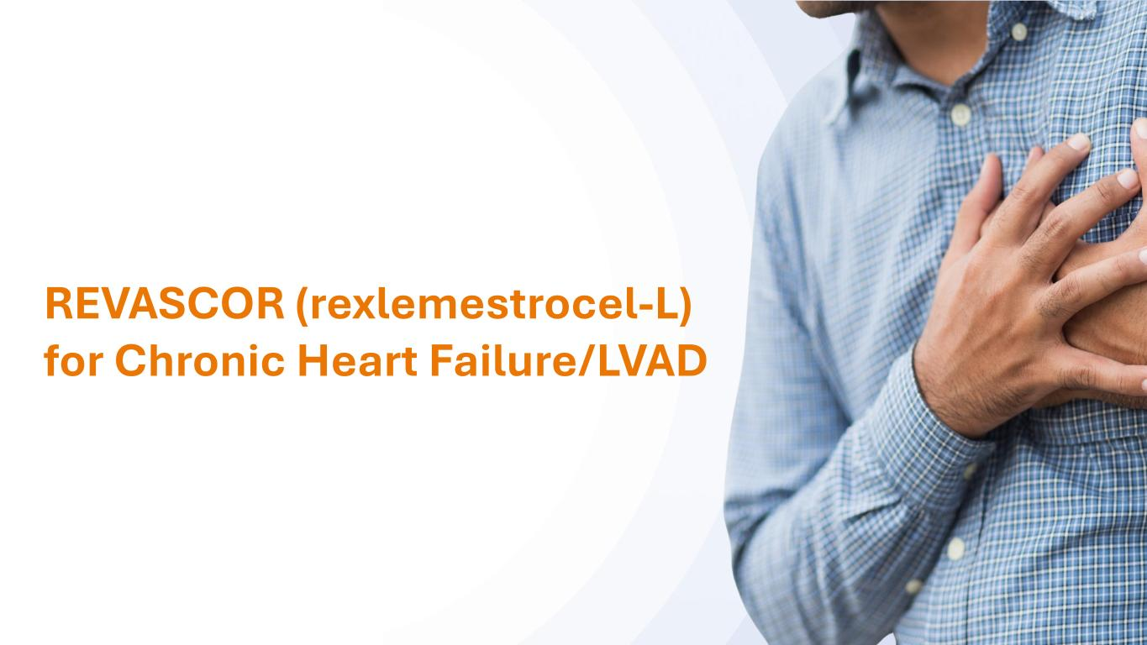
2323 REVASCOR (rexlemestrocel-L) for Chronic Heart Failure/LVAD

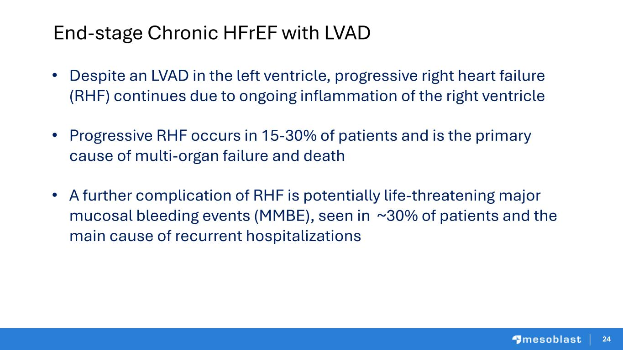
2424 End-stage Chronic HFrEF with LVAD • Despite an LVAD in the left ventricle, progressive right heart failure (RHF) continues due to ongoing inflammation of the right ventricle • Progressive RHF occurs in 15-30% of patients and is the primary cause of multi-organ failure and death • A further complication of RHF is potentially life-threatening major mucosal bleeding events (MMBE), seen in ~30% of patients and the main cause of recurrent hospitalizations

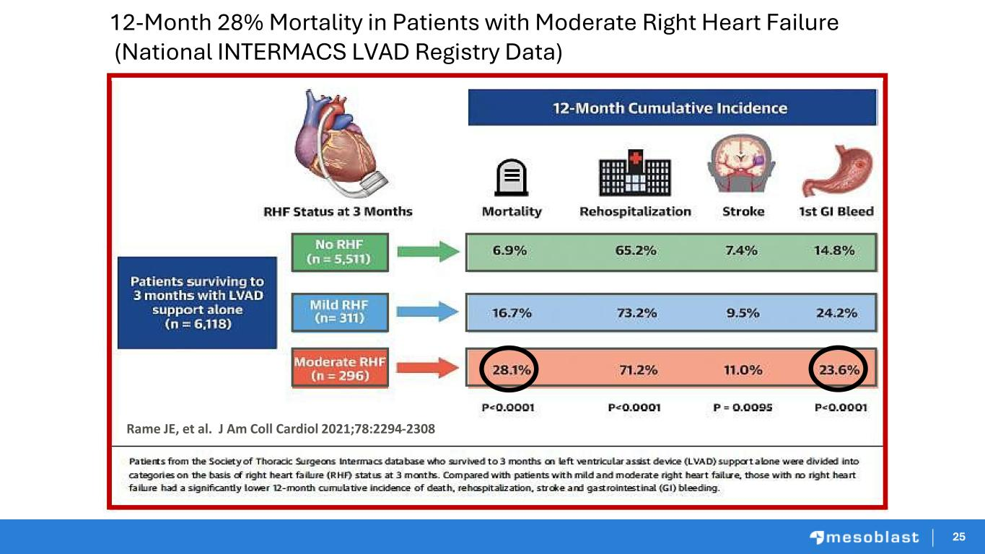
25 12-Month 28% Mortality in Patients with Moderate Right Heart Failure (National INTERMACS LVAD Registry Data) Rame JE, et al. J Am Coll Cardiol 2021;78:2294-2308 25

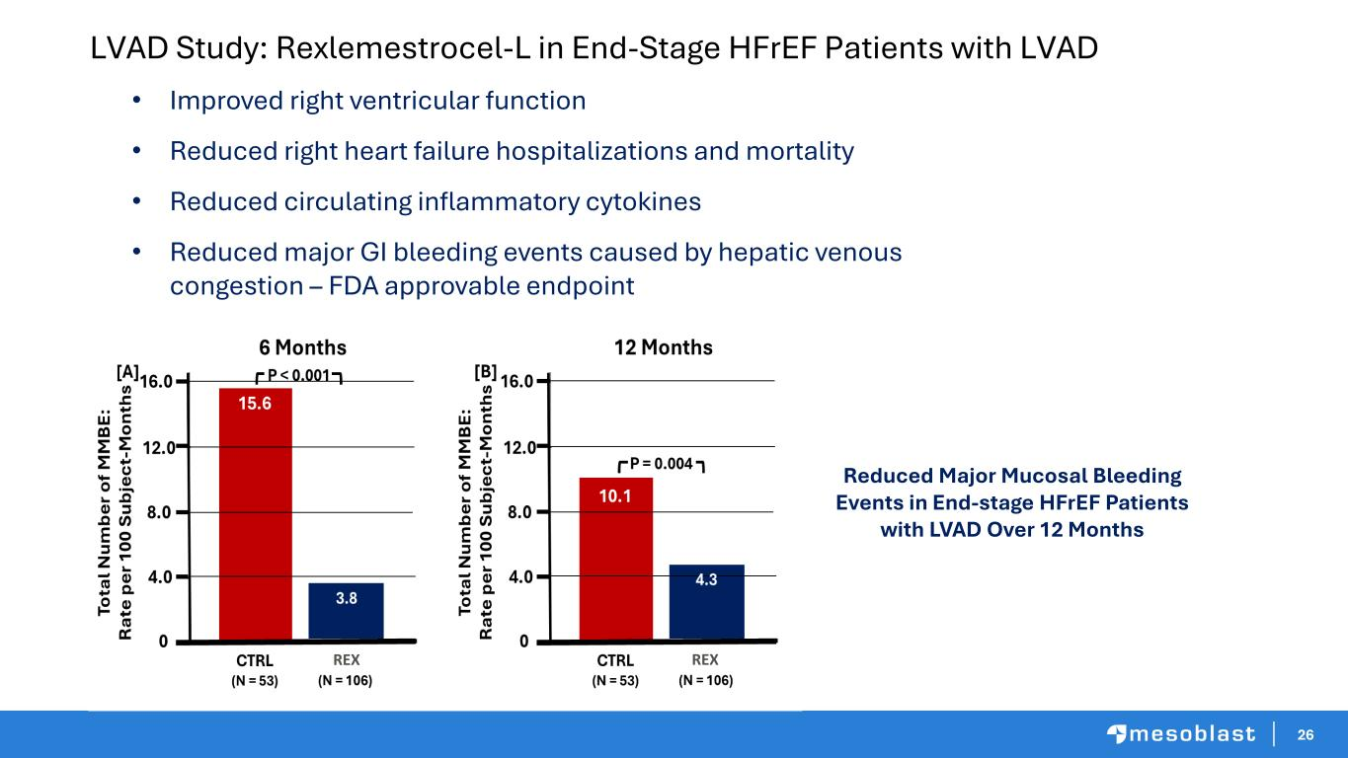
26 LVAD Study: Rexlemestrocel-L in End-Stage HFrEF Patients with LVAD • Improved right ventricular function • Reduced right heart failure hospitalizations and mortality • Reduced circulating inflammatory cytokines • Reduced major GI bleeding events caused by hepatic venous congestion – FDA approvable endpoint Reduced Major Mucosal Bleeding Events in End-stage HFrEF Patients with LVAD Over 12 Months REXREX

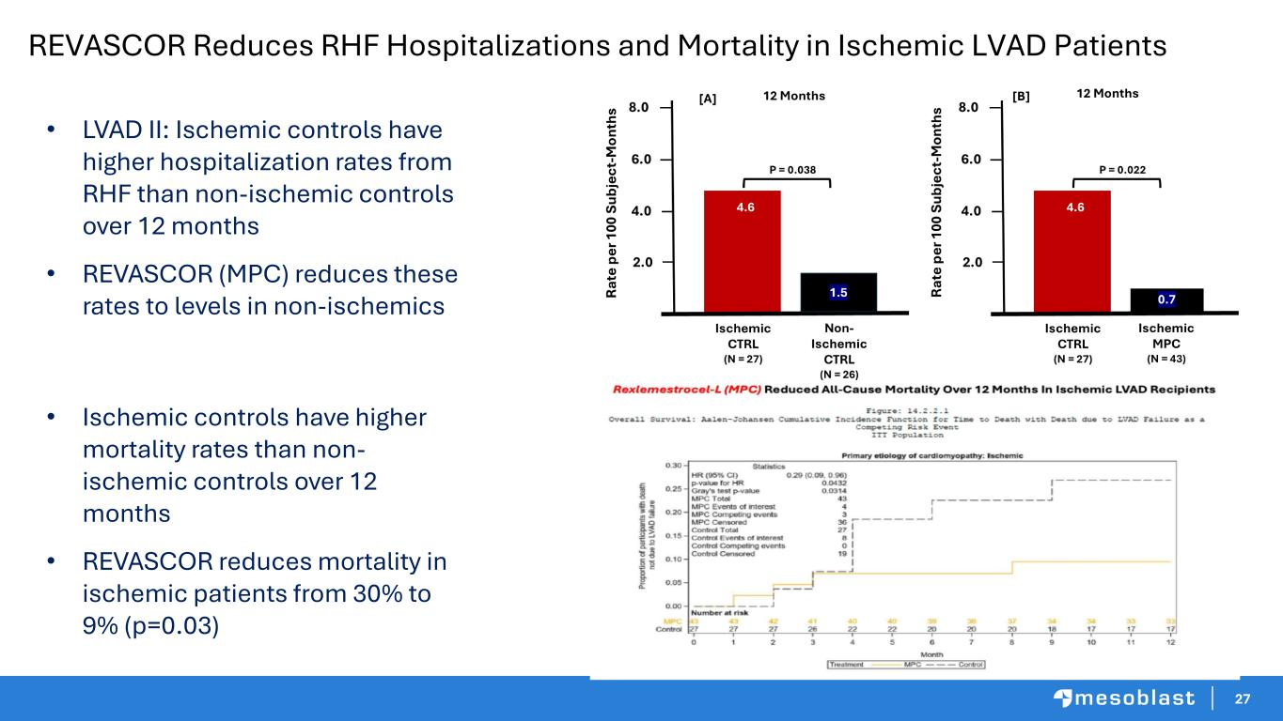
27 REVASCOR Reduces RHF Hospitalizations and Mortality in Ischemic LVAD Patients • LVAD II: Ischemic controls have higher hospitalization rates from RHF than non-ischemic controls over 12 months • REVASCOR (MPC) reduces these rates to levels in non-ischemics • Ischemic controls have higher mortality rates than non- ischemic controls over 12 months • REVASCOR reduces mortality in ischemic patients from 30% to 9% (p=0.03)

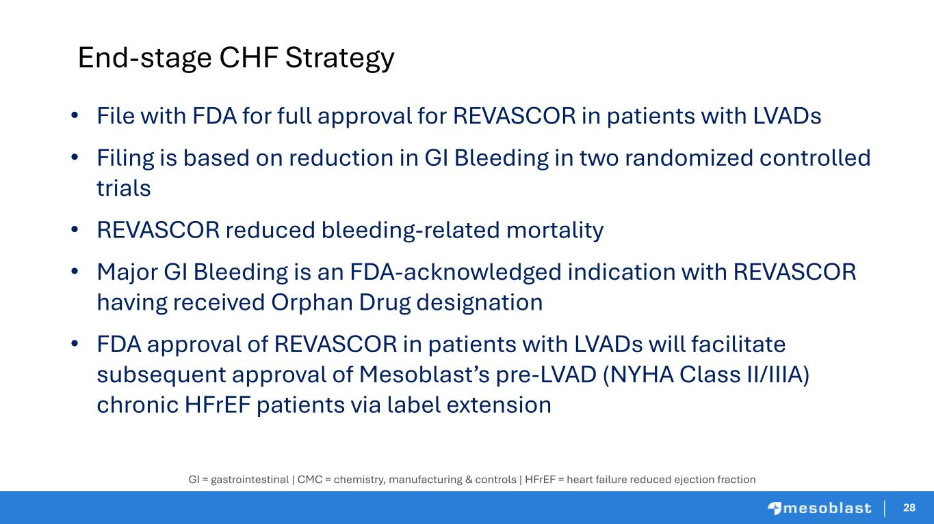
2828 End-stage CHF Strategy • File with FDA for full approval for REVASCOR in patients with LVADs • Filing is based on reduction in GI Bleeding in two randomized controlled trials • REVASCOR reduced bleeding-related mortality • Major GI Bleeding is an FDA-acknowledged indication with REVASCOR having received Orphan Drug designation • FDA approval of REVASCOR in patients with LVADs will facilitate subsequent approval of Mesoblast’s pre-LVAD (NYHA Class II/IIIA) chronic HFrEF patients via label extension GI = gastrointestinal | CMC = chemistry, manufacturing & controls | HFrEF = heart failure reduced ejection fraction


2929 In Summary

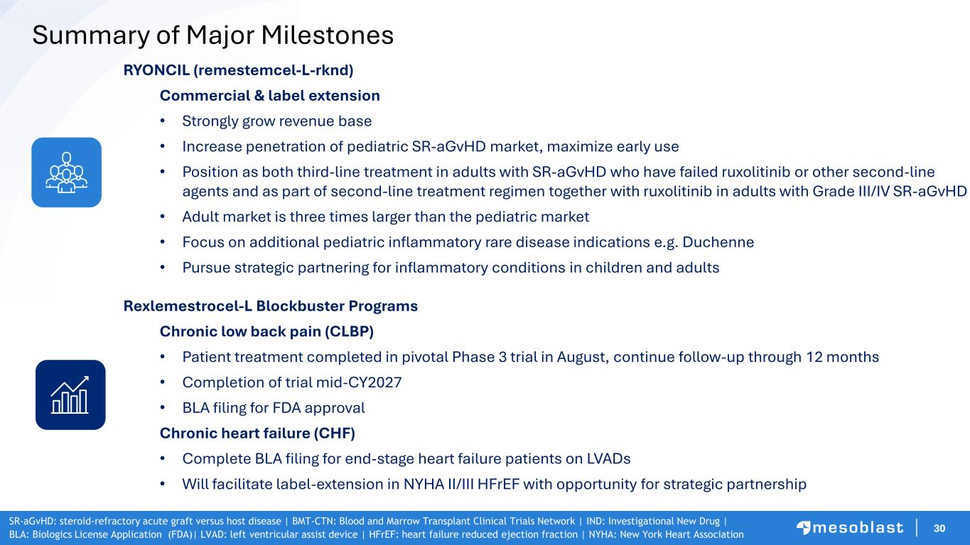
30 Summary of Major Milestones RYONCIL (remestemcel-L-rknd) Commercial & label extension • Strongly grow revenue base • Increase penetration of pediatric SR-aGvHD market, maximize early use • Position as both third-line treatment in adults with SR-aGvHD who have failed ruxolitinib or other second-line agents and as part of second-line treatment regimen together with ruxolitinib in adults with Grade III/IV SR-aGvHD • Adult market is three times larger than the pediatric market • Focus on additional pediatric inflammatory rare disease indications e.g. Duchenne • Pursue strategic partnering for inflammatory conditions in children and adults Rexlemestrocel-L Blockbuster Programs Chronic low back pain (CLBP) • Patient treatment completed in pivotal Phase 3 trial in August, continue follow-up through 12 months • Completion of trial mid-CY2027 • BLA filing for FDA approval Chronic heart failure (CHF) • Complete BLA filing for end-stage heart failure patients on LVADs • Will facilitate label-extension in NYHA II/III HFrEF with opportunity for strategic partnership SR-aGvHD: steroid-refractory acute graft versus host disease | BMT-CTN: Blood and Marrow Transplant Clinical Trials Network | IND: Investigational New Drug | BLA: Biologics License Application (FDA)| LVAD: left ventricular assist device | HFrEF: heart failure reduced ejection fraction | NYHA: New York Heart Association


31 Thank You

