UNITED STATES
SECURITIES AND EXCHANGE COMMISSION
Washington, D.C. 20549
Form 6-K
Report of Foreign Private Issuer
Pursuant to Rule 13a-16 or 15d-16 under the Securities Exchange Act of 1934
For the month of February 2025
Commission File Number 001-37626
Mesoblast Limited
(Exact name of Registrant as specified in its charter)
Not Applicable
(Translation of Registrant’s name into English)
Australia
(Jurisdiction of incorporation or organization)

Silviu Itescu
Chief Executive Officer and Executive Director
Level 38
55 Collins Street
Melbourne 3000
Australia
(Address of principal executive offices)

Indicate by check mark whether the registrant files or will file annual reports under cover Form 20-F or Form 40-F:
Form 20-F ☑ Form 40-F ☐

INFORMATION CONTAINED ON THIS REPORT ON FORM 6-K
On February 14, 2025, Mesoblast Limited filed with the Australian Securities Exchange a new release announcement, which is attached hereto as Exhibit 99.1, and is incorporated herein by reference.

SIGNATURES
Pursuant to the requirements of the Securities Exchange Act of 1934, the registrant has duly caused this report to be signed on its behalf by the undersigned, thereunto duly organized.
Mesoblast Limited
/s/ Paul Hughes
Paul Hughes
Company Secretary
Dated: February 15, 2025

INDEX TO EXHIBITS
Item
99.1 |  |  |  |  |  | Press release of Mesoblast Ltd, dated February 14, 2025.

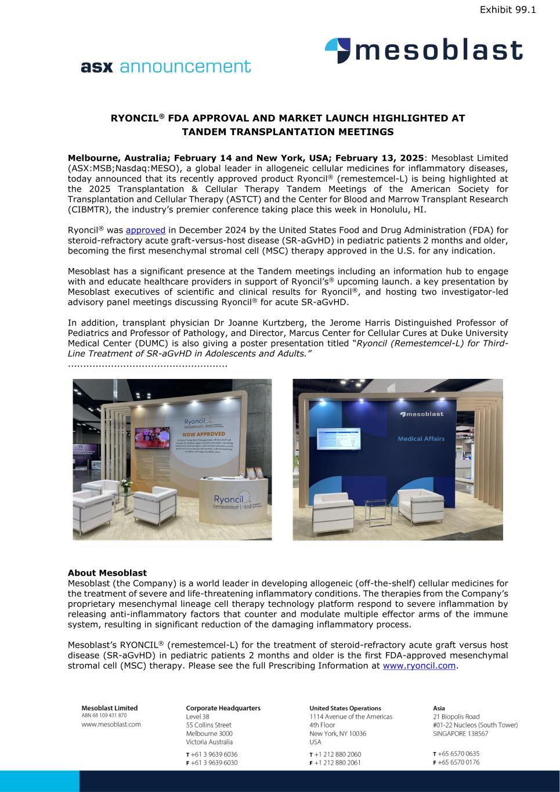

RYONCIL® FDA APPROVAL AND MARKET LAUNCH HIGHLIGHTED AT TANDEM TRANSPLANTATION MEETINGS Melbourne, Australia; February 14 and New York, USA; February 13, 2025: Mesoblast Limited (ASX:MSB;Nasdaq:MESO), a global leader in allogeneic cellular medicines for inflammatory diseases, today announced that its recently approved product Ryoncil® (remestemcel-L) is being highlighted at the 2025 Transplantation & Cellular Therapy Tandem Meetings of the American Society for Transplantation and Cellular Therapy (ASTCT) and the Center for Blood and Marrow Transplant Research (CIBMTR), the industry’s premier conference taking place this week in Honolulu, HI. Ryoncil® was approved in December 2024 by the United States Food and Drug Administration (FDA) for steroid-refractory acute graft-versus-host disease (SR-aGvHD) in pediatric patients 2 months and older, becoming the first mesenchymal stromal cell (MSC) therapy approved in the U.S. for any indication. Mesoblast has a significant presence at the Tandem meetings including an information hub to engage with and educate healthcare providers in support of Ryoncil’s® upcoming launch. a key presentation by Mesoblast executives of scientific and clinical results for Ryoncil®, and hosting two investigator-led advisory panel meetings discussing Ryoncil® for acute SR-aGvHD. In addition, transplant physician Dr Joanne Kurtzberg, the Jerome Harris Distinguished Professor of Pediatrics and Professor of Pathology, and Director, Marcus Center for Cellular Cures at Duke University Medical Center (DUMC) is also giving a poster presentation titled “Ryoncil (Remestemcel-L) for Third- Line Treatment of SR-aGvHD in Adolescents and Adults.” .................................................... About Mesoblast Mesoblast (the Company) is a world leader in developing allogeneic (off-the-shelf) cellular medicines for the treatment of severe and life-threatening inflammatory conditions. The therapies from the Company’s proprietary mesenchymal lineage cell therapy technology platform respond to severe inflammation by releasing anti-inflammatory factors that counter and modulate multiple effector arms of the immune system, resulting in significant reduction of the damaging inflammatory process. Mesoblast’s RYONCIL® (remestemcel-L) for the treatment of steroid-refractory acute graft versus host disease (SR-aGvHD) in pediatric patients 2 months and older is the first FDA-approved mesenchymal stromal cell (MSC) therapy. Please see the full Prescribing Information at www.ryoncil.com. Exhibit 99.1

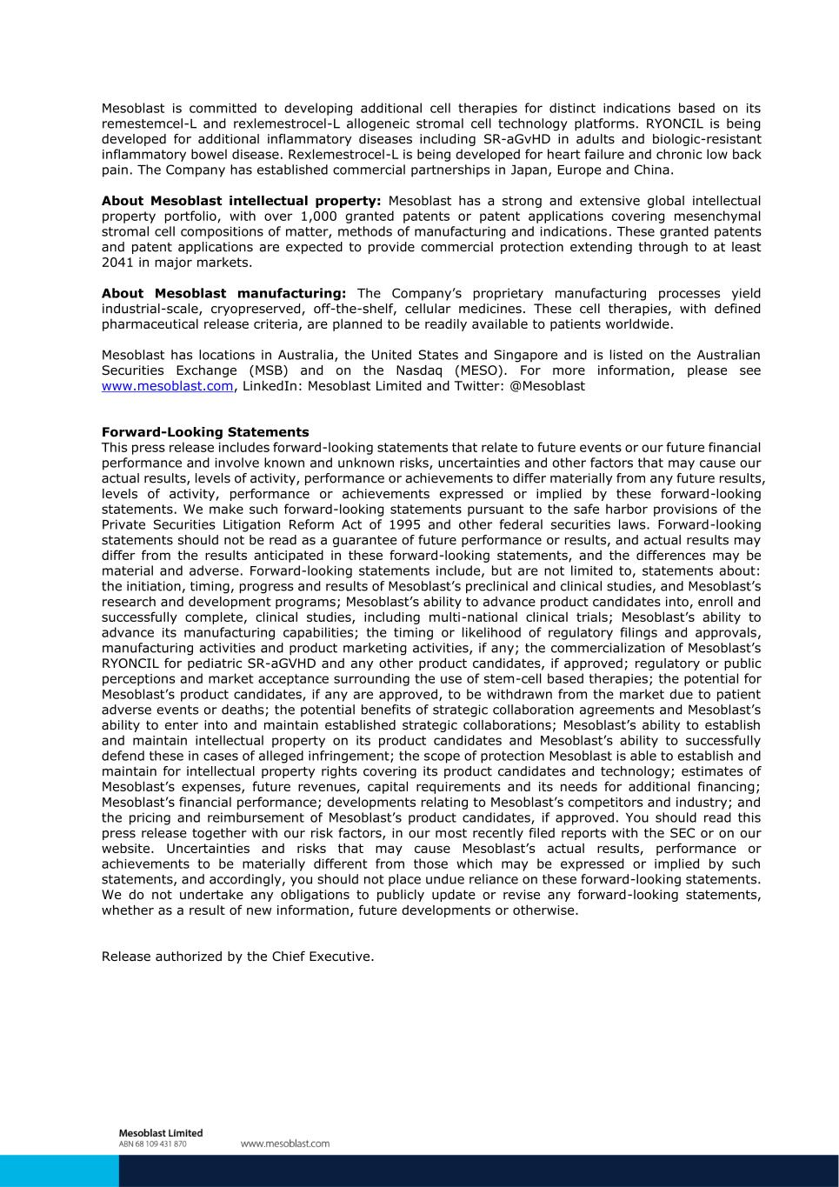
Mesoblast is committed to developing additional cell therapies for distinct indications based on its remestemcel-L and rexlemestrocel-L allogeneic stromal cell technology platforms. RYONCIL is being developed for additional inflammatory diseases including SR-aGvHD in adults and biologic-resistant inflammatory bowel disease. Rexlemestrocel-L is being developed for heart failure and chronic low back pain. The Company has established commercial partnerships in Japan, Europe and China. About Mesoblast intellectual property: Mesoblast has a strong and extensive global intellectual property portfolio, with over 1,000 granted patents or patent applications covering mesenchymal stromal cell compositions of matter, methods of manufacturing and indications. These granted patents and patent applications are expected to provide commercial protection extending through to at least 2041 in major markets. About Mesoblast manufacturing: The Company’s proprietary manufacturing processes yield industrial-scale, cryopreserved, off-the-shelf, cellular medicines. These cell therapies, with defined pharmaceutical release criteria, are planned to be readily available to patients worldwide. Mesoblast has locations in Australia, the United States and Singapore and is listed on the Australian Securities Exchange (MSB) and on the Nasdaq (MESO). For more information, please see www.mesoblast.com, LinkedIn: Mesoblast Limited and Twitter: @Mesoblast Forward-Looking Statements This press release includes forward-looking statements that relate to future events or our future financial performance and involve known and unknown risks, uncertainties and other factors that may cause our actual results, levels of activity, performance or achievements to differ materially from any future results, levels of activity, performance or achievements expressed or implied by these forward-looking statements. We make such forward-looking statements pursuant to the safe harbor provisions of the Private Securities Litigation Reform Act of 1995 and other federal securities laws. Forward-looking statements should not be read as a guarantee of future performance or results, and actual results may differ from the results anticipated in these forward-looking statements, and the differences may be material and adverse. Forward-looking statements include, but are not limited to, statements about: the initiation, timing, progress and results of Mesoblast’s preclinical and clinical studies, and Mesoblast’s research and development programs; Mesoblast’s ability to advance product candidates into, enroll and successfully complete, clinical studies, including multi-national clinical trials; Mesoblast’s ability to advance its manufacturing capabilities; the timing or likelihood of regulatory filings and approvals, manufacturing activities and product marketing activities, if any; the commercialization of Mesoblast’s RYONCIL for pediatric SR-aGVHD and any other product candidates, if approved; regulatory or public perceptions and market acceptance surrounding the use of stem-cell based therapies; the potential for Mesoblast’s product candidates, if any are approved, to be withdrawn from the market due to patient adverse events or deaths; the potential benefits of strategic collaboration agreements and Mesoblast’s ability to enter into and maintain established strategic collaborations; Mesoblast’s ability to establish and maintain intellectual property on its product candidates and Mesoblast’s ability to successfully defend these in cases of alleged infringement; the scope of protection Mesoblast is able to establish and maintain for intellectual property rights covering its product candidates and technology; estimates of Mesoblast’s expenses, future revenues, capital requirements and its needs for additional financing; Mesoblast’s financial performance; developments relating to Mesoblast’s competitors and industry; and the pricing and reimbursement of Mesoblast’s product candidates, if approved. You should read this press release together with our risk factors, in our most recently filed reports with the SEC or on our website. Uncertainties and risks that may cause Mesoblast’s actual results, performance or achievements to be materially different from those which may be expressed or implied by such statements, and accordingly, you should not place undue reliance on these forward-looking statements. We do not undertake any obligations to publicly update or revise any forward-looking statements, whether as a result of new information, future developments or otherwise. Release authorized by the Chief Executive.

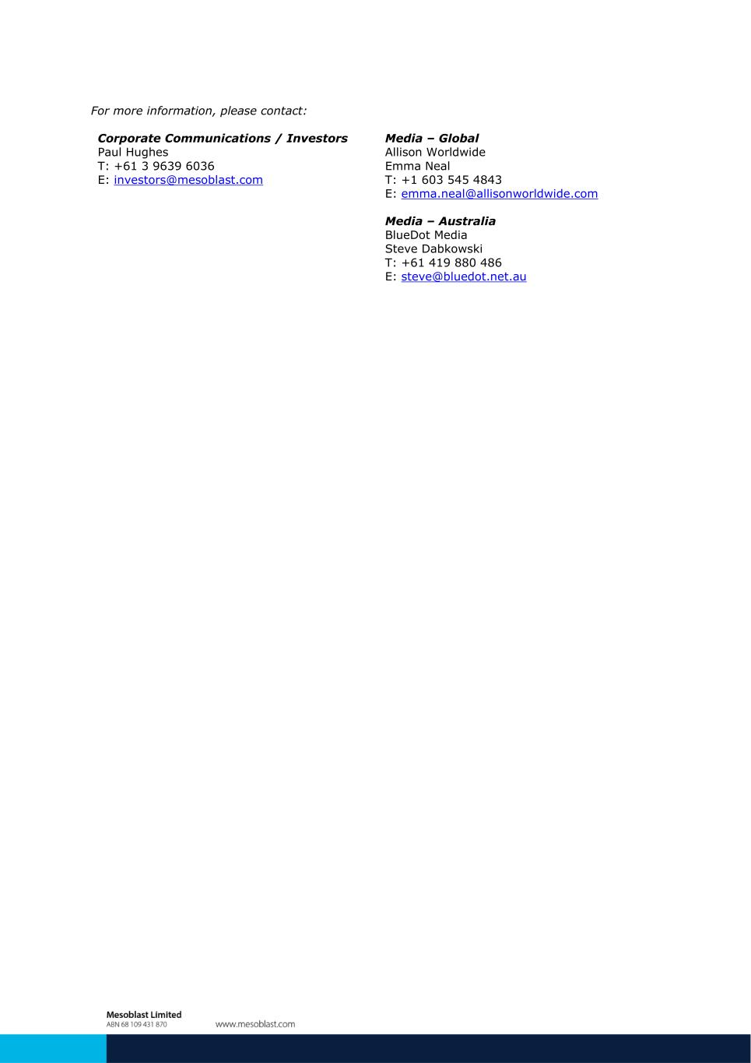
For more information, please contact: Corporate Communications / Investors Media – Global Paul Hughes Allison Worldwide T: +61 3 9639 6036 Emma Neal E: investors@mesoblast.com T: +1 603 545 4843 E: emma.neal@allisonworldwide.com Media – Australia BlueDot Media Steve Dabkowski T: +61 419 880 486 E: steve@bluedot.net.au

