UNITED STATES
SECURITIES AND EXCHANGE COMMISSION
Washington, D.C. 20549
Form 6-K
Report of Foreign Private Issuer
Pursuant to Rule 13a-16 or 15d-16 under the Securities Exchange Act of 1934
For the month of July 2026
Commission File Number 001-37626
Mesoblast Limited
(Exact name of Registrant as specified in its charter)
Not Applicable
(Translation of Registrant’s name into English)
Australia
(Jurisdiction of incorporation or organization)

Silviu Itescu
Chief Executive Officer and Executive Director
Level 38
55 Collins Street
Melbourne 3000
Australia
(Address of principal executive offices)

Indicate by check mark whether the registrant files or will file annual reports under cover Form 20-F or Form 40-F:
Form 20-F ☑ Form 40-F ☐

INFORMATION CONTAINED ON THIS REPORT ON FORM 6-K
On July 30, 2026, Mesoblast Limited filed with the Australian Securities Exchange a quarterly report for entities admitted on the basis of commitments (Appendix 4C) for the quarter ended June 30, 2026, which is attached hereto as Exhibit 99.1, and is incorporated herein by reference.

SIGNATURES
Pursuant to the requirements of the Securities Exchange Act of 1934, the registrant has duly caused this report to be signed on its behalf by the undersigned, thereunto duly organized.
Mesoblast Limited
/s/ Paul Hughes
Paul Hughes
Company Secretary
Dated: July 30, 2026

INDEX TO EXHIBITS
Item
99.1 |  |  |  |  |  | Appendix 4C of Mesoblast Ltd, dated July 30, 2026.

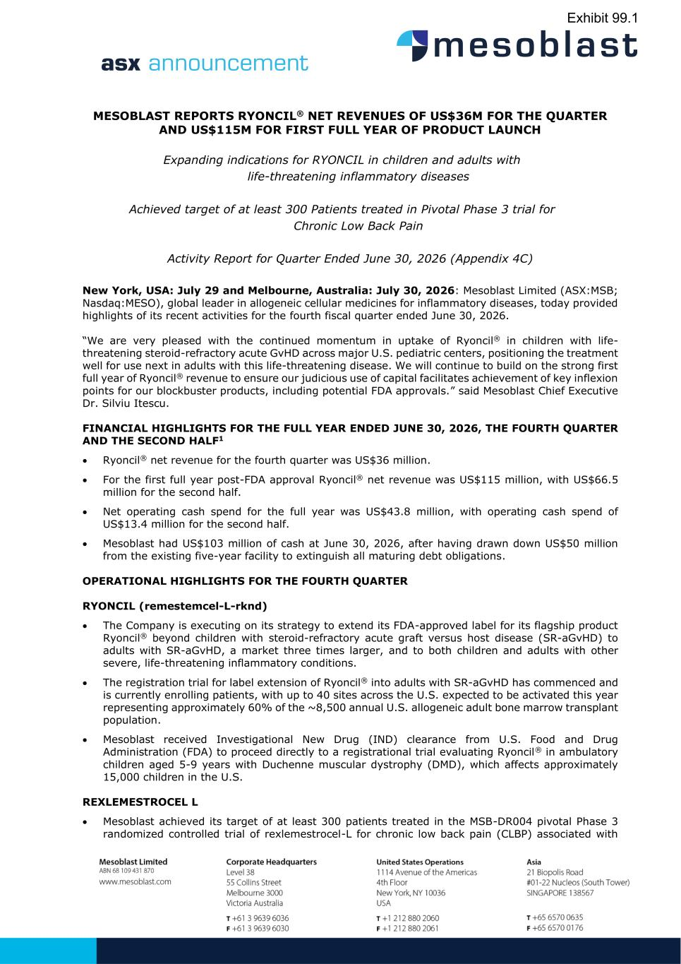

MESOBLAST REPORTS RYONCIL® NET REVENUES OF US$36M FOR THE QUARTER AND US$115M FOR FIRST FULL YEAR OF PRODUCT LAUNCH Expanding indications for RYONCIL in children and adults with life-threatening inflammatory diseases Achieved target of at least 300 Patients treated in Pivotal Phase 3 trial for Chronic Low Back Pain Activity Report for Quarter Ended June 30, 2026 (Appendix 4C) New York, USA: July 29 and Melbourne, Australia: July 30, 2026: Mesoblast Limited (ASX:MSB; Nasdaq:MESO), global leader in allogeneic cellular medicines for inflammatory diseases, today provided highlights of its recent activities for the fourth fiscal quarter ended June 30, 2026. “We are very pleased with the continued momentum in uptake of Ryoncil® in children with life- threatening steroid-refractory acute GvHD across major U.S. pediatric centers, positioning the treatment well for use next in adults with this life-threatening disease. We will continue to build on the strong first full year of Ryoncil® revenue to ensure our judicious use of capital facilitates achievement of key inflexion points for our blockbuster products, including potential FDA approvals.” said Mesoblast Chief Executive Dr. Silviu Itescu. FINANCIAL HIGHLIGHTS FOR THE FULL YEAR ENDED JUNE 30, 2026, THE FOURTH QUARTER AND THE SECOND HALF1 • Ryoncil® net revenue for the fourth quarter was US$36 million. • For the first full year post-FDA approval Ryoncil® net revenue was US$115 million, with US$66.5 million for the second half. • Net operating cash spend for the full year was US$43.8 million, with operating cash spend of US$13.4 million for the second half. • Mesoblast had US$103 million of cash at June 30, 2026, after having drawn down US$50 million from the existing five-year facility to extinguish all maturing debt obligations. OPERATIONAL HIGHLIGHTS FOR THE FOURTH QUARTER RYONCIL (remestemcel-L-rknd) • The Company is executing on its strategy to extend its FDA-approved label for its flagship product Ryoncil® beyond children with steroid-refractory acute graft versus host disease (SR-aGvHD) to adults with SR-aGvHD, a market three times larger, and to both children and adults with other severe, life-threatening inflammatory conditions. • The registration trial for label extension of Ryoncil® into adults with SR-aGvHD has commenced and is currently enrolling patients, with up to 40 sites across the U.S. expected to be activated this year representing approximately 60% of the ~8,500 annual U.S. allogeneic adult bone marrow transplant population. • Mesoblast received Investigational New Drug (IND) clearance from U.S. Food and Drug Administration (FDA) to proceed directly to a registrational trial evaluating Ryoncil® in ambulatory children aged 5-9 years with Duchenne muscular dystrophy (DMD), which affects approximately 15,000 children in the U.S. REXLEMESTROCEL L • Mesoblast achieved its target of at least 300 patients treated in the MSB-DR004 pivotal Phase 3 randomized controlled trial of rexlemestrocel-L for chronic low back pain (CLBP) associated with Exhibit 99.1

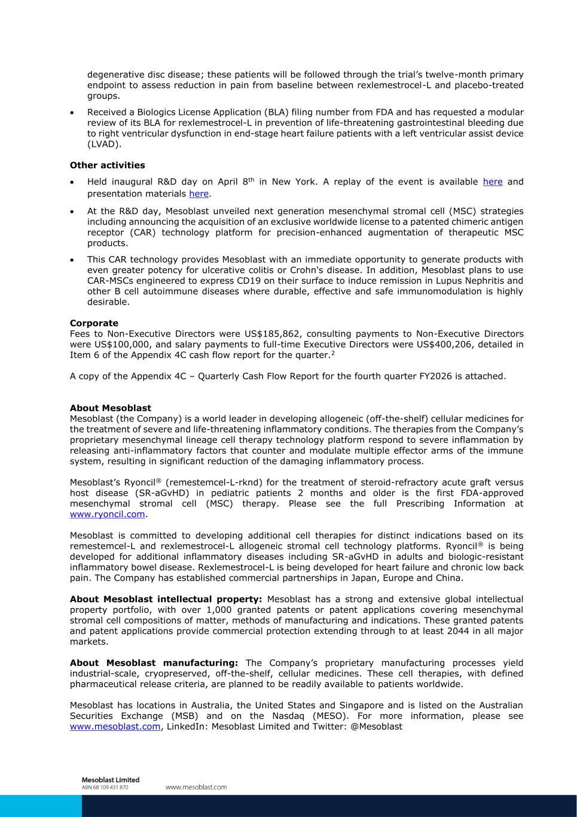
degenerative disc disease; these patients will be followed through the trial’s twelve-month primary endpoint to assess reduction in pain from baseline between rexlemestrocel-L and placebo-treated groups. • Received a Biologics License Application (BLA) filing number from FDA and has requested a modular review of its BLA for rexlemestrocel-L in prevention of life-threatening gastrointestinal bleeding due to right ventricular dysfunction in end-stage heart failure patients with a left ventricular assist device (LVAD). Other activities • Held inaugural R&D day on April 8th in New York. A replay of the event is available here and presentation materials here. • At the R&D day, Mesoblast unveiled next generation mesenchymal stromal cell (MSC) strategies including announcing the acquisition of an exclusive worldwide license to a patented chimeric antigen receptor (CAR) technology platform for precision-enhanced augmentation of therapeutic MSC products. • This CAR technology provides Mesoblast with an immediate opportunity to generate products with even greater potency for ulcerative colitis or Crohn's disease. In addition, Mesoblast plans to use CAR-MSCs engineered to express CD19 on their surface to induce remission in Lupus Nephritis and other B cell autoimmune diseases where durable, effective and safe immunomodulation is highly desirable. Corporate Fees to Non-Executive Directors were US$185,862, consulting payments to Non-Executive Directors were US$100,000, and salary payments to full-time Executive Directors were US$400,206, detailed in Item 6 of the Appendix 4C cash flow report for the quarter.2 A copy of the Appendix 4C – Quarterly Cash Flow Report for the fourth quarter FY2026 is attached. About Mesoblast Mesoblast (the Company) is a world leader in developing allogeneic (off-the-shelf) cellular medicines for the treatment of severe and life-threatening inflammatory conditions. The therapies from the Company’s proprietary mesenchymal lineage cell therapy technology platform respond to severe inflammation by releasing anti-inflammatory factors that counter and modulate multiple effector arms of the immune system, resulting in significant reduction of the damaging inflammatory process. Mesoblast’s Ryoncil® (remestemcel-L-rknd) for the treatment of steroid-refractory acute graft versus host disease (SR-aGvHD) in pediatric patients 2 months and older is the first FDA-approved mesenchymal stromal cell (MSC) therapy. Please see the full Prescribing Information at www.ryoncil.com. Mesoblast is committed to developing additional cell therapies for distinct indications based on its remestemcel-L and rexlemestrocel-L allogeneic stromal cell technology platforms. Ryoncil® is being developed for additional inflammatory diseases including SR-aGvHD in adults and biologic-resistant inflammatory bowel disease. Rexlemestrocel-L is being developed for heart failure and chronic low back pain. The Company has established commercial partnerships in Japan, Europe and China. About Mesoblast intellectual property: Mesoblast has a strong and extensive global intellectual property portfolio, with over 1,000 granted patents or patent applications covering mesenchymal stromal cell compositions of matter, methods of manufacturing and indications. These granted patents and patent applications provide commercial protection extending through to at least 2044 in all major markets. About Mesoblast manufacturing: The Company’s proprietary manufacturing processes yield industrial-scale, cryopreserved, off-the-shelf, cellular medicines. These cell therapies, with defined pharmaceutical release criteria, are planned to be readily available to patients worldwide. Mesoblast has locations in Australia, the United States and Singapore and is listed on the Australian Securities Exchange (MSB) and on the Nasdaq (MESO). For more information, please see www.mesoblast.com, LinkedIn: Mesoblast Limited and Twitter: @Mesoblast

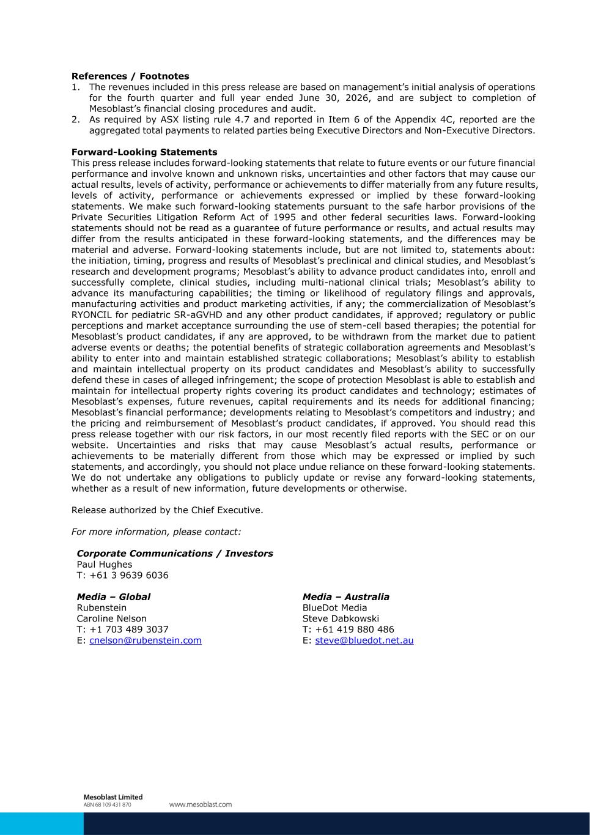
References / Footnotes 1. The revenues included in this press release are based on management’s initial analysis of operations for the fourth quarter and full year ended June 30, 2026, and are subject to completion of Mesoblast’s financial closing procedures and audit. 2. As required by ASX listing rule 4.7 and reported in Item 6 of the Appendix 4C, reported are the aggregated total payments to related parties being Executive Directors and Non-Executive Directors. Forward-Looking Statements This press release includes forward-looking statements that relate to future events or our future financial performance and involve known and unknown risks, uncertainties and other factors that may cause our actual results, levels of activity, performance or achievements to differ materially from any future results, levels of activity, performance or achievements expressed or implied by these forward-looking statements. We make such forward-looking statements pursuant to the safe harbor provisions of the Private Securities Litigation Reform Act of 1995 and other federal securities laws. Forward-looking statements should not be read as a guarantee of future performance or results, and actual results may differ from the results anticipated in these forward-looking statements, and the differences may be material and adverse. Forward-looking statements include, but are not limited to, statements about: the initiation, timing, progress and results of Mesoblast’s preclinical and clinical studies, and Mesoblast’s research and development programs; Mesoblast’s ability to advance product candidates into, enroll and successfully complete, clinical studies, including multi-national clinical trials; Mesoblast’s ability to advance its manufacturing capabilities; the timing or likelihood of regulatory filings and approvals, manufacturing activities and product marketing activities, if any; the commercialization of Mesoblast’s RYONCIL for pediatric SR-aGVHD and any other product candidates, if approved; regulatory or public perceptions and market acceptance surrounding the use of stem-cell based therapies; the potential for Mesoblast’s product candidates, if any are approved, to be withdrawn from the market due to patient adverse events or deaths; the potential benefits of strategic collaboration agreements and Mesoblast’s ability to enter into and maintain established strategic collaborations; Mesoblast’s ability to establish and maintain intellectual property on its product candidates and Mesoblast’s ability to successfully defend these in cases of alleged infringement; the scope of protection Mesoblast is able to establish and maintain for intellectual property rights covering its product candidates and technology; estimates of Mesoblast’s expenses, future revenues, capital requirements and its needs for additional financing; Mesoblast’s financial performance; developments relating to Mesoblast’s competitors and industry; and the pricing and reimbursement of Mesoblast’s product candidates, if approved. You should read this press release together with our risk factors, in our most recently filed reports with the SEC or on our website. Uncertainties and risks that may cause Mesoblast’s actual results, performance or achievements to be materially different from those which may be expressed or implied by such statements, and accordingly, you should not place undue reliance on these forward-looking statements. We do not undertake any obligations to publicly update or revise any forward-looking statements, whether as a result of new information, future developments or otherwise. Release authorized by the Chief Executive. For more information, please contact: Corporate Communications / Investors Paul Hughes T: +61 3 9639 6036 Media – Global Media – Australia Rubenstein BlueDot Media Caroline Nelson Steve Dabkowski T: +1 703 489 3037 T: +61 419 880 486 E: cnelson@rubenstein.com E: steve@bluedot.net.au

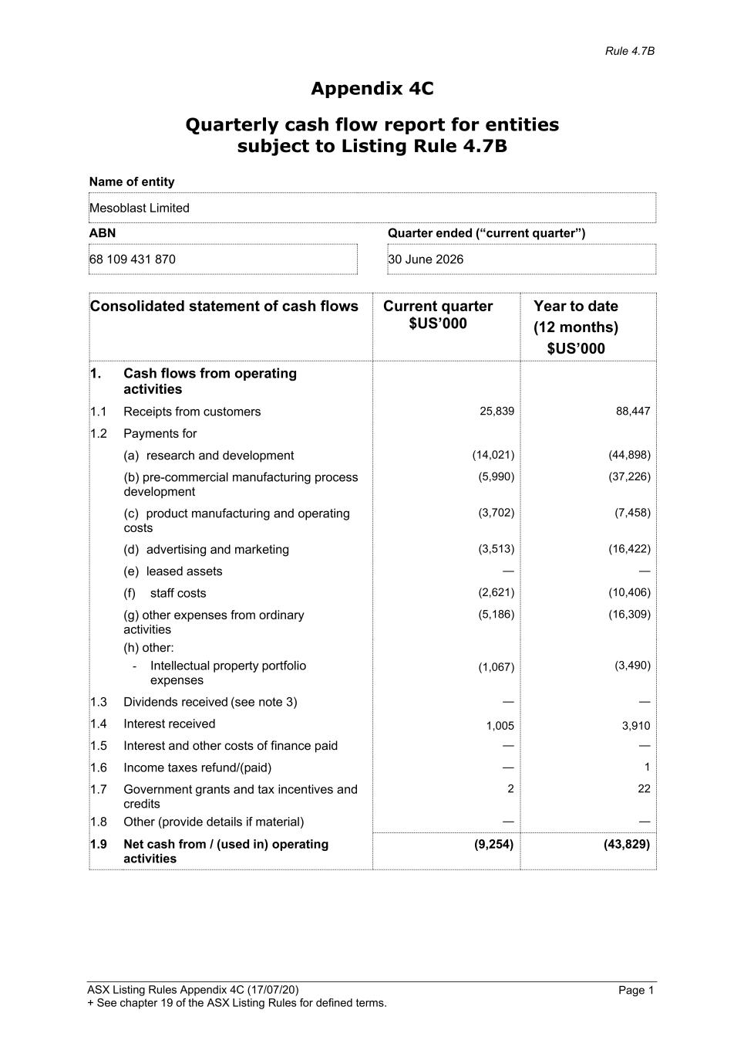
Rule 4.7B ASX Listing Rules Appendix 4C (17/07/20) + See chapter 19 of the ASX Listing Rules for defined terms. Page 1 Appendix 4C Quarterly cash flow report for entities subject to Listing Rule 4.7B Name of entity Mesoblast Limited ABN Quarter ended (“current quarter”) 68 109 431 870 30 June 2026 Consolidated statement of cash flows Current quarter $US’000 Year to date (12 months) $US’000 1. Cash flows from operating activities 1.1 Receipts from customers 25,839 88,447 1.2 Payments for (a) research and development (14,021) (44,898) (b) pre-commercial manufacturing process development (5,990) (37,226) (c) product manufacturing and operating costs (3,702) (7,458) (d) advertising and marketing (3,513) (16,422) (e) leased assets — — (f) staff costs (2,621) (10,406) (g) other expenses from ordinary activities (h) other: - Intellectual property portfolio expenses (5,186) (16,309) (1,067) (3,490) 1.3 Dividends received (see note 3) — — 1.4 Interest received 1,005 3,910 1.5 Interest and other costs of finance paid — — 1.6 Income taxes refund/(paid) — 1 1.7 Government grants and tax incentives and credits 2 22 1.8 Other (provide details if material) — — 1.9 Net cash from / (used in) operating activities (9,254) (43,829)

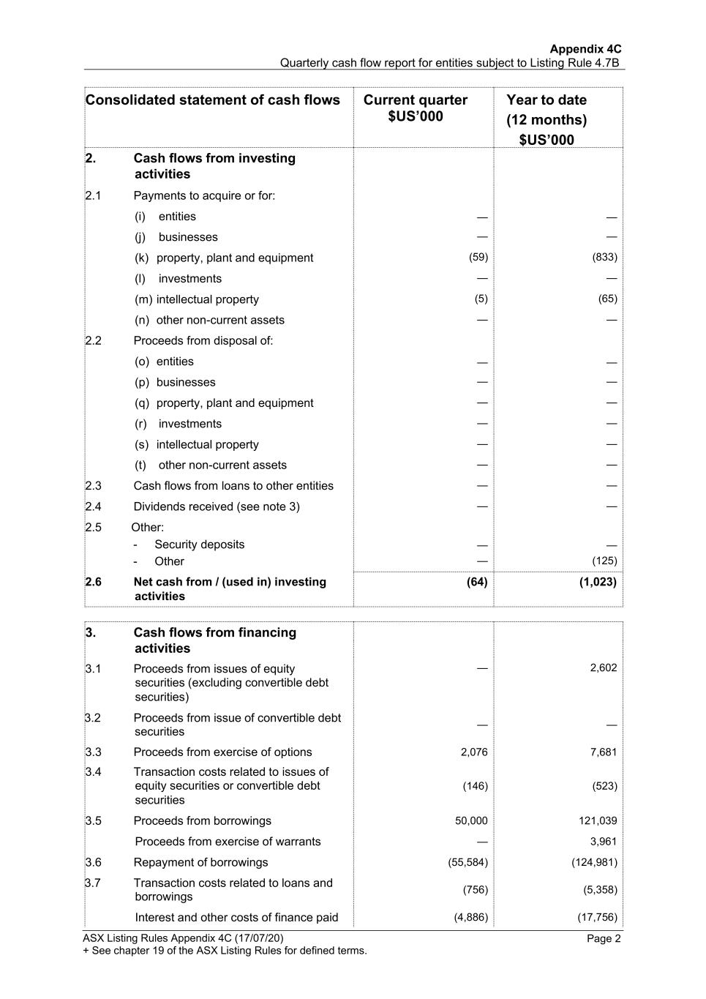
Appendix 4C Quarterly cash flow report for entities subject to Listing Rule 4.7B ASX Listing Rules Appendix 4C (17/07/20) + See chapter 19 of the ASX Listing Rules for defined terms. Page 2 Consolidated statement of cash flows Current quarter $US’000 Year to date (12 months) $US’000 2. Cash flows from investing activities 2.1 Payments to acquire or for: (i) entities — — (j) businesses — — (k) property, plant and equipment (59) (833) (l) investments — — (m) intellectual property (5) (65) (n) other non-current assets — — 2.2 Proceeds from disposal of: (o) entities — — (p) businesses — — (q) property, plant and equipment — — (r) investments — — (s) intellectual property — — (t) other non-current assets — — 2.3 Cash flows from loans to other entities — — 2.4 Dividends received (see note 3) — — 2.5 Other: - Security deposits — — - Other — (125) 2.6 Net cash from / (used in) investing (64) (1,023) activities 3. Cash flows from financing activities 3.1 Proceeds from issues of equity — 2,602 securities (excluding convertible debt securities) 3.2 Proceeds from issue of convertible debt securities — — 3.3 Proceeds from exercise of options 2,076 7,681 3.4 Transaction costs related to issues of equity securities or convertible debt (146) (523) securities 3.5 Proceeds from borrowings 50,000 121,039 Proceeds from exercise of warrants — 3,961 3.6 Repayment of borrowings (55,584) (124,981) 3.7 Transaction costs related to loans and borrowings (756) (5,358) Interest and other costs of finance paid (4,886) (17,756)

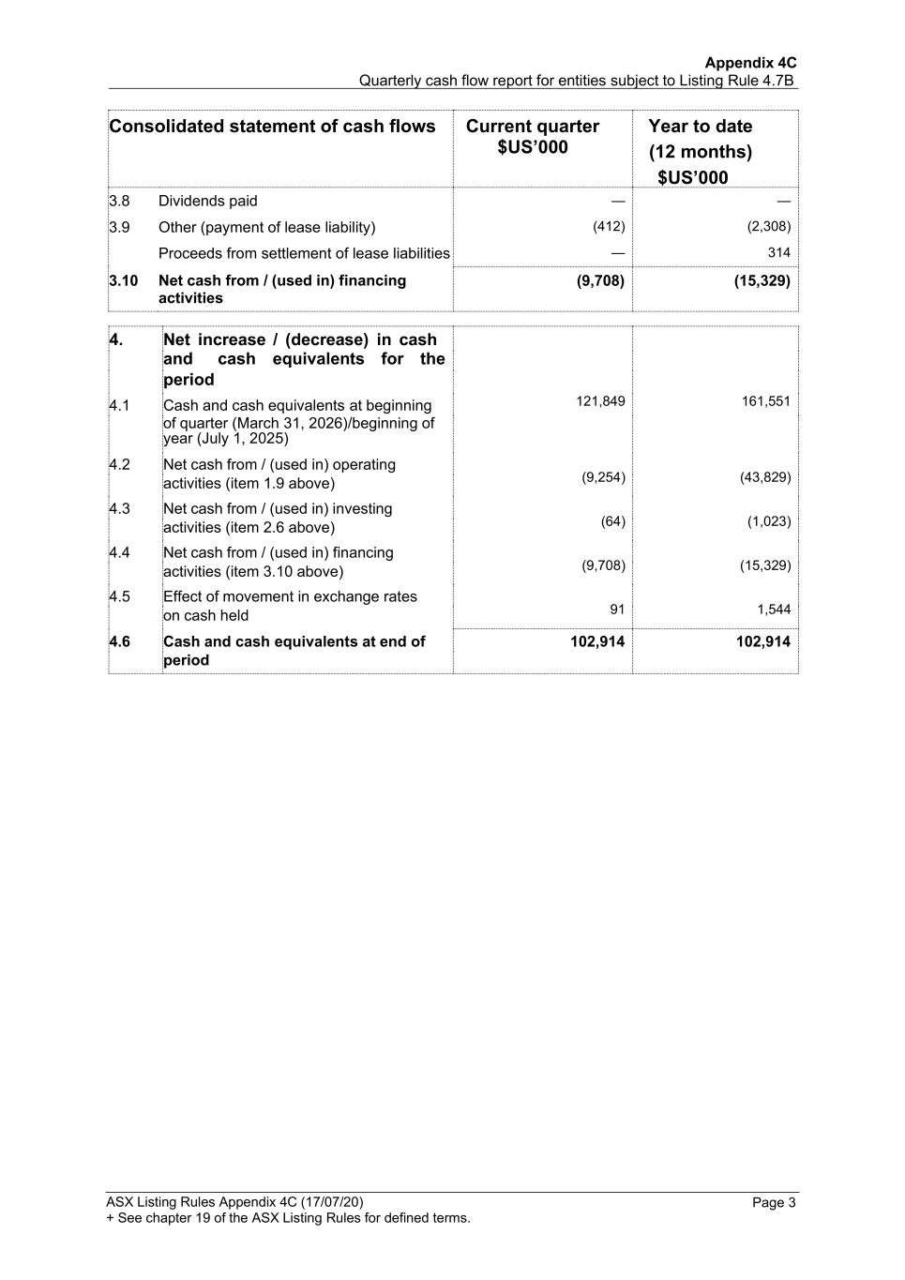
Appendix 4C Quarterly cash flow report for entities subject to Listing Rule 4.7B ASX Listing Rules Appendix 4C (17/07/20) + See chapter 19 of the ASX Listing Rules for defined terms. Page 3 Consolidated statement of cash flows Current quarter $US’000 Year to date (12 months) $US’000 3.8 Dividends paid — — 3.9 Other (payment of lease liability) (412) (2,308) Proceeds from settlement of lease liabilities — 314 3.10 Net cash from / (used in) financing activities (9,708) (15,329) 4. Net increase / (decrease) in cash 121,849 (9,254) (64) (9,708) 91 161,551 (43,829) (1,023) (15,329) 1,544 and cash equivalents for the period 4.1 Cash and cash equivalents at beginning of quarter (March 31, 2026)/beginning of year (July 1, 2025) 4.2 Net cash from / (used in) operating activities (item 1.9 above) 4.3 Net cash from / (used in) investing activities (item 2.6 above) 4.4 Net cash from / (used in) financing activities (item 3.10 above) 4.5 Effect of movement in exchange rates on cash held 4.6 Cash and cash equivalents at end of 102,914 102,914 period

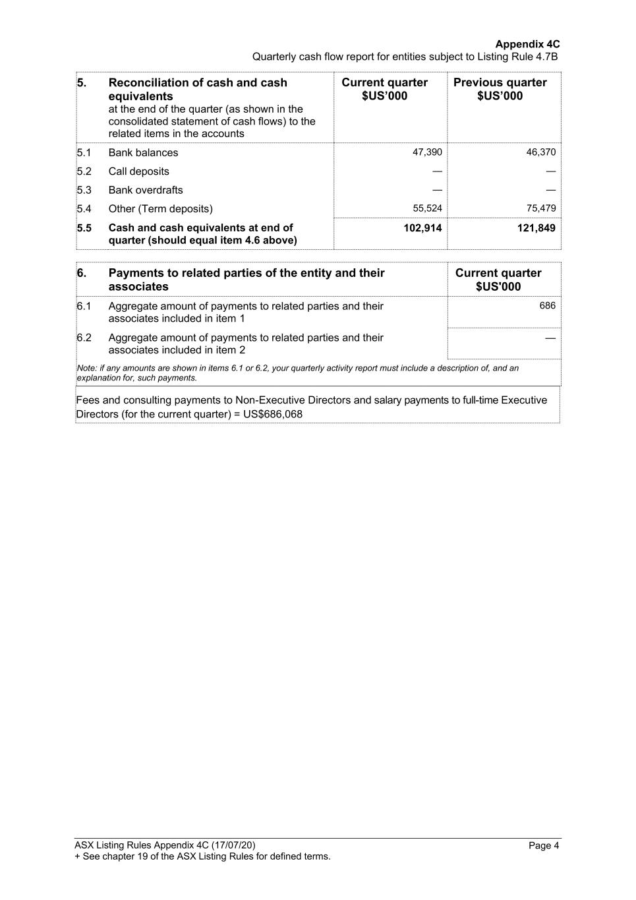
Appendix 4C Quarterly cash flow report for entities subject to Listing Rule 4.7B ASX Listing Rules Appendix 4C (17/07/20) + See chapter 19 of the ASX Listing Rules for defined terms. Page 4 5. Reconciliation of cash and cash equivalents at the end of the quarter (as shown in the consolidated statement of cash flows) to the related items in the accounts Current quarter $US’000 Previous quarter $US’000 5.1 Bank balances 47,390 46,370 5.2 Call deposits — — 5.3 Bank overdrafts — — 5.4 Other (Term deposits) 55,524 75,479 5.5 Cash and cash equivalents at end of quarter (should equal item 4.6 above) 102,914 121,849 6. Payments to related parties of the entity and their associates Current quarter $US'000 6.1 Aggregate amount of payments to related parties and their associates included in item 1 686 6.2 Aggregate amount of payments to related parties and their associates included in item 2 — Note: if any amounts are shown in items 6.1 or 6.2, your quarterly activity report must include a description of, and an explanation for, such payments. Fees and consulting payments to Non-Executive Directors and salary payments to full-time Executive Directors (for the current quarter) = US$686,068

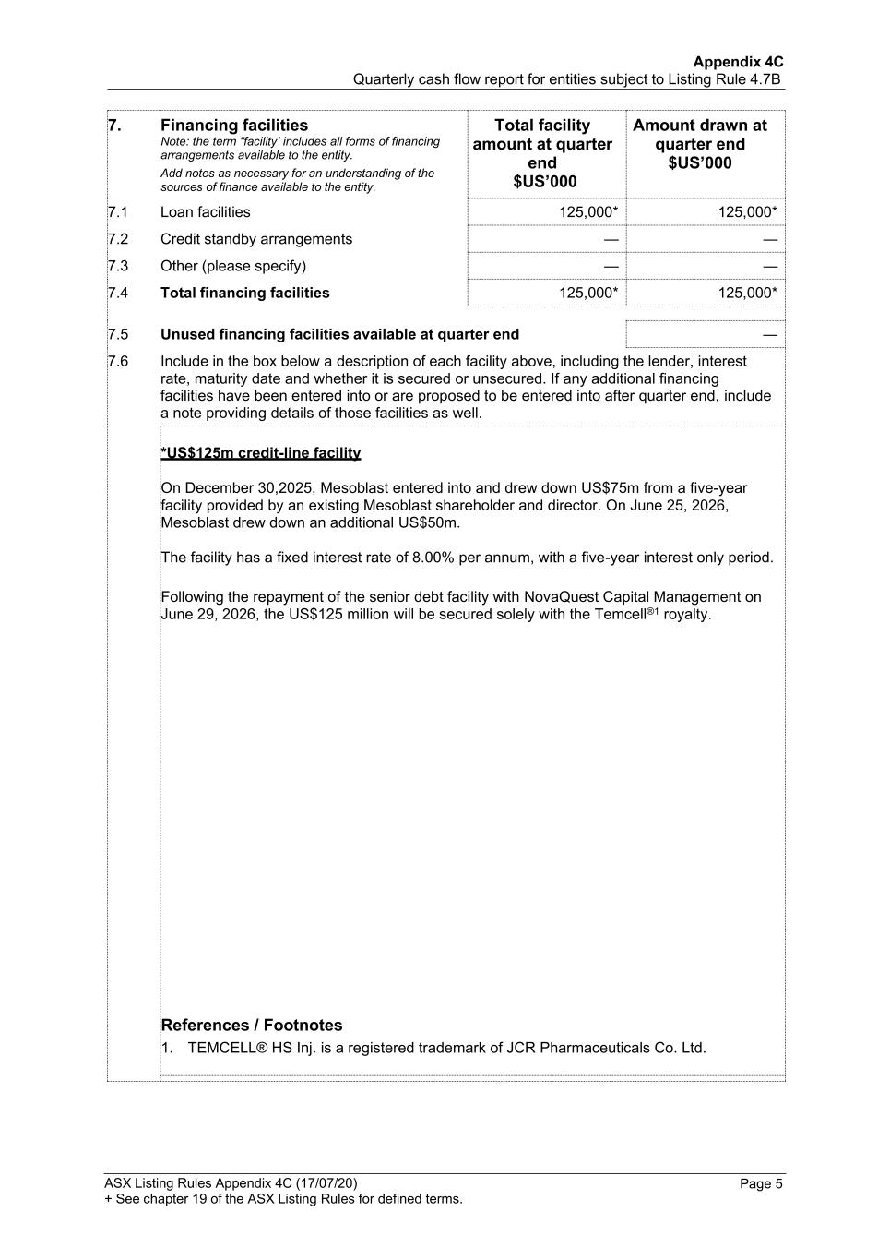
Appendix 4C Quarterly cash flow report for entities subject to Listing Rule 4.7B ASX Listing Rules Appendix 4C (17/07/20) + See chapter 19 of the ASX Listing Rules for defined terms. Page 5 7. Financing facilities Note: the term “facility’ includes all forms of financing arrangements available to the entity. Add notes as necessary for an understanding of the sources of finance available to the entity. Total facility amount at quarter end $US’000 Amount drawn at quarter end $US’000 7.1 Loan facilities 125,000* 125,000* 7.2 Credit standby arrangements — — 7.3 Other (please specify) — — 7.4 Total financing facilities 125,000* 125,000* 7.5 Unused financing facilities available at quarter end — 7.6 Include in the box below a description of each facility above, including the lender, interest rate, maturity date and whether it is secured or unsecured. If any additional financing facilities have been entered into or are proposed to be entered into after quarter end, include a note providing details of those facilities as well. *US$125m credit-line facility On December 30,2025, Mesoblast entered into and drew down US$75m from a five-year facility provided by an existing Mesoblast shareholder and director. On June 25, 2026, Mesoblast drew down an additional US$50m. The facility has a fixed interest rate of 8.00% per annum, with a five-year interest only period. Following the repayment of the senior debt facility with NovaQuest Capital Management on June 29, 2026, the US$125 million will be secured solely with the Temcell®1 royalty. References / Footnotes 1. TEMCELL® HS Inj. is a registered trademark of JCR Pharmaceuticals Co. Ltd.

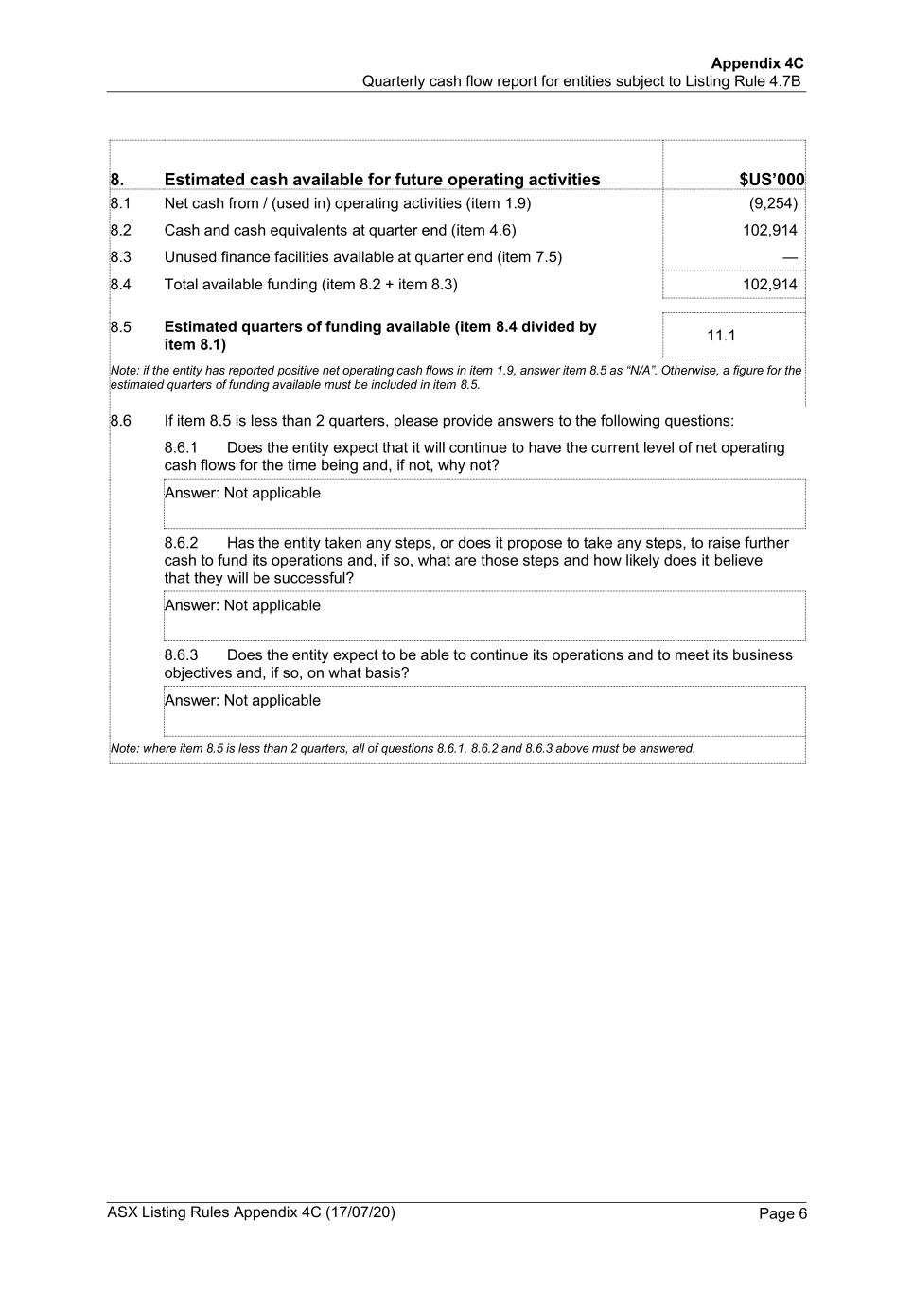
Appendix 4C Quarterly cash flow report for entities subject to Listing Rule 4.7B ASX Listing Rules Appendix 4C (17/07/20) + See chapter 19 of the ASX Listing Rules for defined terms. Page 6 8. Estimated cash available for future operating activities $US’000 8.1 Net cash from / (used in) operating activities (item 1.9) (9,254) 8.2 Cash and cash equivalents at quarter end (item 4.6) 102,914 8.3 Unused finance facilities available at quarter end (item 7.5) — 8.4 Total available funding (item 8.2 + item 8.3) 102,914 8.5 Estimated quarters of funding available (item 8.4 divided by item 8.1) 11.1 Note: if the entity has reported positive net operating cash flows in item 1.9, answer item 8.5 as “N/A”. Otherwise, a figure for the estimated quarters of funding available must be included in item 8.5. 8.6 If item 8.5 is less than 2 quarters, please provide answers to the following questions: 8.6.1 Does the entity expect that it will continue to have the current level of net operating cash flows for the time being and, if not, why not? Answer: Not applicable 8.6.2 Has the entity taken any steps, or does it propose to take any steps, to raise further cash to fund its operations and, if so, what are those steps and how likely does it believe that they will be successful? Answer: Not applicable 8.6.3 Does the entity expect to be able to continue its operations and to meet its business objectives and, if so, on what basis? Answer: Not applicable Note: where item 8.5 is less than 2 quarters, all of questions 8.6.1, 8.6.2 and 8.6.3 above must be answered.

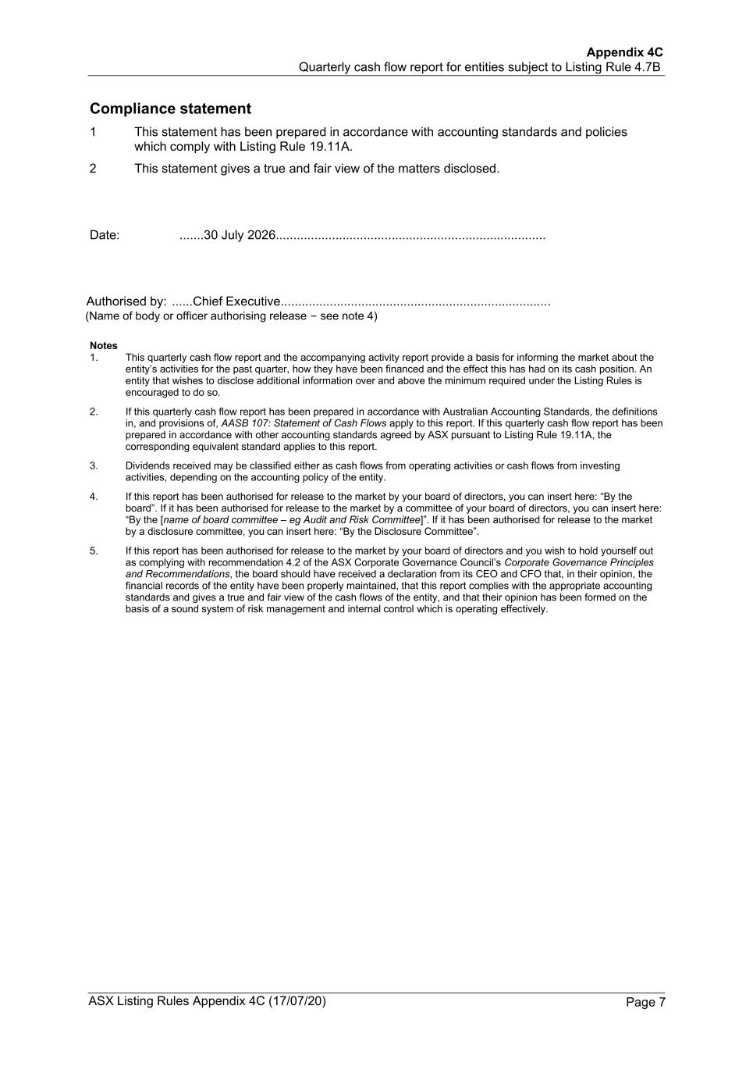
Appendix 4C Quarterly cash flow report for entities subject to Listing Rule 4.7B ASX Listing Rules Appendix 4C (17/07/20) + See chapter 19 of the ASX Listing Rules for defined terms. Page 7 Compliance statement 1 This statement has been prepared in accordance with accounting standards and policies which comply with Listing Rule 19.11A. 2 This statement gives a true and fair view of the matters disclosed. Date: .......30 July 2026............................................................................. Authorised by: ......Chief Executive............................................................................. (Name of body or officer authorising release – see note 4) Notes 1. This quarterly cash flow report and the accompanying activity report provide a basis for informing the market about the entity’s activities for the past quarter, how they have been financed and the effect this has had on its cash position. An entity that wishes to disclose additional information over and above the minimum required under the Listing Rules is encouraged to do so. 2. If this quarterly cash flow report has been prepared in accordance with Australian Accounting Standards, the definitions in, and provisions of, AASB 107: Statement of Cash Flows apply to this report. If this quarterly cash flow report has been prepared in accordance with other accounting standards agreed by ASX pursuant to Listing Rule 19.11A, the corresponding equivalent standard applies to this report. 3. Dividends received may be classified either as cash flows from operating activities or cash flows from investing activities, depending on the accounting policy of the entity. 4. If this report has been authorised for release to the market by your board of directors, you can insert here: “By the board”. If it has been authorised for release to the market by a committee of your board of directors, you can insert here: “By the [name of board committee – eg Audit and Risk Committee]”. If it has been authorised for release to the market by a disclosure committee, you can insert here: “By the Disclosure Committee”. 5. If this report has been authorised for release to the market by your board of directors and you wish to hold yourself out as complying with recommendation 4.2 of the ASX Corporate Governance Council’s Corporate Governance Principles and Recommendations, the board should have received a declaration from its CEO and CFO that, in their opinion, the financial records of the entity have been properly maintained, that this report complies with the appropriate accounting standards and gives a true and fair view of the cash flows of the entity, and that their opinion has been formed on the basis of a sound system of risk management and internal control which is operating effectively.

