UNITED STATES
SECURITIES AND EXCHANGE COMMISSION
Washington, D.C. 20549
Form 6-K
Report of Foreign Private Issuer
Pursuant to Rule 13a-16 or 15d-16 under the Securities Exchange Act of 1934
For the month of August 2026
Commission File Number 001-37626
Mesoblast Limited
(Exact name of Registrant as specified in its charter)
Not Applicable
(Translation of Registrant’s name into English)
Australia
(Jurisdiction of incorporation or organization)

Silviu Itescu
Chief Executive Officer and Executive Director
Level 38
55 Collins Street
Melbourne 3000
Australia
(Address of principal executive offices)

Indicate by check mark whether the registrant files or will file annual reports under cover Form 20-F or Form 40-F:
Form 20-F ☑ Form 40-F ☐

INFORMATION CONTAINED ON THIS REPORT ON FORM 6-K
On August 24, 2026, Mesoblast Limited filed with the Australian Securities Exchange a new issue announcement, change of director’s interest notice (Appendix 3Y) which is attached hereto as Exhibit 99.1, and is incorporated herein by reference.
On August 24, 2026, Mesoblast Limited filed with the Australian Securities Exchange a new issue announcement, notification of issue, conversion or payment up of unquoted equity securities (Appendix 3G) which is attached hereto as Exhibit 99.2, and is incorporated herein by reference.

SIGNATURES
Pursuant to the requirements of the Securities Exchange Act of 1934, the registrant has duly caused this report to be signed on its behalf by the undersigned, thereunto duly organized.
Mesoblast Limited
/s/ Niva Sivakumar
Niva Sivakumar
Company Secretary
Dated: August 25, 2026

INDEX TO EXHIBITS
Item
99.1 |  |  |  |  |  | Appendix 3Y of Mesoblast Ltd, dated August 24, 2026.
99.2 |  |  |  |  |  | Appendix 3G of Mesoblast Ltd, dated August 24, 2026.

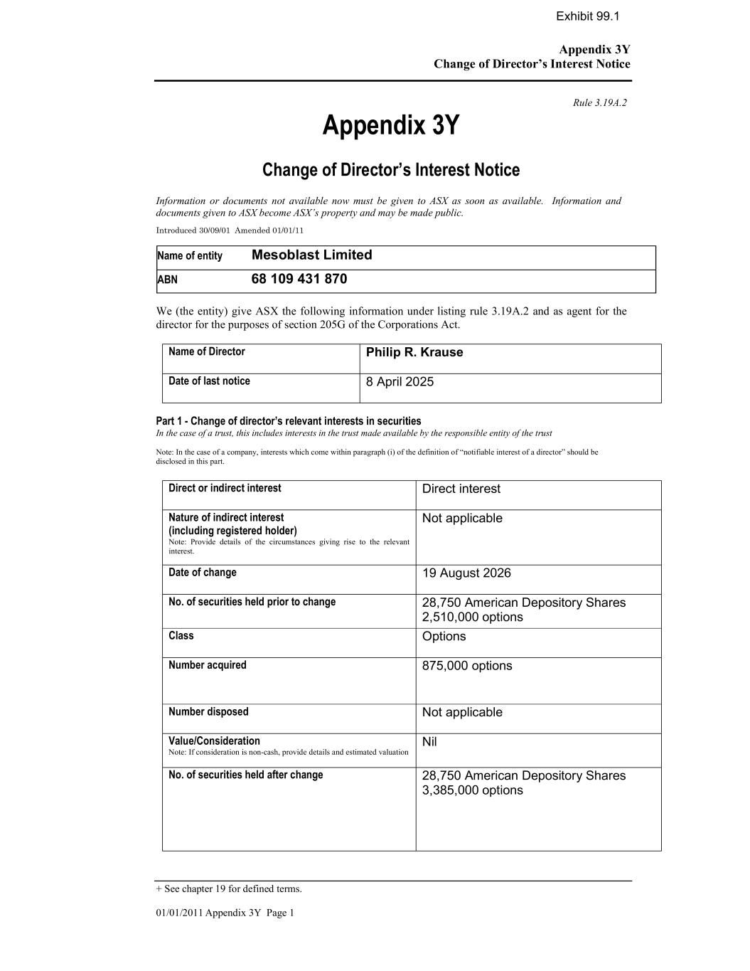

Appendix 3Y Change of Director’s Interest Notice + See chapter 19 for defined terms. 01/01/2011 Appendix 3Y Page 1 Rule 3.19A.2 Appendix 3Y Change of Director’s Interest Notice Information or documents not available now must be given to ASX as soon as available. Information and documents given to ASX become ASX’s property and may be made public. Introduced 30/09/01 Amended 01/01/11 Name of entity Mesoblast Limited ABN 68 109 431 870 We (the entity) give ASX the following information under listing rule 3.19A.2 and as agent for the director for the purposes of section 205G of the Corporations Act. Name of Director Philip R. Krause Date of last notice 8 April 2025 Part 1 - Change of director’s relevant interests in securities In the case of a trust, this includes interests in the trust made available by the responsible entity of the trust Note: In the case of a company, interests which come within paragraph (i) of the definition of “notifiable interest of a director” should be disclosed in this part. Direct or indirect interest Direct interest Nature of indirect interest (including registered holder) Note: Provide details of the circumstances giving rise to the relevant interest. Not applicable Date of change 19 August 2026 No. of securities held prior to change 28,750 American Depository Shares 2,510,000 options Class Options Number acquired 875,000 options Number disposed Not applicable Value/Consideration Note: If consideration is non-cash, provide details and estimated valuation Nil No. of securities held after change 28,750 American Depository Shares 3,385,000 options Exhibit 99.1

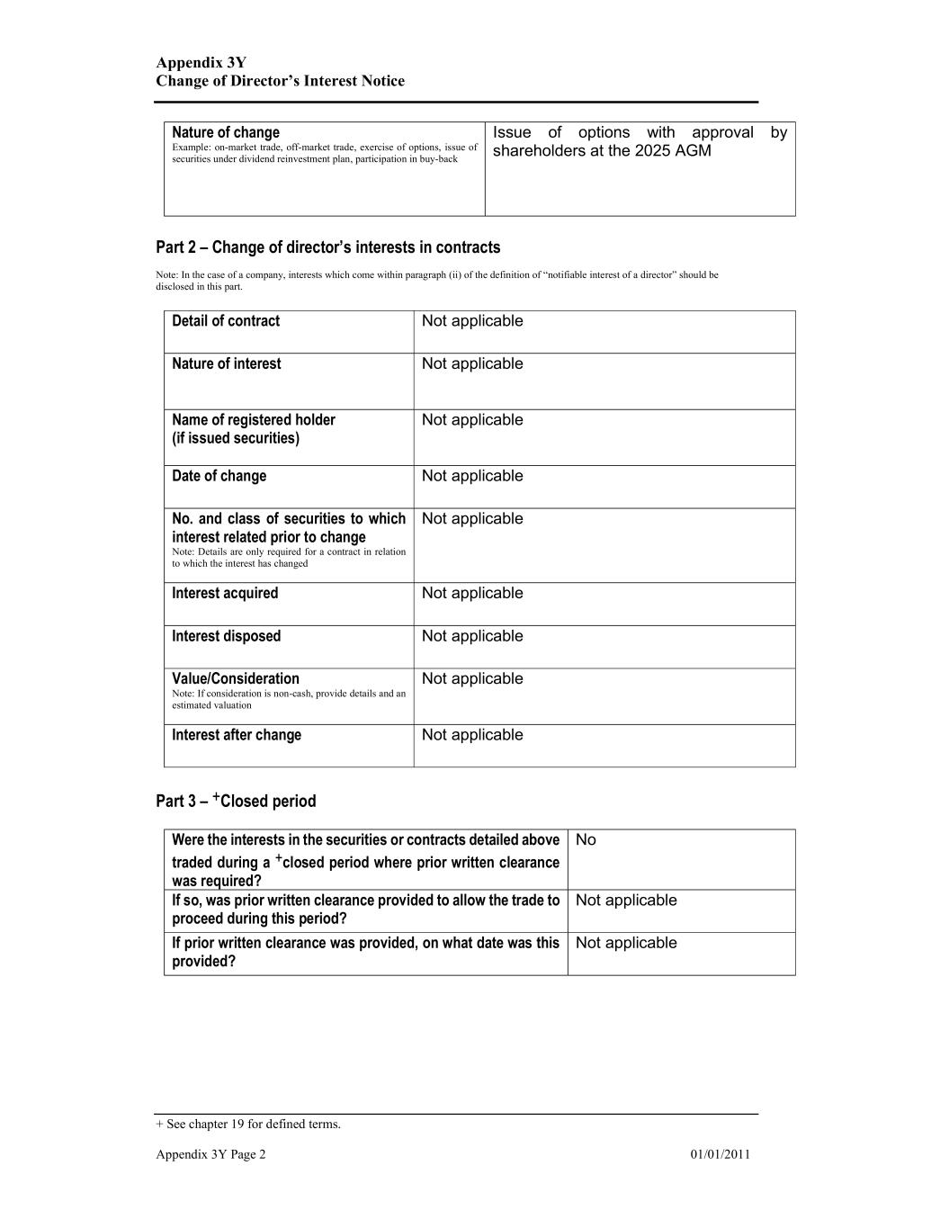
Appendix 3Y Change of Director’s Interest Notice + See chapter 19 for defined terms. Appendix 3Y Page 2 01/01/2011 Nature of change Example: on-market trade, off-market trade, exercise of options, issue of securities under dividend reinvestment plan, participation in buy-back Issue of options with approval by shareholders at the 2025 AGM Part 2 – Change of director’s interests in contracts Note: In the case of a company, interests which come within paragraph (ii) of the definition of “notifiable interest of a director” should be disclosed in this part. Detail of contract Not applicable Nature of interest Not applicable Name of registered holder (if issued securities) Not applicable Date of change Not applicable No. and class of securities to which interest related prior to change Note: Details are only required for a contract in relation to which the interest has changed Not applicable Interest acquired Not applicable Interest disposed Not applicable Value/Consideration Note: If consideration is non-cash, provide details and an estimated valuation Not applicable Interest after change Not applicable Part 3 – +Closed period Were the interests in the securities or contracts detailed above traded during a +closed period where prior written clearance was required? No If so, was prior written clearance provided to allow the trade to proceed during this period? Not applicable If prior written clearance was provided, on what date was this provided? Not applicable

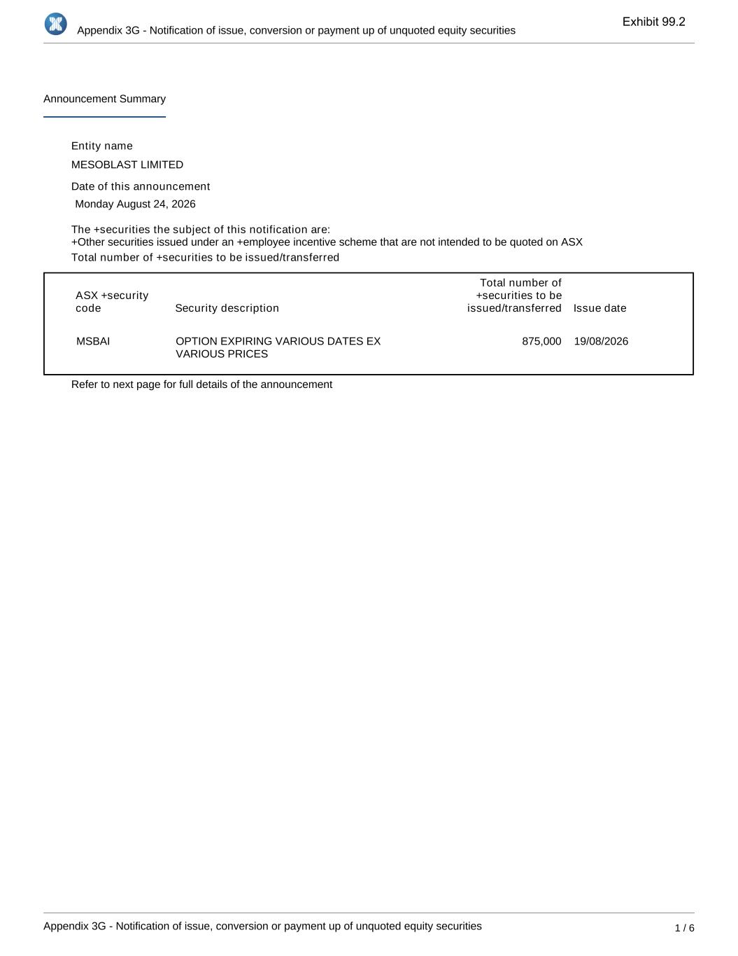
Appendix 3G - Notification of issue, conversion or payment up of unquoted equity securities Appendix 3G - Notification of issue, conversion or payment up of unquoted equity securities 1 / 6 Announcement Summary Entity name MESOBLAST LIMITED Date of this announcement Monday August 24, 2026 The +securities the subject of this notification are: Total number of +securities to be issued/transferred ASX +security code Security description Total number of +securities to be issued/transferred Issue date MSBAI OPTION EXPIRING VARIOUS DATES EX VARIOUS PRICES 875,000 19/08/2026 Refer to next page for full details of the announcement +Other securities issued under an +employee incentive scheme that are not intended to be quoted on ASX Exhibit 99.2

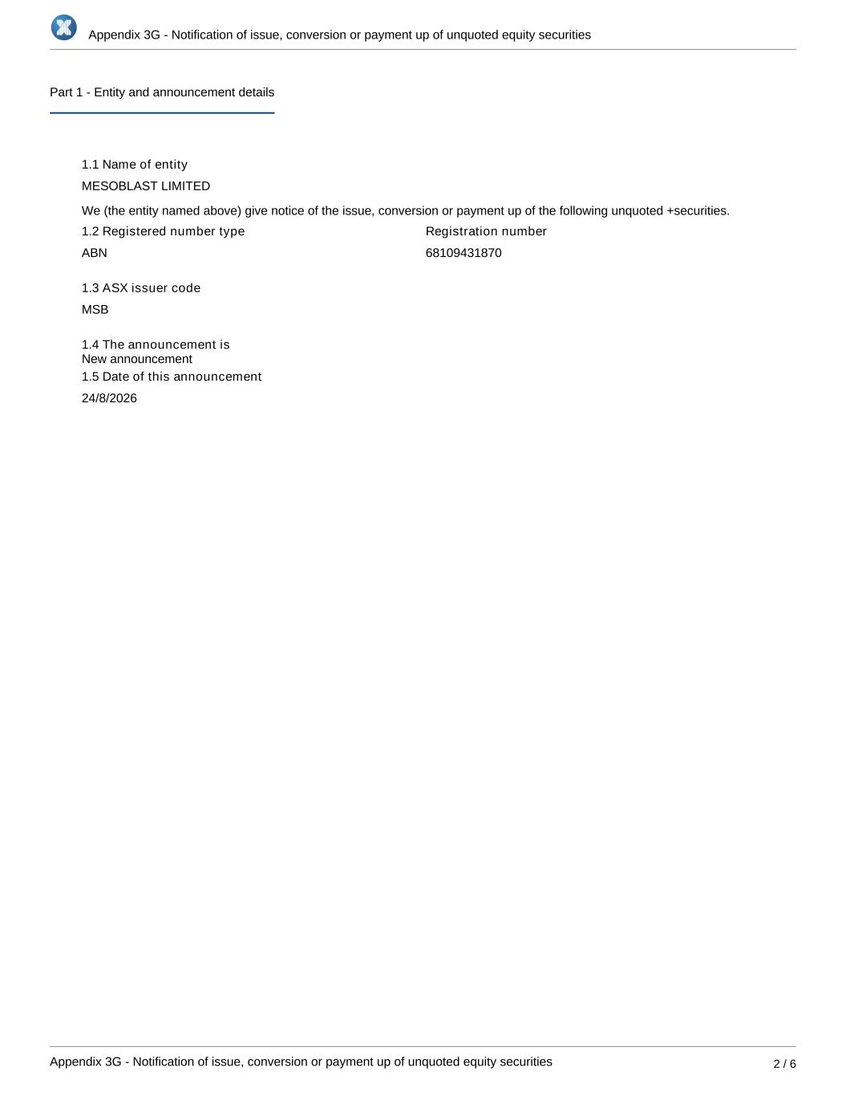
Appendix 3G - Notification of issue, conversion or payment up of unquoted equity securities Appendix 3G - Notification of issue, conversion or payment up of unquoted equity securities 2 / 6 Part 1 - Entity and announcement details 1.1 Name of entity MESOBLAST LIMITED We (the entity named above) give notice of the issue, conversion or payment up of the following unquoted +securities. 1.2 Registered number type ABN Registration number 68109431870 1.3 ASX issuer code MSB 1.4 The announcement is 1.5 Date of this announcement 24/8/2026 New announcement

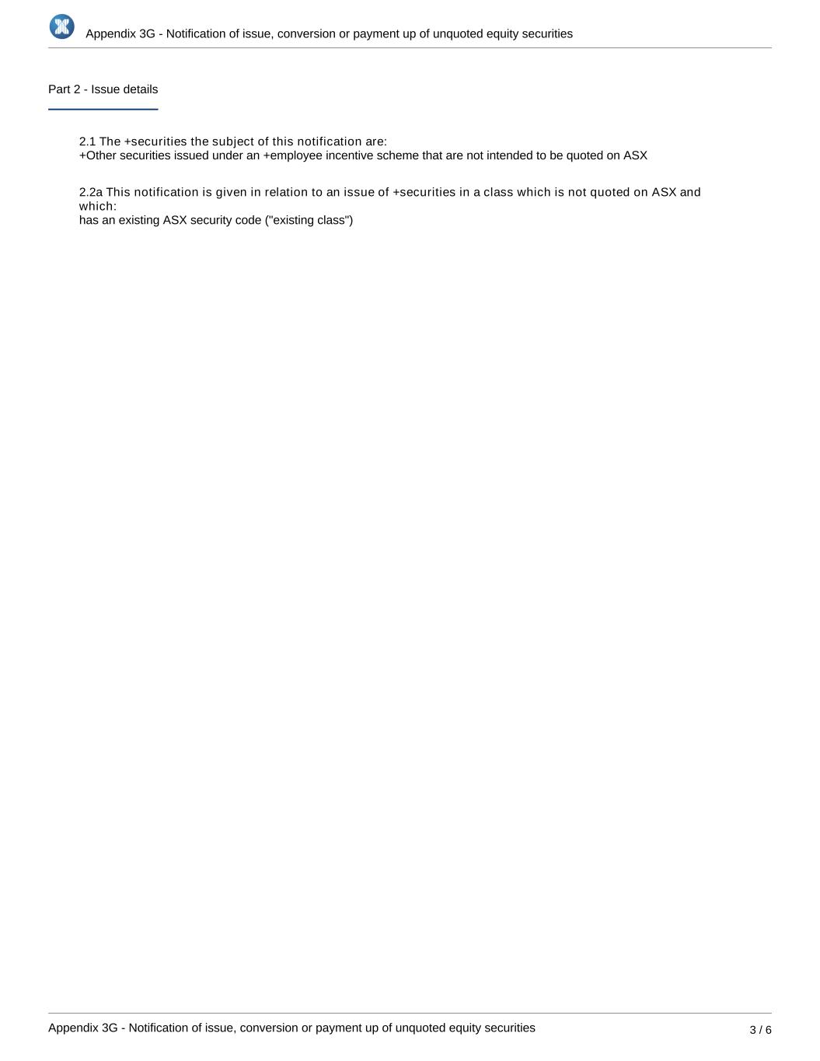
Appendix 3G - Notification of issue, conversion or payment up of unquoted equity securities Appendix 3G - Notification of issue, conversion or payment up of unquoted equity securities 3 / 6 Part 2 - Issue details 2.1 The +securities the subject of this notification are: 2.2a This notification is given in relation to an issue of +securities in a class which is not quoted on ASX and which: has an existing ASX security code ("existing class") +Other securities issued under an +employee incentive scheme that are not intended to be quoted on ASX

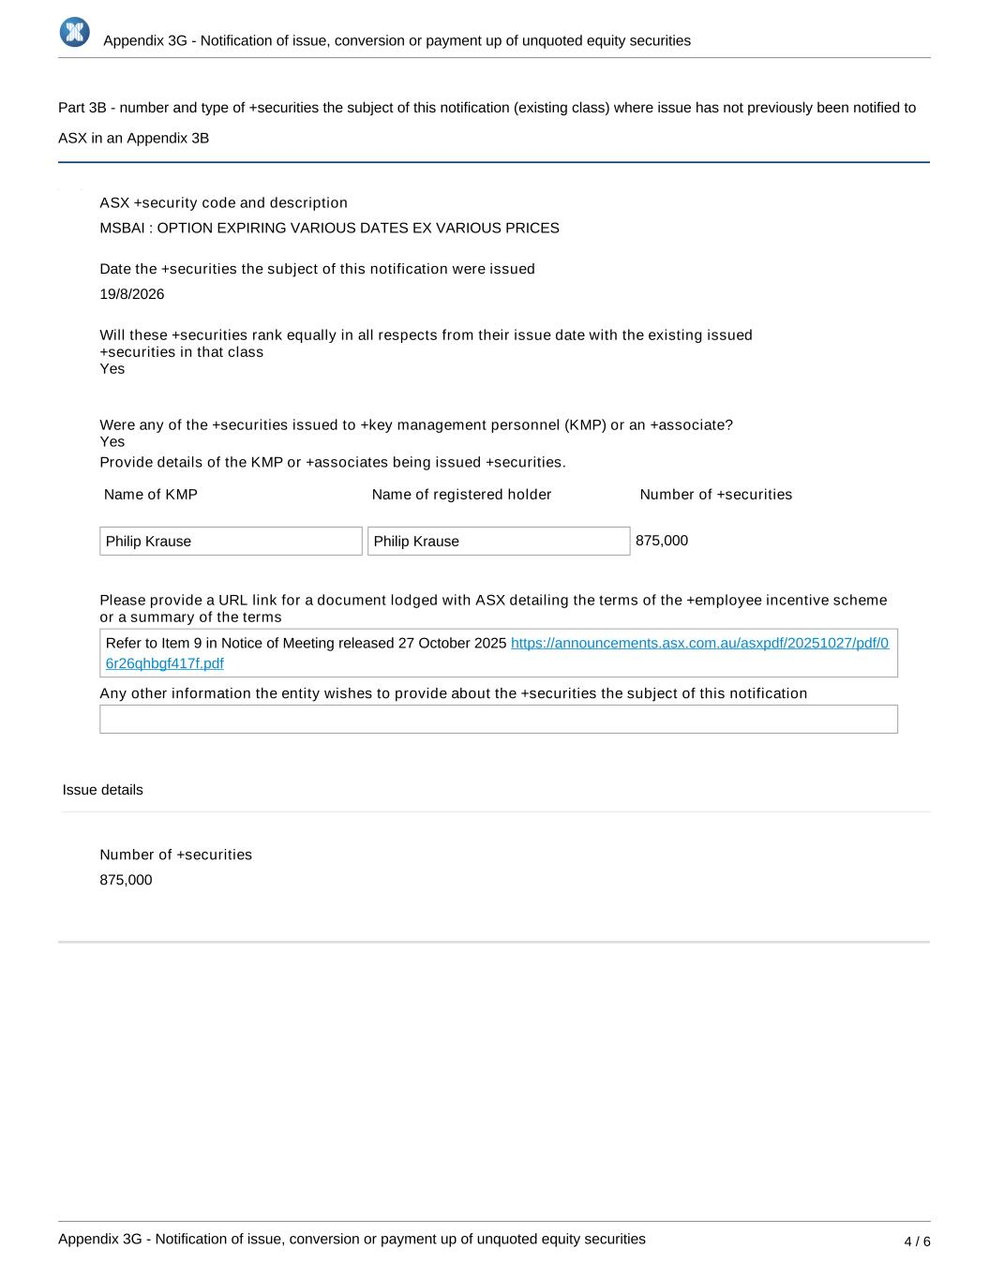
Appendix 3G - Notification of issue, conversion or payment up of unquoted equity securities Appendix 3G - Notification of issue, conversion or payment up of unquoted equity securities 4 / 6 Part 3B - number and type of +securities the subject of this notification (existing class) where issue has not previously been notified to ASX in an Appendix 3B ASX +security code and description MSBAI : OPTION EXPIRING VARIOUS DATES EX VARIOUS PRICES Date the +securities the subject of this notification were issued 19/8/2026 Will these +securities rank equally in all respects from their issue date with the existing issued +securities in that class Were any of the +securities issued to +key management personnel (KMP) or an +associate? Provide details of the KMP or +associates being issued +securities. Name of KMP Name of registered holder Number of +securities Philip Krause Philip Krause 875,000 Please provide a URL link for a document lodged with ASX detailing the terms of the +employee incentive scheme or a summary of the terms Refer to Item 9 in Notice of Meeting released 27 October 2025 https://announcements.asx.com.au/asxpdf/20251027/pdf/0 6r26qhbgf417f.pdf Any other information the entity wishes to provide about the +securities the subject of this notification Issue details Number of +securities 875,000 Yes Yes

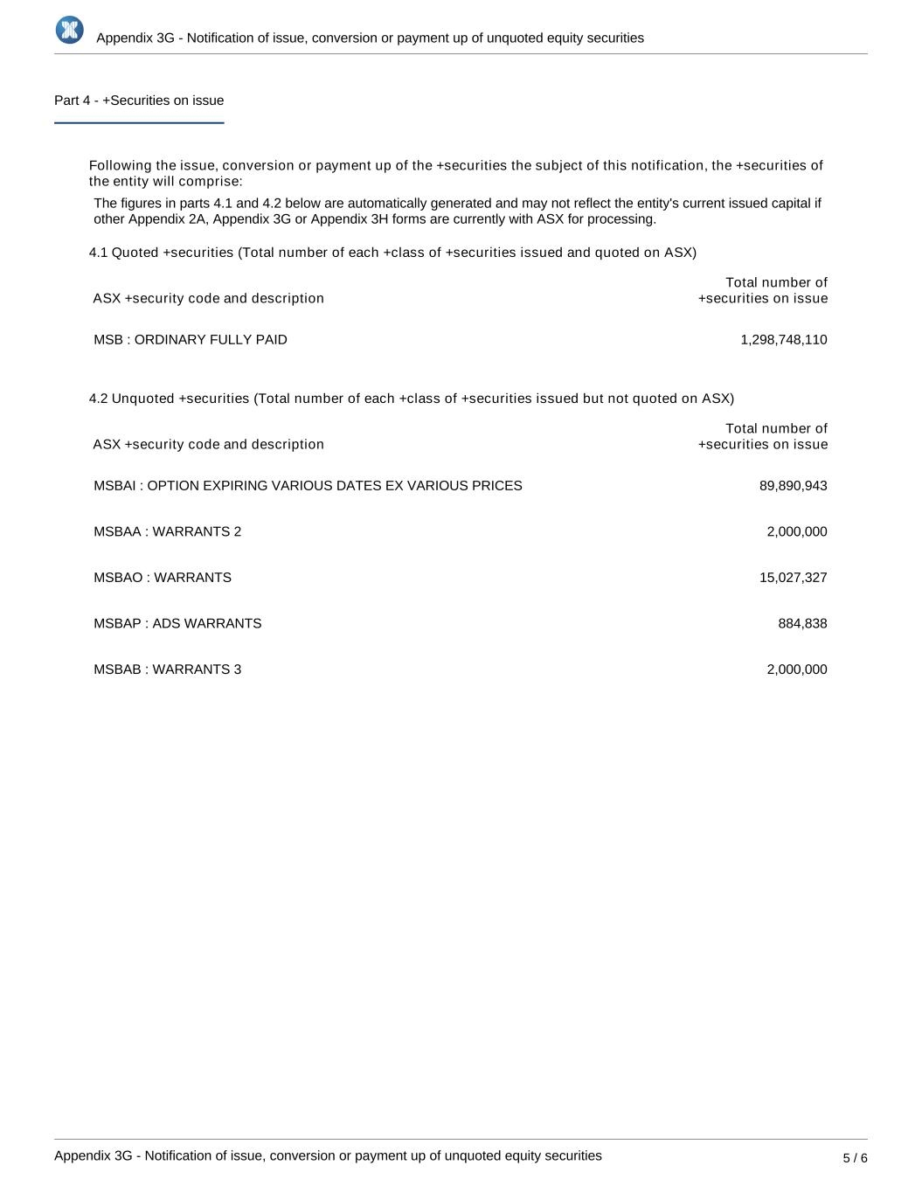
Appendix 3G - Notification of issue, conversion or payment up of unquoted equity securities Appendix 3G - Notification of issue, conversion or payment up of unquoted equity securities 5 / 6 Part 4 - +Securities on issue Following the issue, conversion or payment up of the +securities the subject of this notification, the +securities of the entity will comprise: The figures in parts 4.1 and 4.2 below are automatically generated and may not reflect the entity's current issued capital if other Appendix 2A, Appendix 3G or Appendix 3H forms are currently with ASX for processing. 4.1 Quoted +securities (Total number of each +class of +securities issued and quoted on ASX) ASX +security code and description Total number of +securities on issue MSB : ORDINARY FULLY PAID 1,298,748,110 4.2 Unquoted +securities (Total number of each +class of +securities issued but not quoted on ASX) ASX +security code and description Total number of +securities on issue MSBAI : OPTION EXPIRING VARIOUS DATES EX VARIOUS PRICES 89,890,943 MSBAA : WARRANTS 2 2,000,000 MSBAO : WARRANTS 15,027,327 MSBAP : ADS WARRANTS 884,838 MSBAB : WARRANTS 3 2,000,000

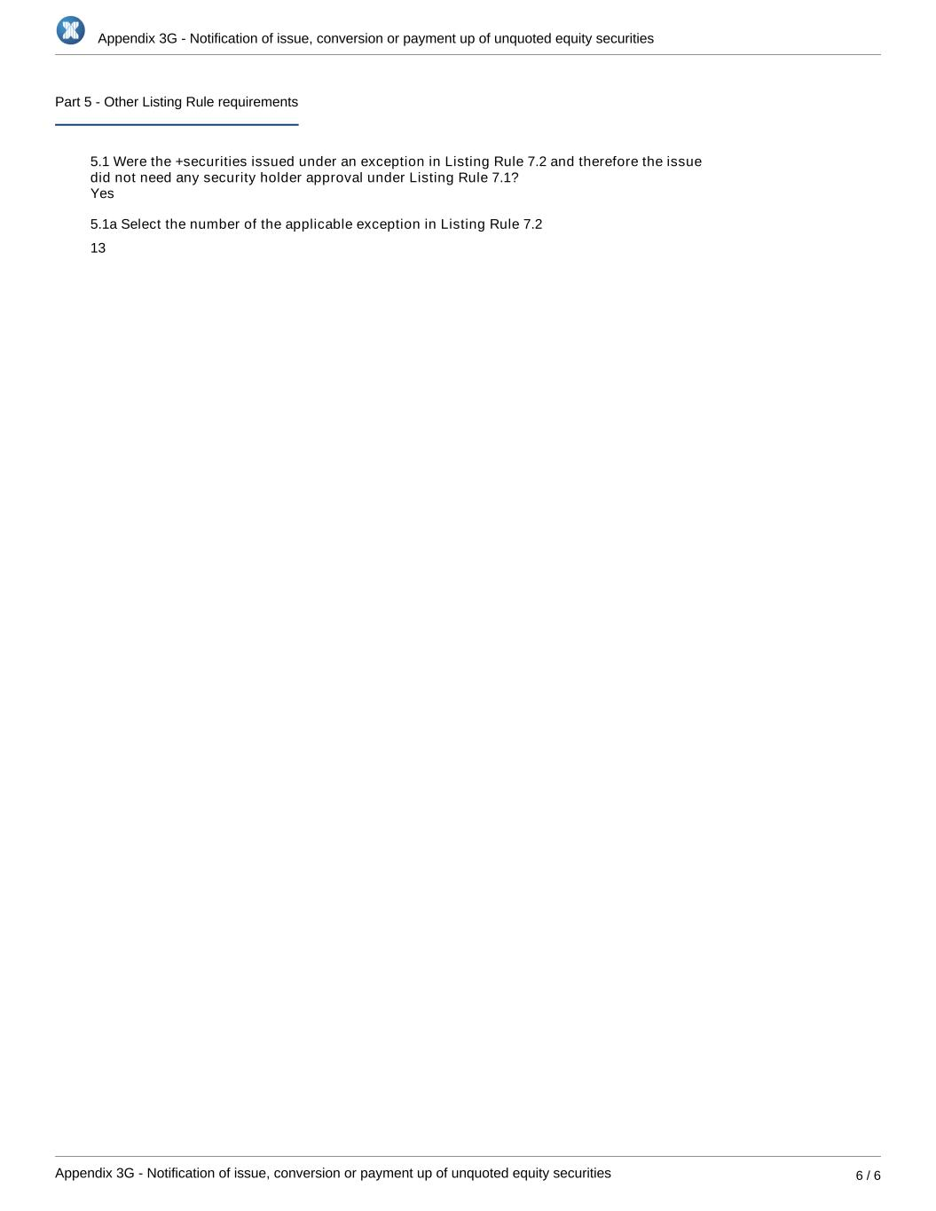
Appendix 3G - Notification of issue, conversion or payment up of unquoted equity securities Appendix 3G - Notification of issue, conversion or payment up of unquoted equity securities 6 / 6 Part 5 - Other Listing Rule requirements 5.1 Were the +securities issued under an exception in Listing Rule 7.2 and therefore the issue did not need any security holder approval under Listing Rule 7.1? 5.1a Select the number of the applicable exception in Listing Rule 7.2 13 Yes

