UNITED STATES
SECURITIES AND EXCHANGE COMMISSION
Washington, D.C. 20549
Form 6-K
Report of Foreign Private Issuer
Pursuant to Rule 13a-16 or 15d-16 under the Securities Exchange Act of 1934
For the month of July 2026
Commission File Number 001-37626
Mesoblast Limited
(Exact name of Registrant as specified in its charter)
Not Applicable
(Translation of Registrant’s name into English)
Australia
(Jurisdiction of incorporation or organization)

Silviu Itescu
Chief Executive Officer and Executive Director
Level 38
55 Collins Street
Melbourne 3000
Australia
(Address of principal executive offices)

Indicate by check mark whether the registrant files or will file annual reports under cover Form 20-F or Form 40-F:
Form 20-F ☑ Form 40-F ☐

INFORMATION CONTAINED ON THIS REPORT ON FORM 6-K
On July 1, 2026, Mesoblast Limited filed with the Australian Securities Exchange a new release announcement, which is attached hereto as Exhibit 99.1, and is incorporated herein by reference.

SIGNATURES
Pursuant to the requirements of the Securities Exchange Act of 1934, the registrant has duly caused this report to be signed on its behalf by the undersigned, thereunto duly organized.
Mesoblast Limited
/s/ Paul Hughes
Paul Hughes
Company Secretary
Dated: July 1, 2026

INDEX TO EXHIBITS
Item
99.1 |  |  |  |  |  | Press release of Mesoblast Ltd, dated July 1, 2026.

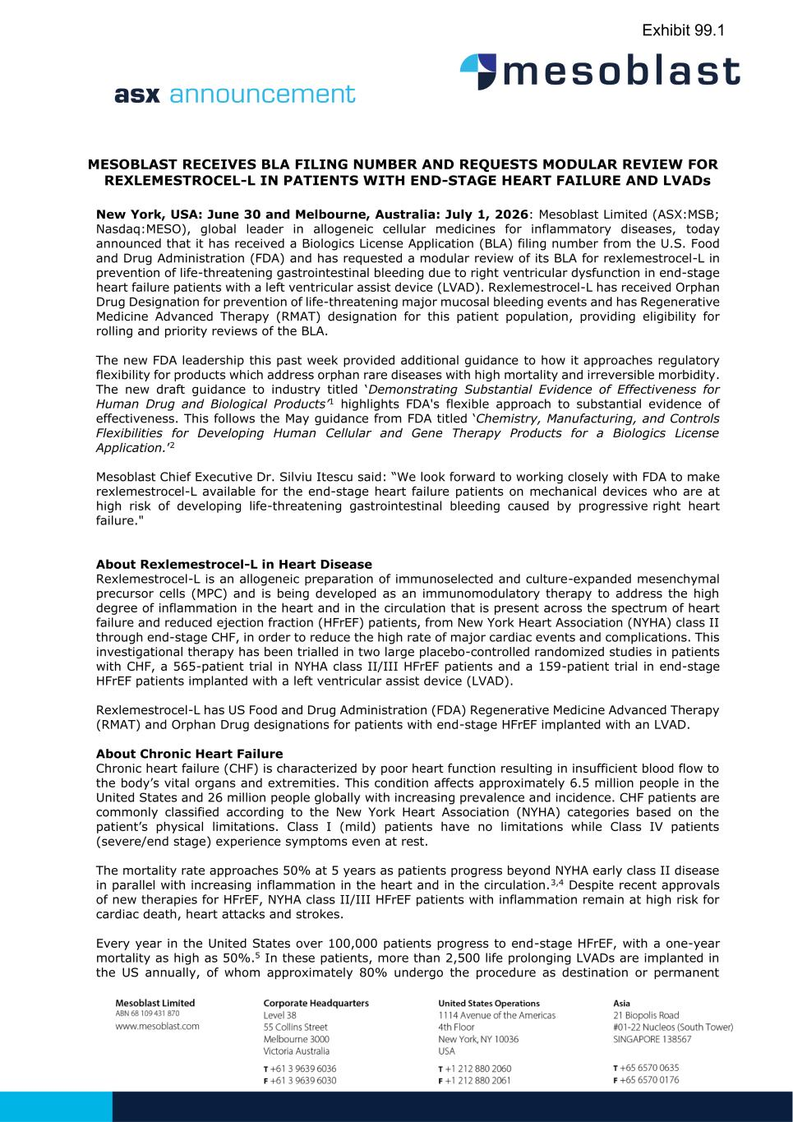

MESOBLAST RECEIVES BLA FILING NUMBER AND REQUESTS MODULAR REVIEW FOR REXLEMESTROCEL-L IN PATIENTS WITH END-STAGE HEART FAILURE AND LVADs New York, USA: June 30 and Melbourne, Australia: July 1, 2026: Mesoblast Limited (ASX:MSB; Nasdaq:MESO), global leader in allogeneic cellular medicines for inflammatory diseases, today announced that it has received a Biologics License Application (BLA) filing number from the U.S. Food and Drug Administration (FDA) and has requested a modular review of its BLA for rexlemestrocel-L in prevention of life-threatening gastrointestinal bleeding due to right ventricular dysfunction in end-stage heart failure patients with a left ventricular assist device (LVAD). Rexlemestrocel-L has received Orphan Drug Designation for prevention of life-threatening major mucosal bleeding events and has Regenerative Medicine Advanced Therapy (RMAT) designation for this patient population, providing eligibility for rolling and priority reviews of the BLA. The new FDA leadership this past week provided additional guidance to how it approaches regulatory flexibility for products which address orphan rare diseases with high mortality and irreversible morbidity. The new draft guidance to industry titled ‘Demonstrating Substantial Evidence of Effectiveness for Human Drug and Biological Products’1 highlights FDA's flexible approach to substantial evidence of effectiveness. This follows the May guidance from FDA titled ‘Chemistry, Manufacturing, and Controls Flexibilities for Developing Human Cellular and Gene Therapy Products for a Biologics License Application.’2 Mesoblast Chief Executive Dr. Silviu Itescu said: “We look forward to working closely with FDA to make rexlemestrocel-L available for the end-stage heart failure patients on mechanical devices who are at high risk of developing life-threatening gastrointestinal bleeding caused by progressive right heart failure." About Rexlemestrocel-L in Heart Disease Rexlemestrocel-L is an allogeneic preparation of immunoselected and culture-expanded mesenchymal precursor cells (MPC) and is being developed as an immunomodulatory therapy to address the high degree of inflammation in the heart and in the circulation that is present across the spectrum of heart failure and reduced ejection fraction (HFrEF) patients, from New York Heart Association (NYHA) class II through end-stage CHF, in order to reduce the high rate of major cardiac events and complications. This investigational therapy has been trialled in two large placebo-controlled randomized studies in patients with CHF, a 565-patient trial in NYHA class II/III HFrEF patients and a 159-patient trial in end-stage HFrEF patients implanted with a left ventricular assist device (LVAD). Rexlemestrocel-L has US Food and Drug Administration (FDA) Regenerative Medicine Advanced Therapy (RMAT) and Orphan Drug designations for patients with end-stage HFrEF implanted with an LVAD. About Chronic Heart Failure Chronic heart failure (CHF) is characterized by poor heart function resulting in insufficient blood flow to the body’s vital organs and extremities. This condition affects approximately 6.5 million people in the United States and 26 million people globally with increasing prevalence and incidence. CHF patients are commonly classified according to the New York Heart Association (NYHA) categories based on the patient’s physical limitations. Class I (mild) patients have no limitations while Class IV patients (severe/end stage) experience symptoms even at rest. The mortality rate approaches 50% at 5 years as patients progress beyond NYHA early class II disease in parallel with increasing inflammation in the heart and in the circulation.3,4 Despite recent approvals of new therapies for HFrEF, NYHA class II/III HFrEF patients with inflammation remain at high risk for cardiac death, heart attacks and strokes. Every year in the United States over 100,000 patients progress to end-stage HFrEF, with a one-year mortality as high as 50%.5 In these patients, more than 2,500 life prolonging LVADs are implanted in the US annually, of whom approximately 80% undergo the procedure as destination or permanent Exhibit 99.1

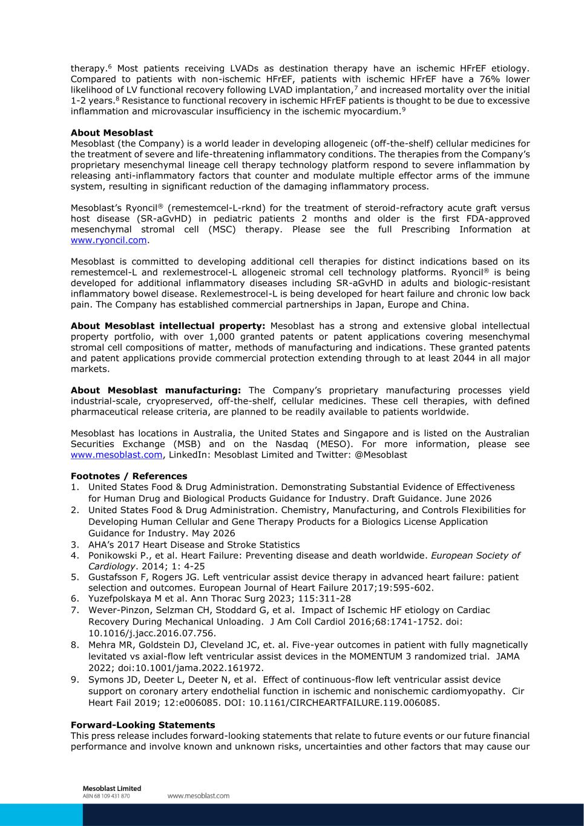
therapy.6 Most patients receiving LVADs as destination therapy have an ischemic HFrEF etiology. Compared to patients with non-ischemic HFrEF, patients with ischemic HFrEF have a 76% lower likelihood of LV functional recovery following LVAD implantation,7 and increased mortality over the initial 1-2 years.8 Resistance to functional recovery in ischemic HFrEF patients is thought to be due to excessive inflammation and microvascular insufficiency in the ischemic myocardium.9 About Mesoblast Mesoblast (the Company) is a world leader in developing allogeneic (off-the-shelf) cellular medicines for the treatment of severe and life-threatening inflammatory conditions. The therapies from the Company’s proprietary mesenchymal lineage cell therapy technology platform respond to severe inflammation by releasing anti-inflammatory factors that counter and modulate multiple effector arms of the immune system, resulting in significant reduction of the damaging inflammatory process. Mesoblast’s Ryoncil® (remestemcel-L-rknd) for the treatment of steroid-refractory acute graft versus host disease (SR-aGvHD) in pediatric patients 2 months and older is the first FDA-approved mesenchymal stromal cell (MSC) therapy. Please see the full Prescribing Information at www.ryoncil.com. Mesoblast is committed to developing additional cell therapies for distinct indications based on its remestemcel-L and rexlemestrocel-L allogeneic stromal cell technology platforms. Ryoncil® is being developed for additional inflammatory diseases including SR-aGvHD in adults and biologic-resistant inflammatory bowel disease. Rexlemestrocel-L is being developed for heart failure and chronic low back pain. The Company has established commercial partnerships in Japan, Europe and China. About Mesoblast intellectual property: Mesoblast has a strong and extensive global intellectual property portfolio, with over 1,000 granted patents or patent applications covering mesenchymal stromal cell compositions of matter, methods of manufacturing and indications. These granted patents and patent applications provide commercial protection extending through to at least 2044 in all major markets. About Mesoblast manufacturing: The Company’s proprietary manufacturing processes yield industrial-scale, cryopreserved, off-the-shelf, cellular medicines. These cell therapies, with defined pharmaceutical release criteria, are planned to be readily available to patients worldwide. Mesoblast has locations in Australia, the United States and Singapore and is listed on the Australian Securities Exchange (MSB) and on the Nasdaq (MESO). For more information, please see www.mesoblast.com, LinkedIn: Mesoblast Limited and Twitter: @Mesoblast Footnotes / References 1. United States Food & Drug Administration. Demonstrating Substantial Evidence of Effectiveness for Human Drug and Biological Products Guidance for Industry. Draft Guidance. June 2026 2. United States Food & Drug Administration. Chemistry, Manufacturing, and Controls Flexibilities for Developing Human Cellular and Gene Therapy Products for a Biologics License Application Guidance for Industry. May 2026 3. AHA’s 2017 Heart Disease and Stroke Statistics 4. Ponikowski P., et al. Heart Failure: Preventing disease and death worldwide. European Society of Cardiology. 2014; 1: 4-25 5. Gustafsson F, Rogers JG. Left ventricular assist device therapy in advanced heart failure: patient selection and outcomes. European Journal of Heart Failure 2017;19:595-602. 6. Yuzefpolskaya M et al. Ann Thorac Surg 2023; 115:311-28 7. Wever-Pinzon, Selzman CH, Stoddard G, et al. Impact of Ischemic HF etiology on Cardiac Recovery During Mechanical Unloading. J Am Coll Cardiol 2016;68:1741-1752. doi: 10.1016/j.jacc.2016.07.756. 8. Mehra MR, Goldstein DJ, Cleveland JC, et. al. Five-year outcomes in patient with fully magnetically levitated vs axial-flow left ventricular assist devices in the MOMENTUM 3 randomized trial. JAMA 2022; doi:10.1001/jama.2022.161972. 9. Symons JD, Deeter L, Deeter N, et al. Effect of continuous-flow left ventricular assist device support on coronary artery endothelial function in ischemic and nonischemic cardiomyopathy. Cir Heart Fail 2019; 12:e006085. DOI: 10.1161/CIRCHEARTFAILURE.119.006085. Forward-Looking Statements This press release includes forward-looking statements that relate to future events or our future financial performance and involve known and unknown risks, uncertainties and other factors that may cause our

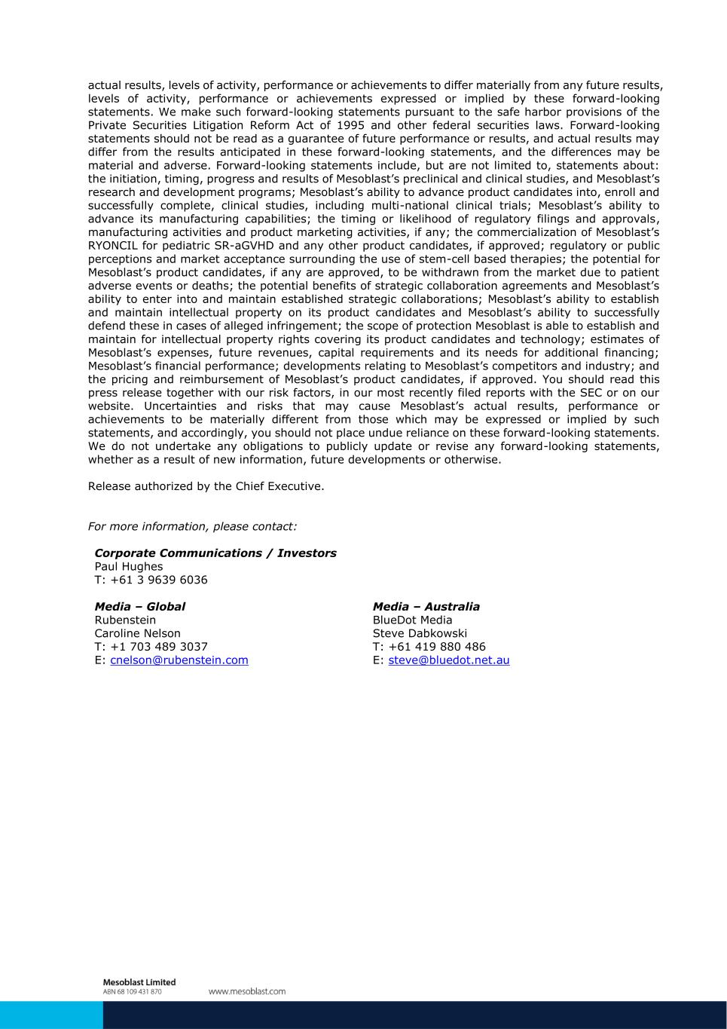
actual results, levels of activity, performance or achievements to differ materially from any future results, levels of activity, performance or achievements expressed or implied by these forward-looking statements. We make such forward-looking statements pursuant to the safe harbor provisions of the Private Securities Litigation Reform Act of 1995 and other federal securities laws. Forward-looking statements should not be read as a guarantee of future performance or results, and actual results may differ from the results anticipated in these forward-looking statements, and the differences may be material and adverse. Forward-looking statements include, but are not limited to, statements about: the initiation, timing, progress and results of Mesoblast’s preclinical and clinical studies, and Mesoblast’s research and development programs; Mesoblast’s ability to advance product candidates into, enroll and successfully complete, clinical studies, including multi-national clinical trials; Mesoblast’s ability to advance its manufacturing capabilities; the timing or likelihood of regulatory filings and approvals, manufacturing activities and product marketing activities, if any; the commercialization of Mesoblast’s RYONCIL for pediatric SR-aGVHD and any other product candidates, if approved; regulatory or public perceptions and market acceptance surrounding the use of stem-cell based therapies; the potential for Mesoblast’s product candidates, if any are approved, to be withdrawn from the market due to patient adverse events or deaths; the potential benefits of strategic collaboration agreements and Mesoblast’s ability to enter into and maintain established strategic collaborations; Mesoblast’s ability to establish and maintain intellectual property on its product candidates and Mesoblast’s ability to successfully defend these in cases of alleged infringement; the scope of protection Mesoblast is able to establish and maintain for intellectual property rights covering its product candidates and technology; estimates of Mesoblast’s expenses, future revenues, capital requirements and its needs for additional financing; Mesoblast’s financial performance; developments relating to Mesoblast’s competitors and industry; and the pricing and reimbursement of Mesoblast’s product candidates, if approved. You should read this press release together with our risk factors, in our most recently filed reports with the SEC or on our website. Uncertainties and risks that may cause Mesoblast’s actual results, performance or achievements to be materially different from those which may be expressed or implied by such statements, and accordingly, you should not place undue reliance on these forward-looking statements. We do not undertake any obligations to publicly update or revise any forward-looking statements, whether as a result of new information, future developments or otherwise. Release authorized by the Chief Executive. For more information, please contact: Corporate Communications / Investors Paul Hughes T: +61 3 9639 6036 Media – Global Media – Australia Rubenstein BlueDot Media Caroline Nelson Steve Dabkowski T: +1 703 489 3037 T: +61 419 880 486 E: cnelson@rubenstein.com E: steve@bluedot.net.au

