UNITED STATES
SECURITIES AND EXCHANGE COMMISSION
Washington, D.C. 20549
Form 6-K
Report of Foreign Private Issuer
Pursuant to Rule 13a-16 or 15d-16 under the Securities Exchange Act of 1934
For the month of August 2026
Commission File Number 001-37626
Mesoblast Limited
(Exact name of Registrant as specified in its charter)
Not Applicable
(Translation of Registrant’s name into English)
Australia
(Jurisdiction of incorporation or organization)

Silviu Itescu
Chief Executive Officer and Executive Director
Level 38
55 Collins Street
Melbourne 3000
Australia
(Address of principal executive offices)

Indicate by check mark whether the registrant files or will file annual reports under cover Form 20-F or Form 40-F:
Form 20-F ☑ Form 40-F ☐

INFORMATION CONTAINED ON THIS REPORT ON FORM 6-K
On August 24, 2026, Mesoblast Limited filed with the Australian Securities Exchange a new release announcement, which is attached hereto as Exhibit 99.1, and is incorporated herein by reference.

SIGNATURES
Pursuant to the requirements of the Securities Exchange Act of 1934, the registrant has duly caused this report to be signed on its behalf by the undersigned, thereunto duly organized.
Mesoblast Limited
/s/ Paul Hughes
Paul Hughes
Company Secretary
Dated: August 24, 2026

INDEX TO EXHIBITS
Item
99.1 |  |  |  |  |  | Press release of Mesoblast Ltd, dated August 24, 2026.

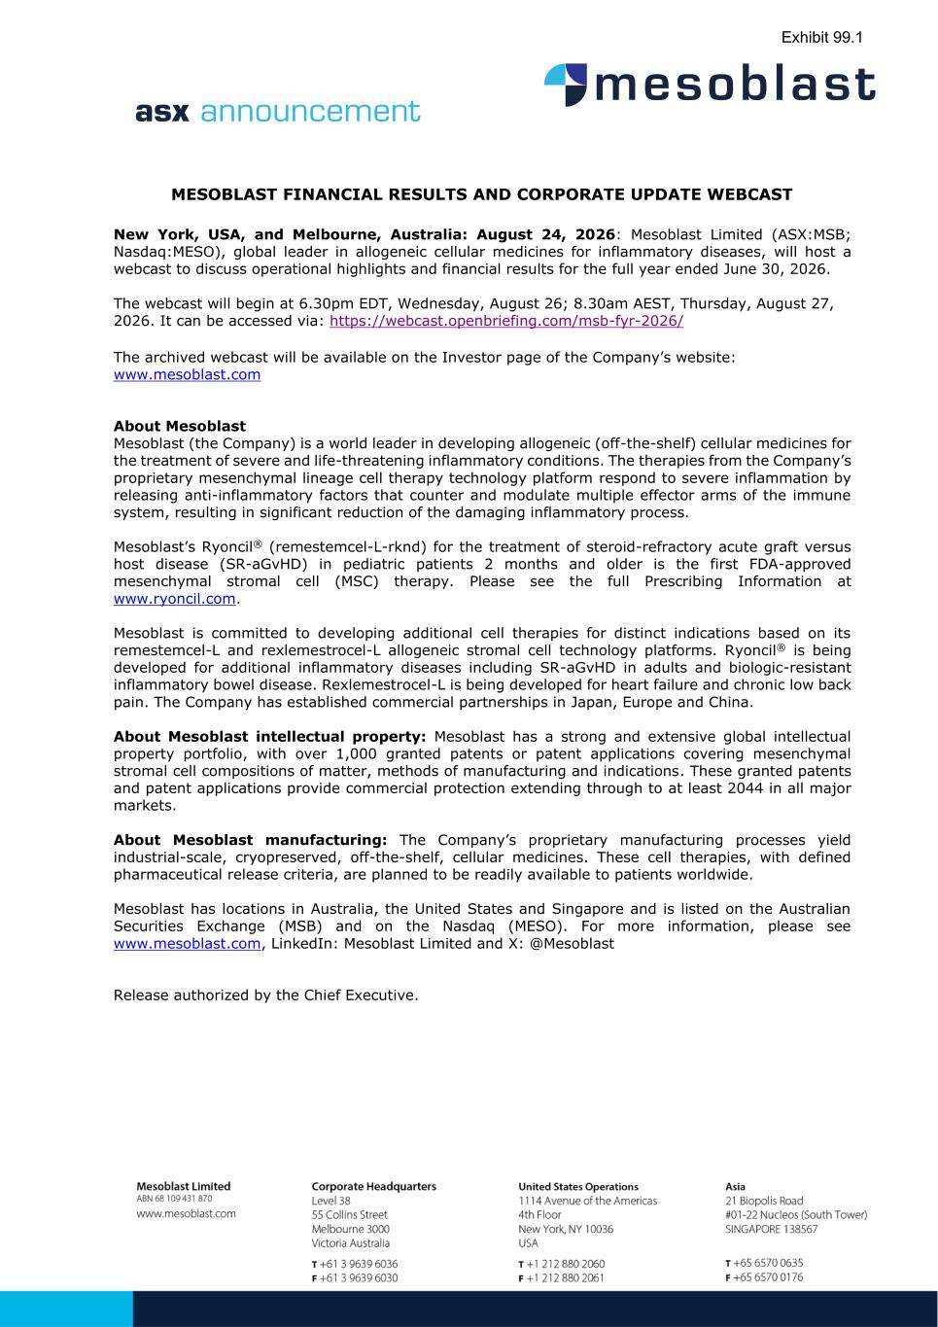

MESOBLAST FINANCIAL RESULTS AND CORPORATE UPDATE WEBCAST New York, USA, and Melbourne, Australia: August 24, 2026: Mesoblast Limited (ASX:MSB; Nasdaq:MESO), global leader in allogeneic cellular medicines for inflammatory diseases, will host a webcast to discuss operational highlights and financial results for the full year ended June 30, 2026. The webcast will begin at 6.30pm EDT, Wednesday, August 26; 8.30am AEST, Thursday, August 27, 2026. It can be accessed via: https://webcast.openbriefing.com/msb-fyr-2026/ The archived webcast will be available on the Investor page of the Company’s website: www.mesoblast.com About Mesoblast Mesoblast (the Company) is a world leader in developing allogeneic (off-the-shelf) cellular medicines for the treatment of severe and life-threatening inflammatory conditions. The therapies from the Company’s proprietary mesenchymal lineage cell therapy technology platform respond to severe inflammation by releasing anti-inflammatory factors that counter and modulate multiple effector arms of the immune system, resulting in significant reduction of the damaging inflammatory process. Mesoblast’s Ryoncil® (remestemcel-L-rknd) for the treatment of steroid-refractory acute graft versus host disease (SR-aGvHD) in pediatric patients 2 months and older is the first FDA-approved mesenchymal stromal cell (MSC) therapy. Please see the full Prescribing Information at www.ryoncil.com. Mesoblast is committed to developing additional cell therapies for distinct indications based on its remestemcel-L and rexlemestrocel-L allogeneic stromal cell technology platforms. Ryoncil® is being developed for additional inflammatory diseases including SR-aGvHD in adults and biologic-resistant inflammatory bowel disease. Rexlemestrocel-L is being developed for heart failure and chronic low back pain. The Company has established commercial partnerships in Japan, Europe and China. About Mesoblast intellectual property: Mesoblast has a strong and extensive global intellectual property portfolio, with over 1,000 granted patents or patent applications covering mesenchymal stromal cell compositions of matter, methods of manufacturing and indications. These granted patents and patent applications provide commercial protection extending through to at least 2044 in all major markets. About Mesoblast manufacturing: The Company’s proprietary manufacturing processes yield industrial-scale, cryopreserved, off-the-shelf, cellular medicines. These cell therapies, with defined pharmaceutical release criteria, are planned to be readily available to patients worldwide. Mesoblast has locations in Australia, the United States and Singapore and is listed on the Australian Securities Exchange (MSB) and on the Nasdaq (MESO). For more information, please see www.mesoblast.com, LinkedIn: Mesoblast Limited and X: @Mesoblast Release authorized by the Chief Executive. Exhibit 99.1

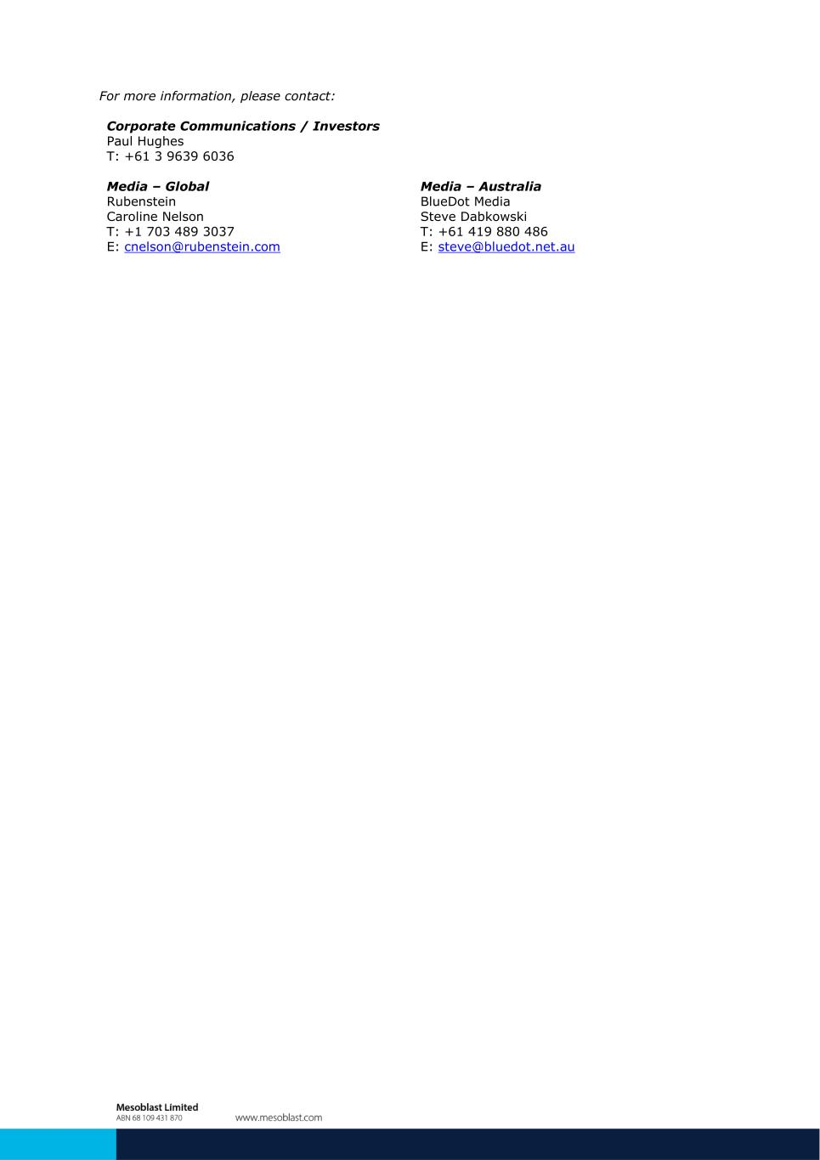
For more information, please contact: Corporate Communications / Investors Paul Hughes T: +61 3 9639 6036 Media – Global Media – Australia Rubenstein BlueDot Media Caroline Nelson Steve Dabkowski T: +1 703 489 3037 T: +61 419 880 486 E: cnelson@rubenstein.com E: steve@bluedot.net.au

